

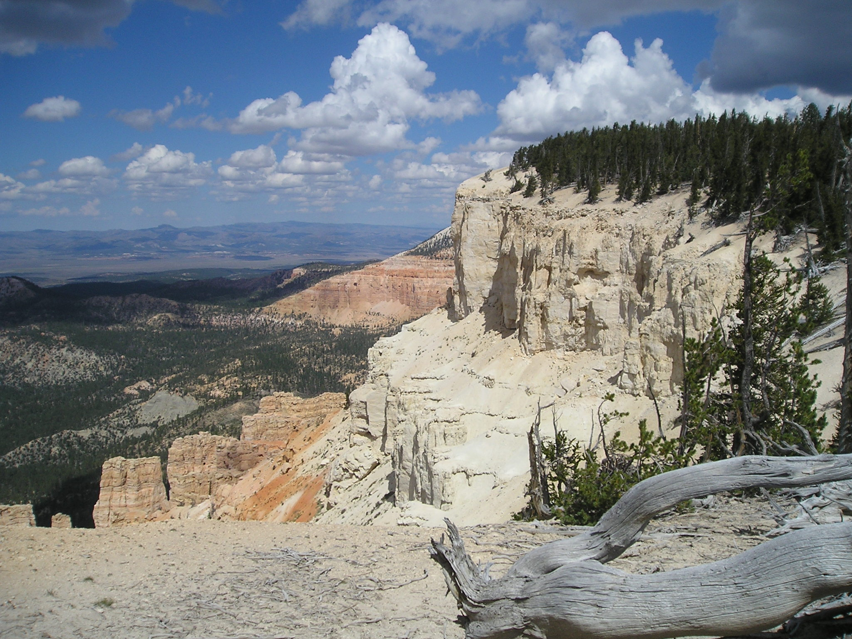

Ride Info
Length: Approximately 30 miles
Time: Approximately 8 ½ hours
Skill Level: Easy
This is a trailered ride
SATURDAY ONLY

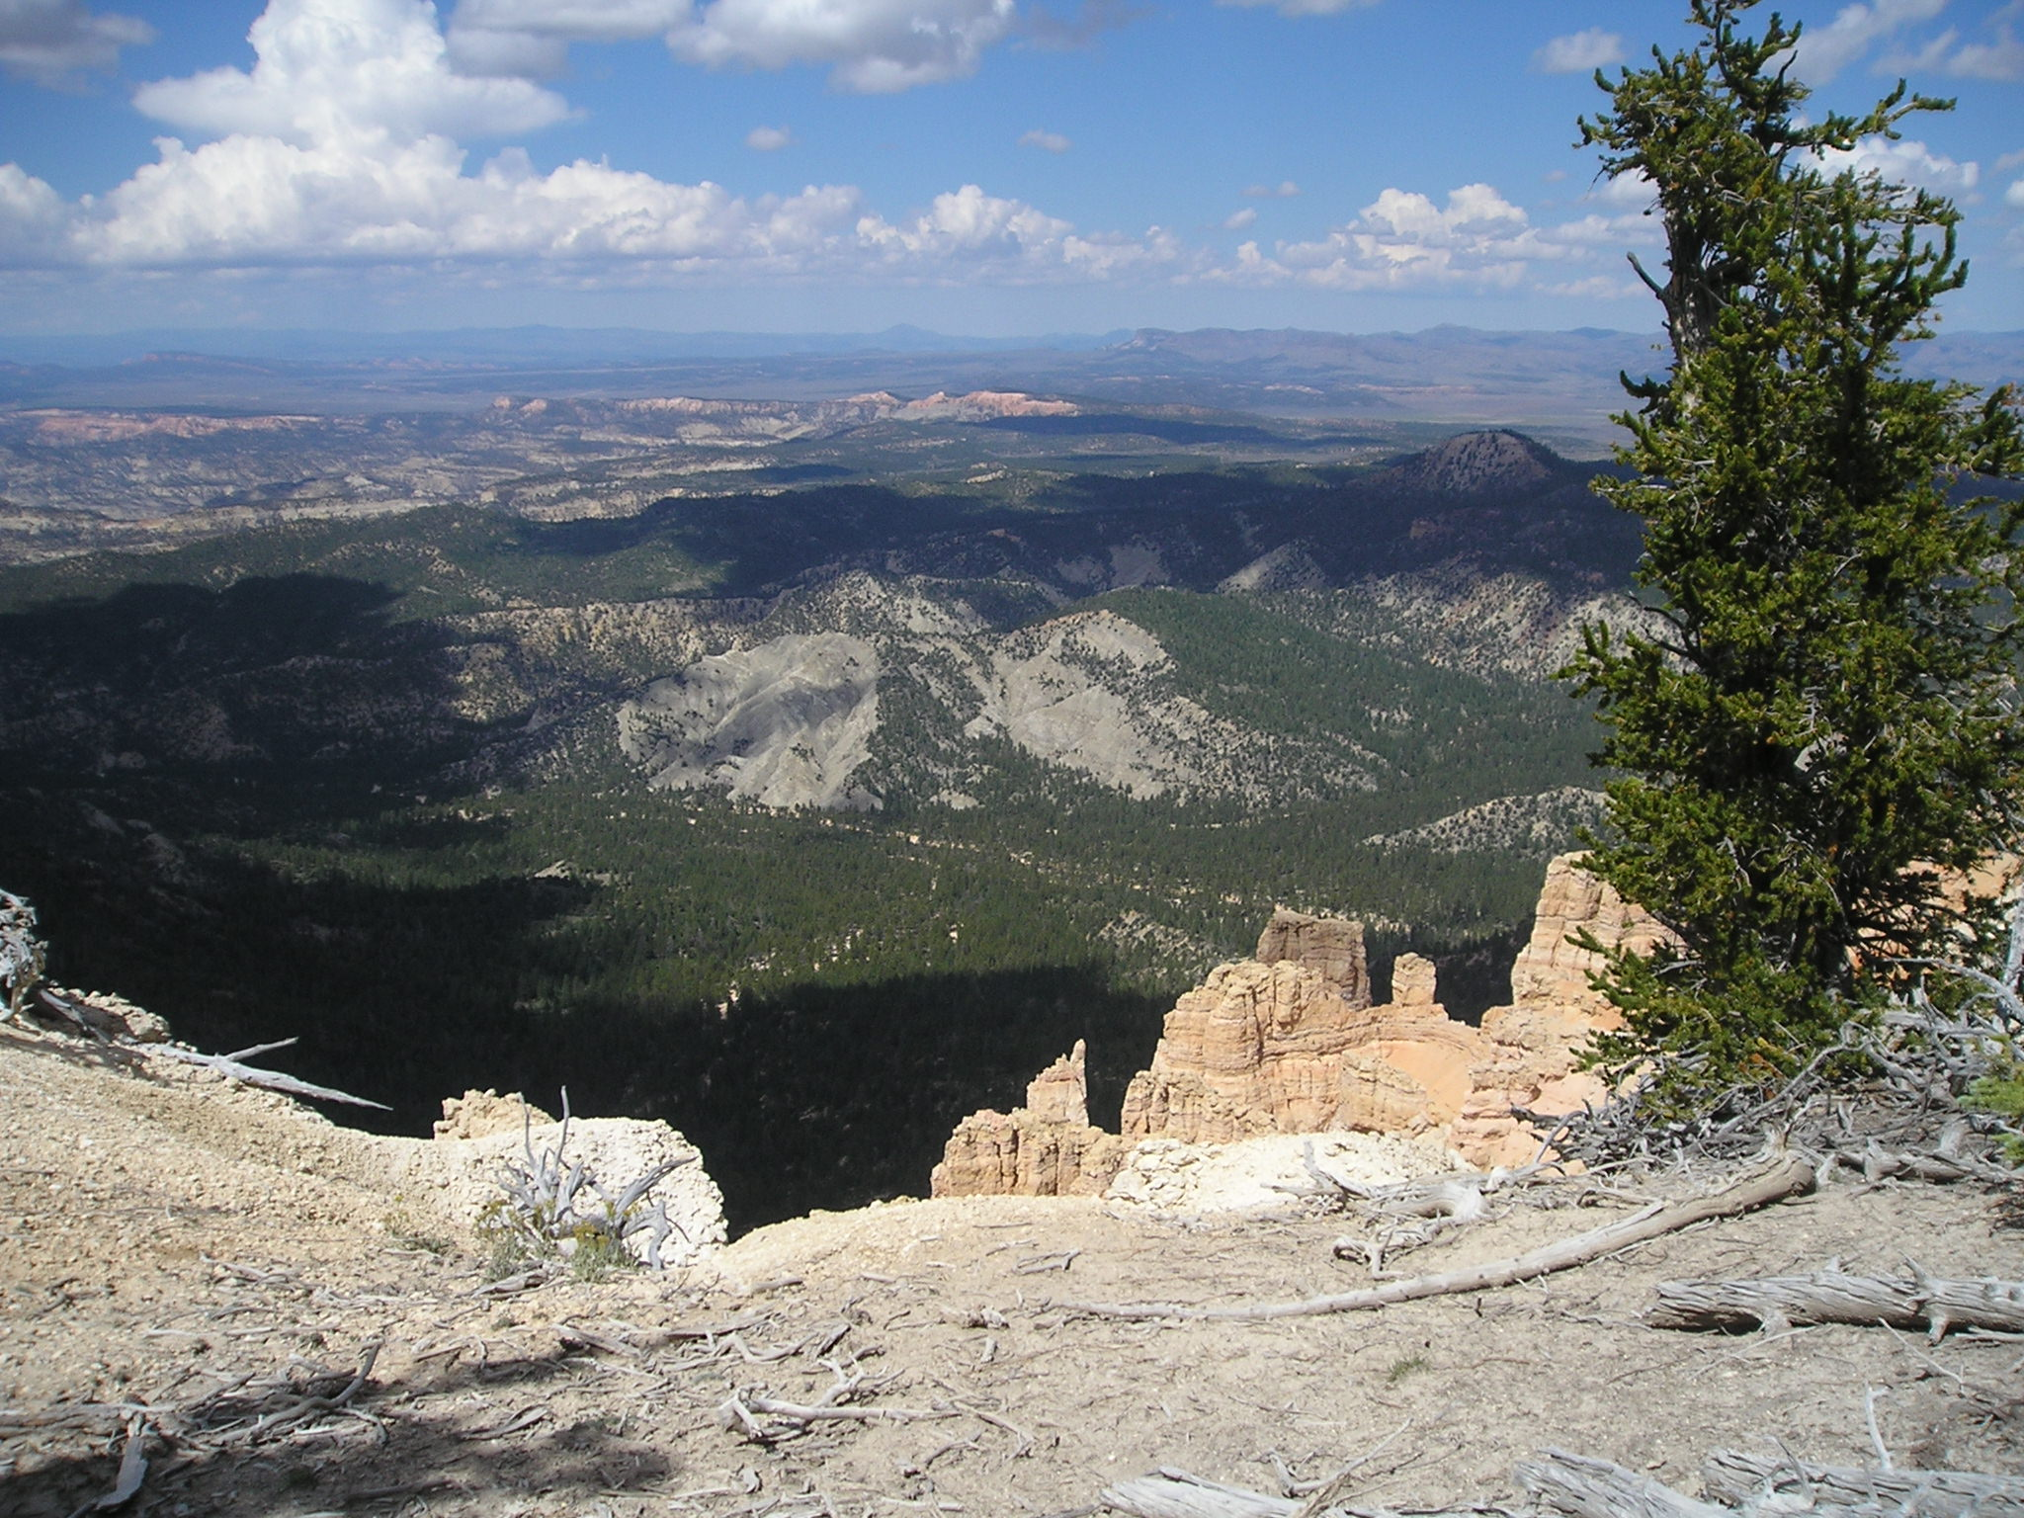
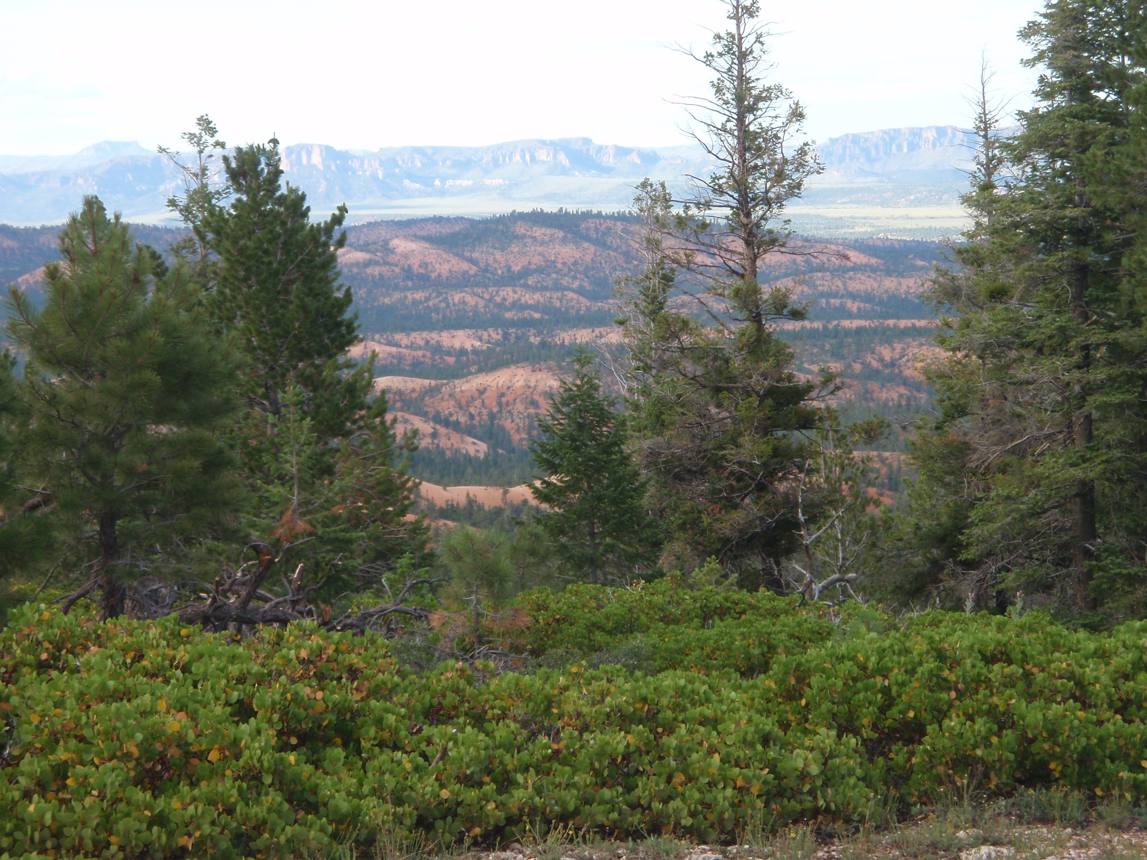

Riders will trailer their ATV’s to the staging area and trailhead at Pine Lake approximately 55 miles from downtown Panguitch. The view from the top of Powell Point are majestic and certainly worth the trip. Riders will enjoy the ¾ mile hike at the top, to Powell Point. The elevation here is well over 10,000 feet. The ATV ride then travels onto the Barney Top and down to the Widtsoe Cemetery and back to the staging area. Bring a lunch as we will be stopping along the trail for a break.

