Trail #11 Panguitch/Limekiln/West Hunt Loop
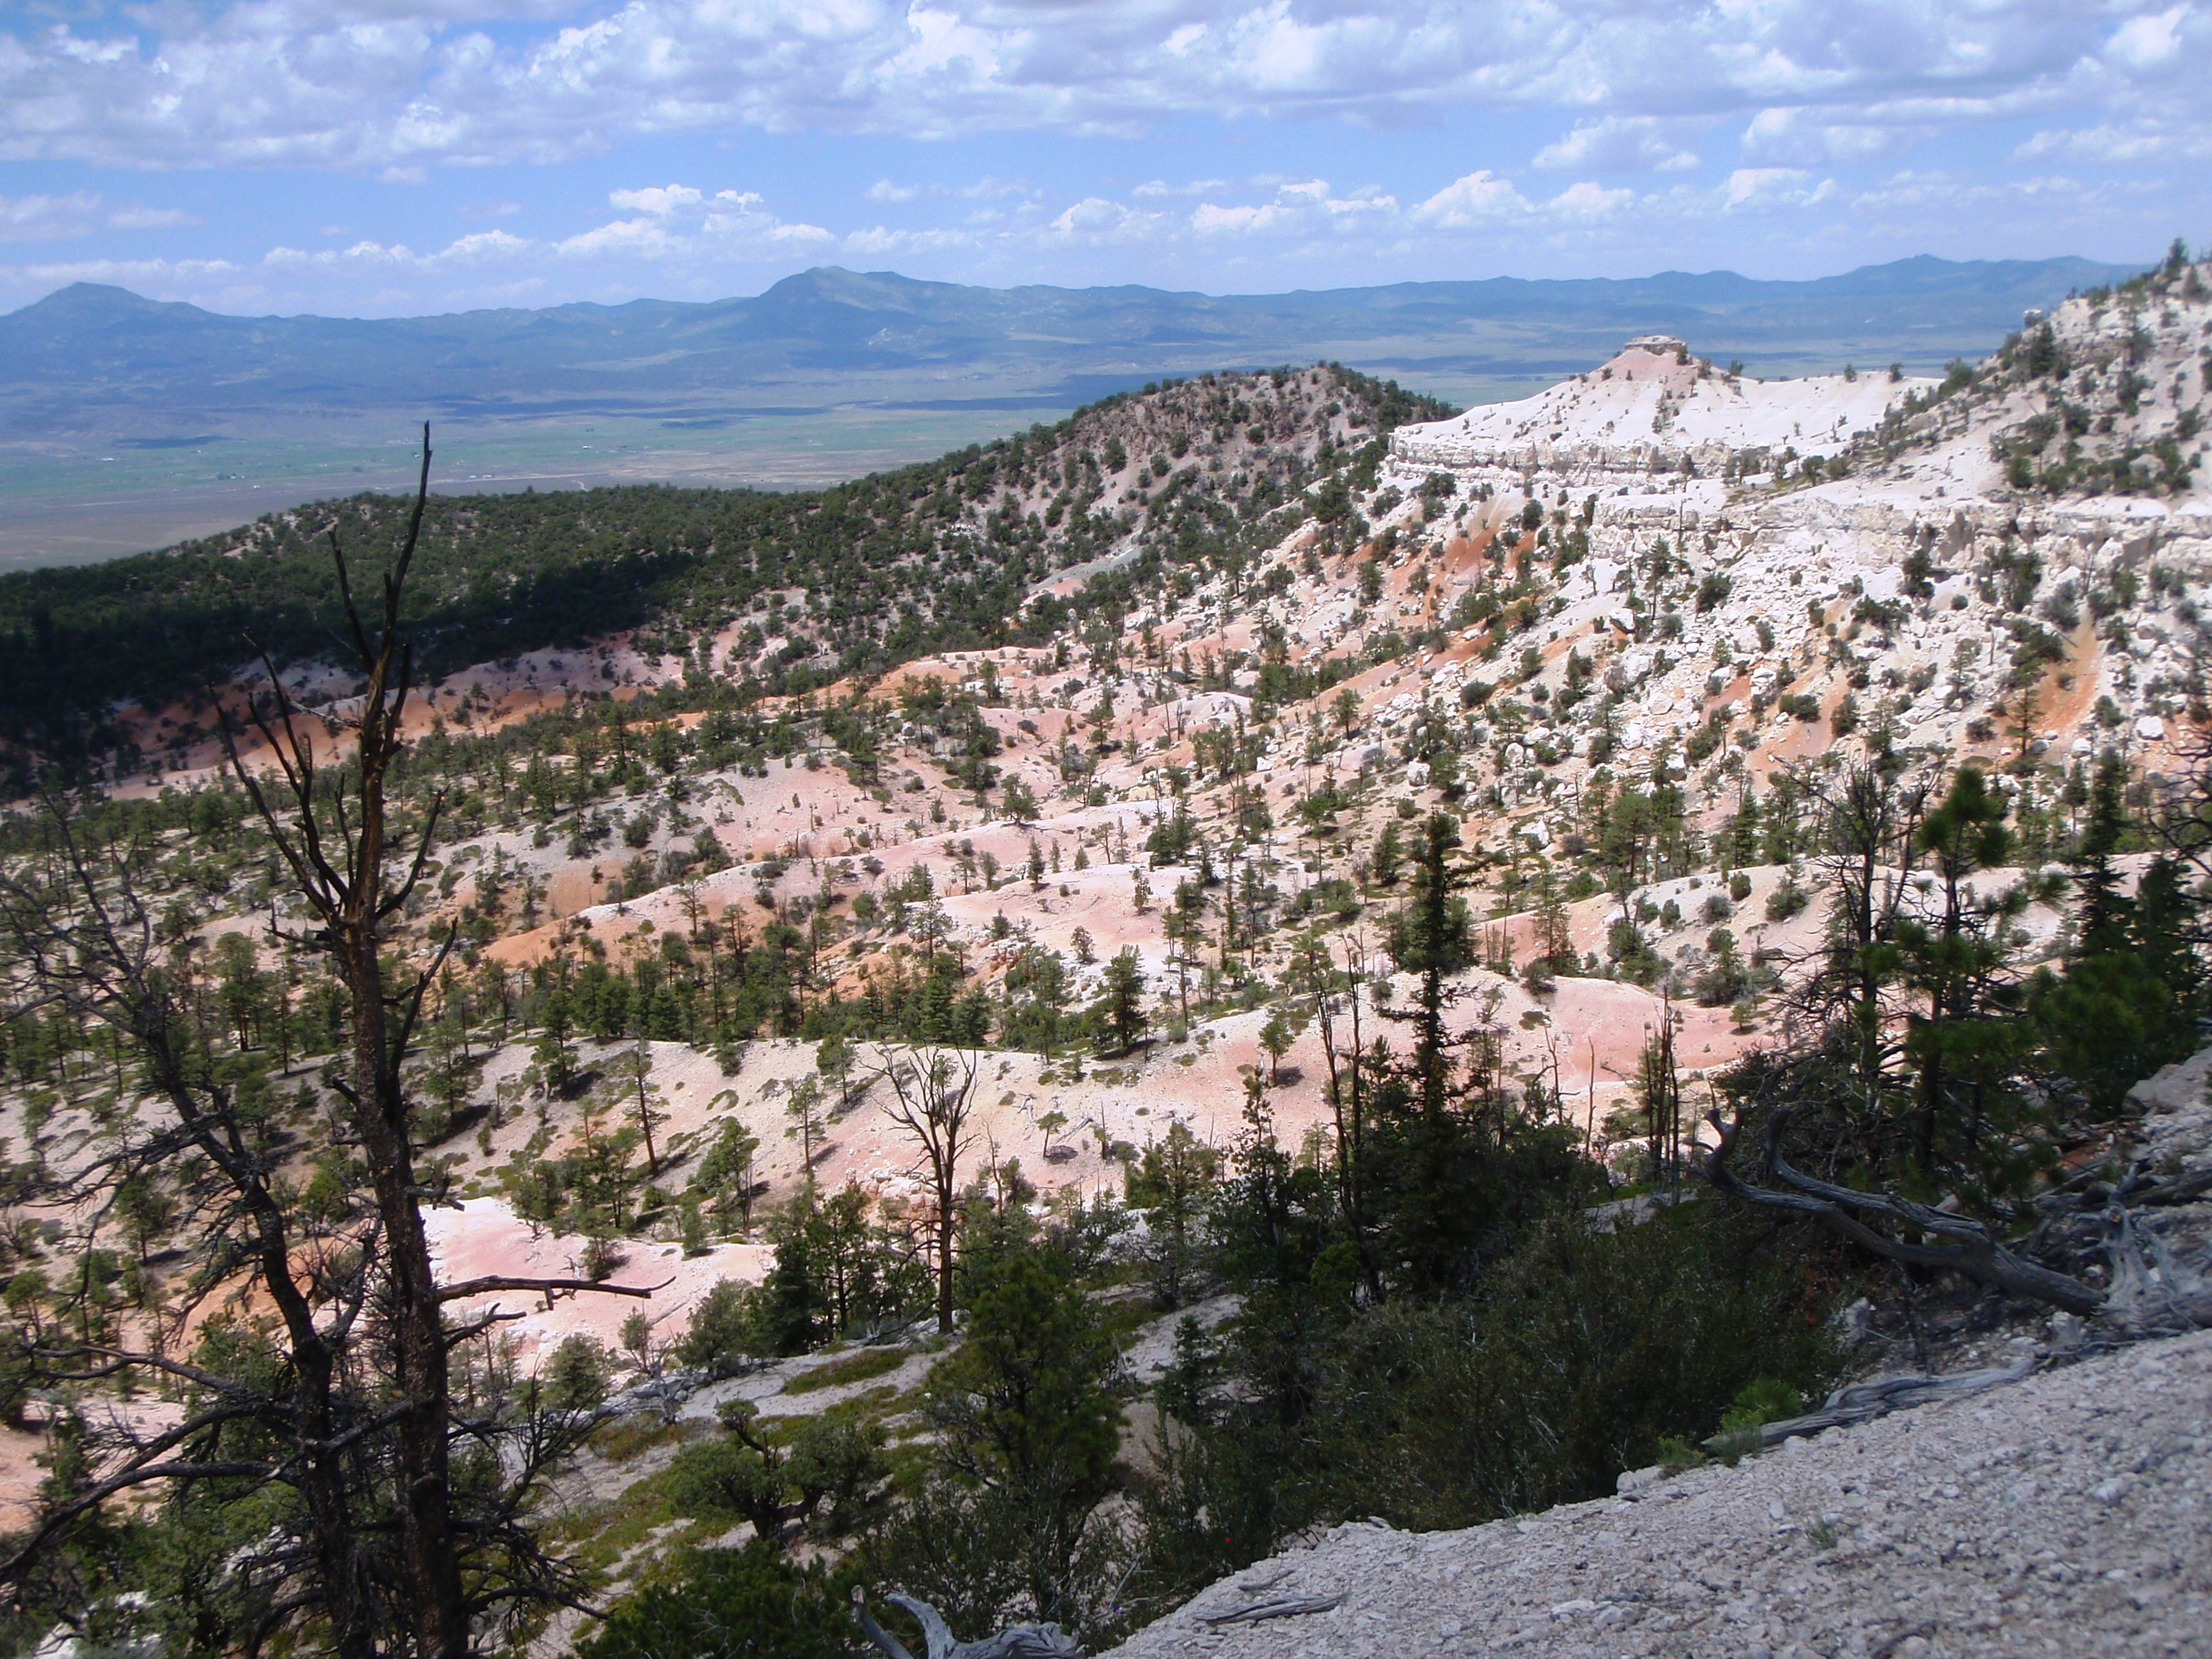

Ride Info:
Length: Approximately 75 miles
Time: 9 hours
Rider Skill Level: Intermediate
Early Departure: 8 AM
FASTER PACED RIDE

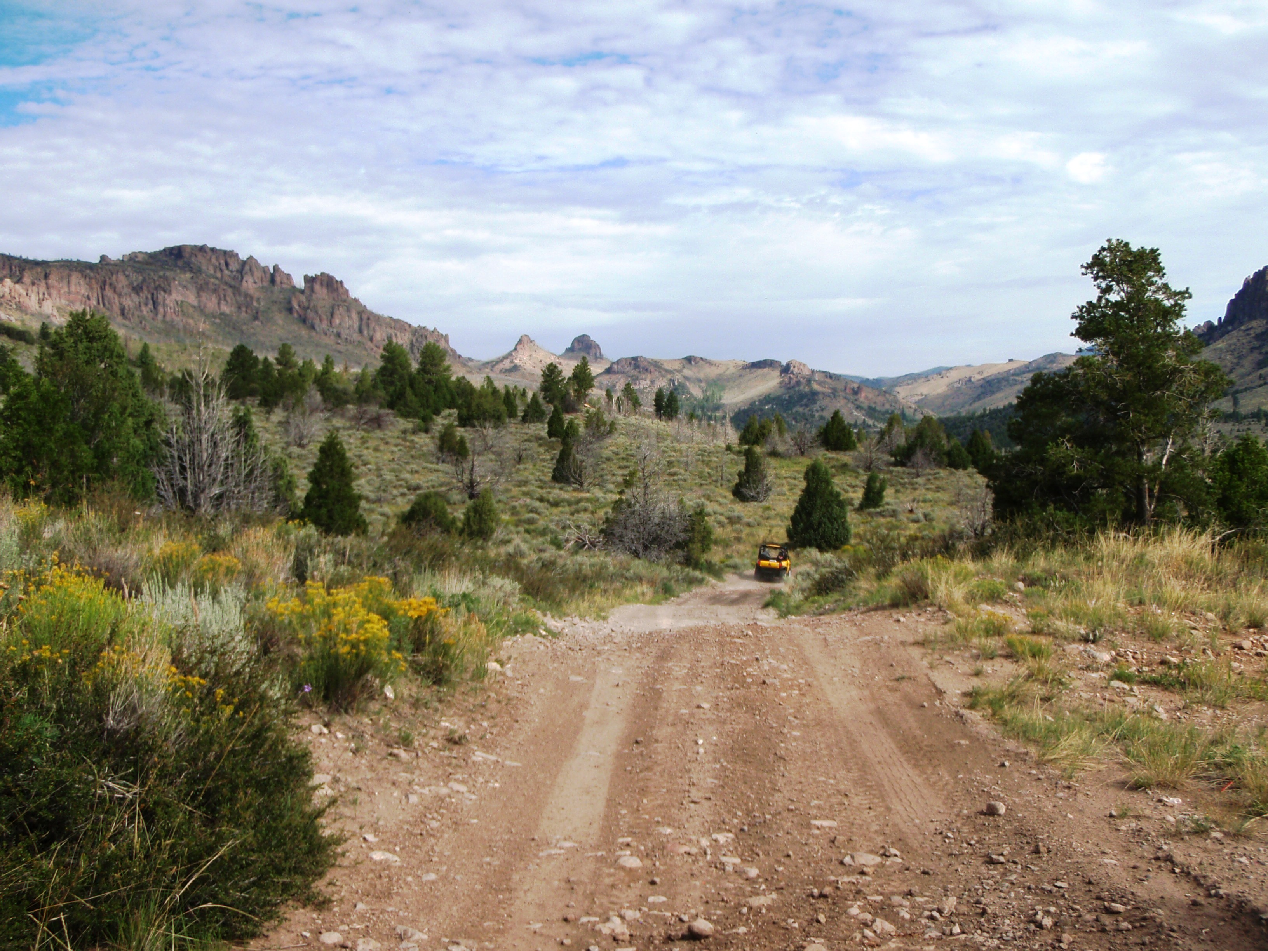
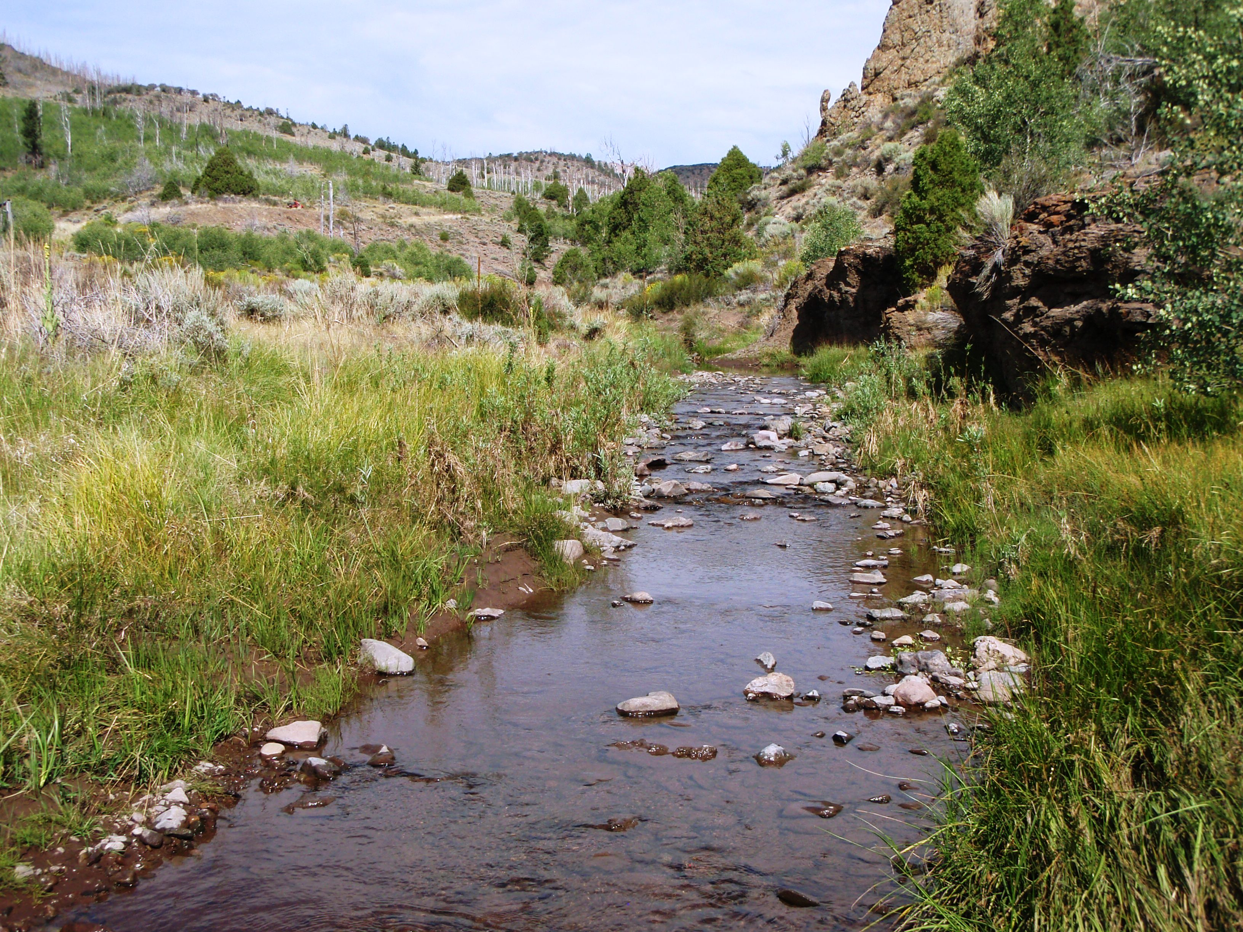
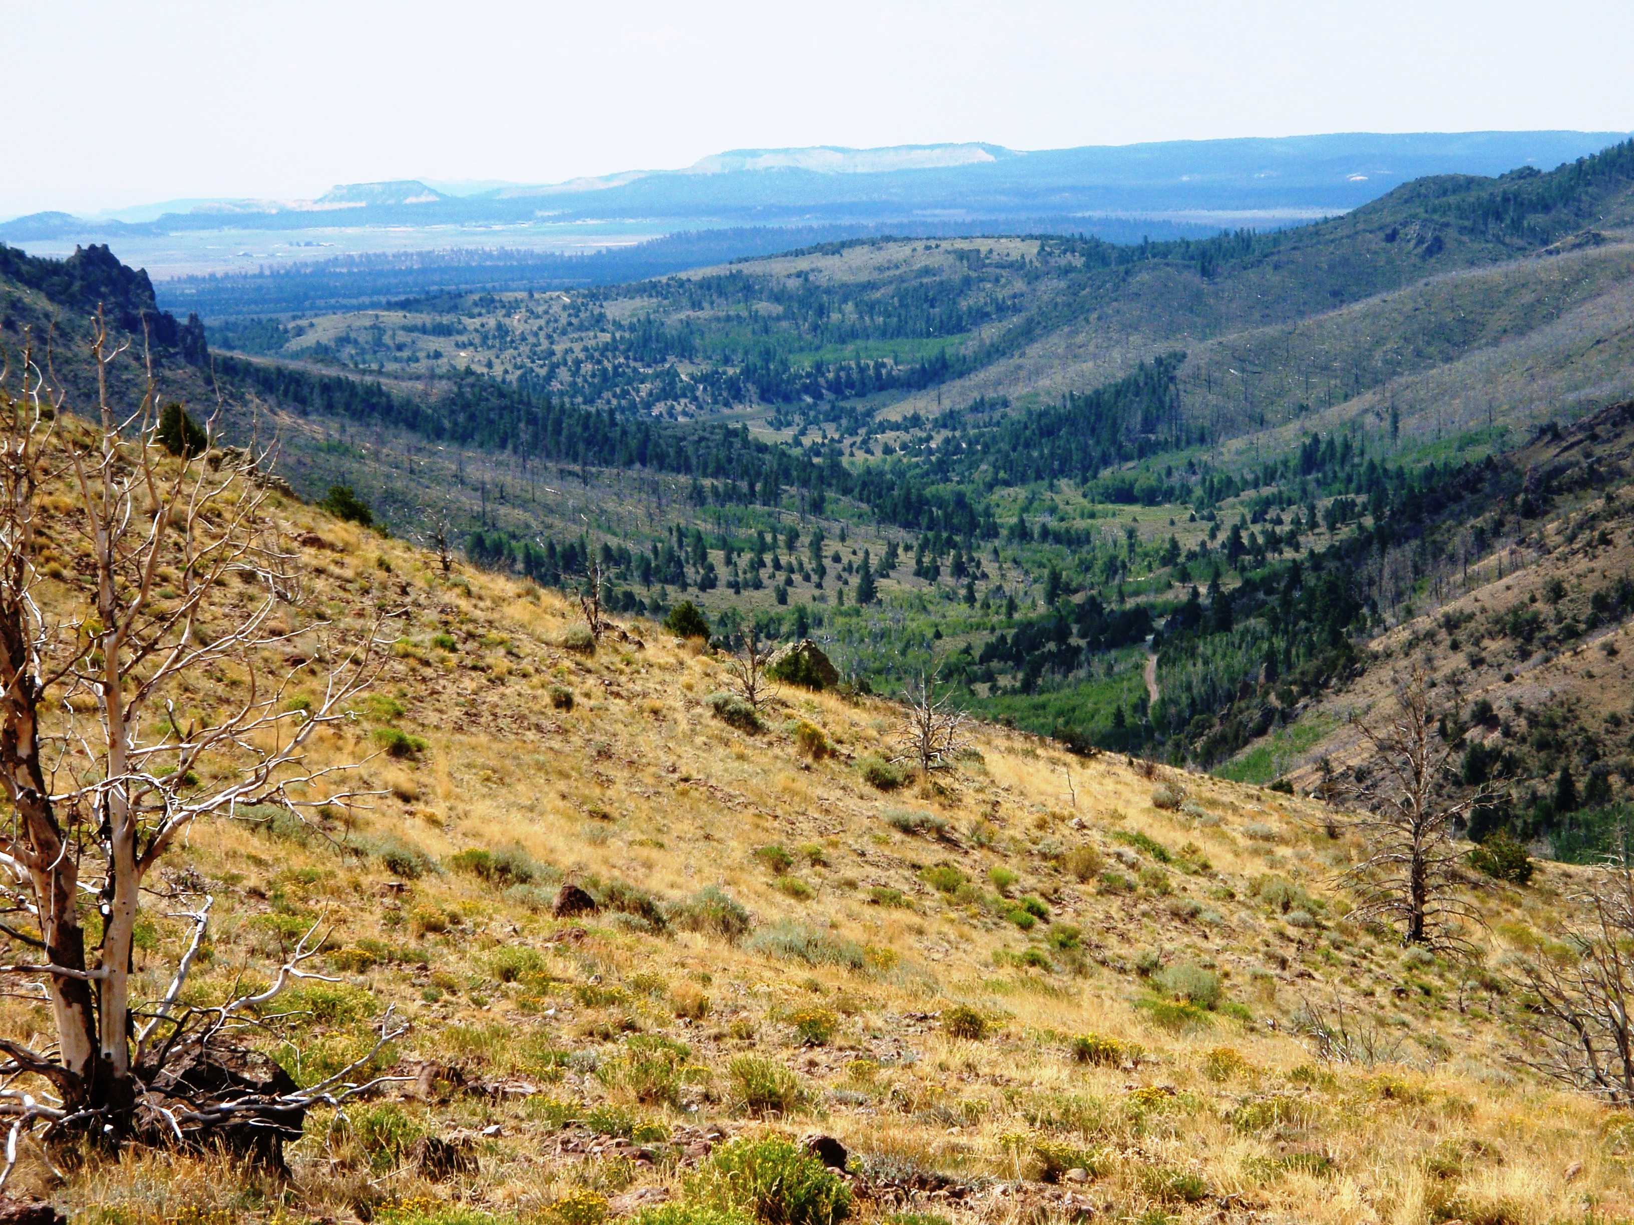

This ride begins in Panguitch and climbs up Limekiln, to the Fremont Trail then down into the West Hunt Creek drainage. Enjoy sagebrush flats, pine forests, majestic views and a nice long ride. Water crossings are shallow. Bring a lunch as we will be stopping along the trail for a break. This ride has it all: length, elevation, water, trees and sagebrush. There are some steep climbs and a few rocky spots. There are no ATV/UTV vehicle restrictions.

This is an EARLY DEPARTING ride

