
#12 Sandy Loop Trail

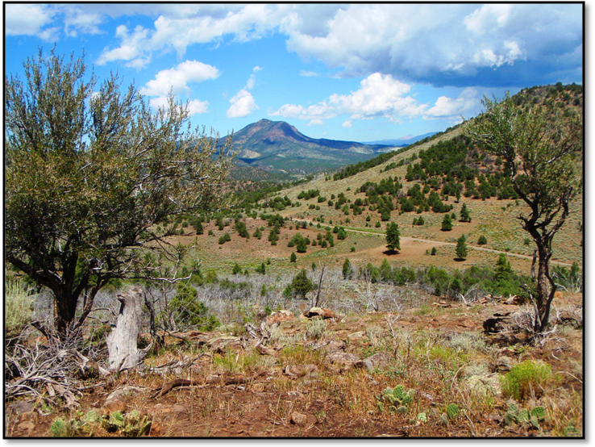
Ride Info:
Length: Approximately 40 miles
Time: Approximately 6 hours
Rider Skill Level: Moderate

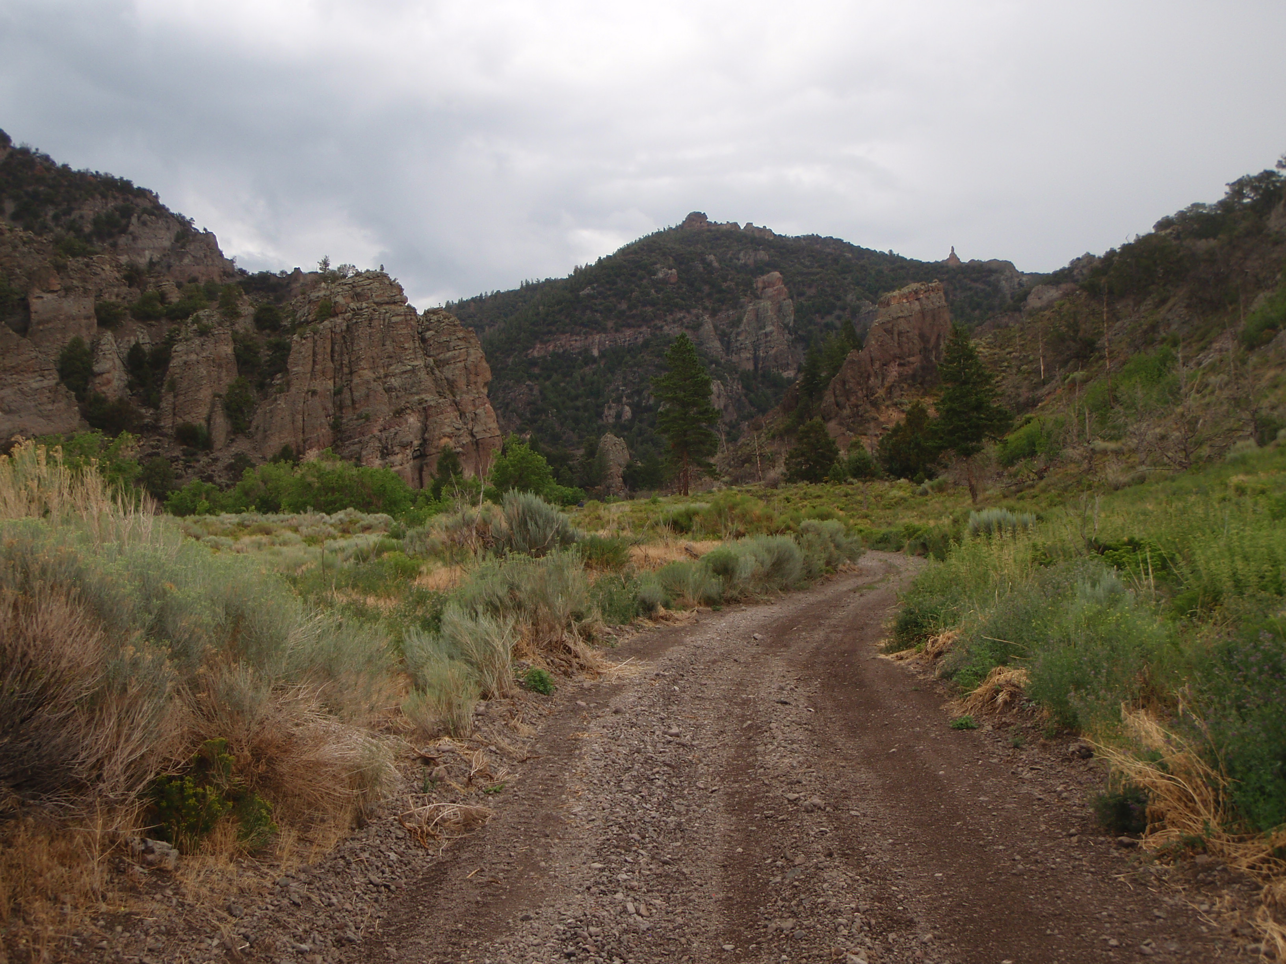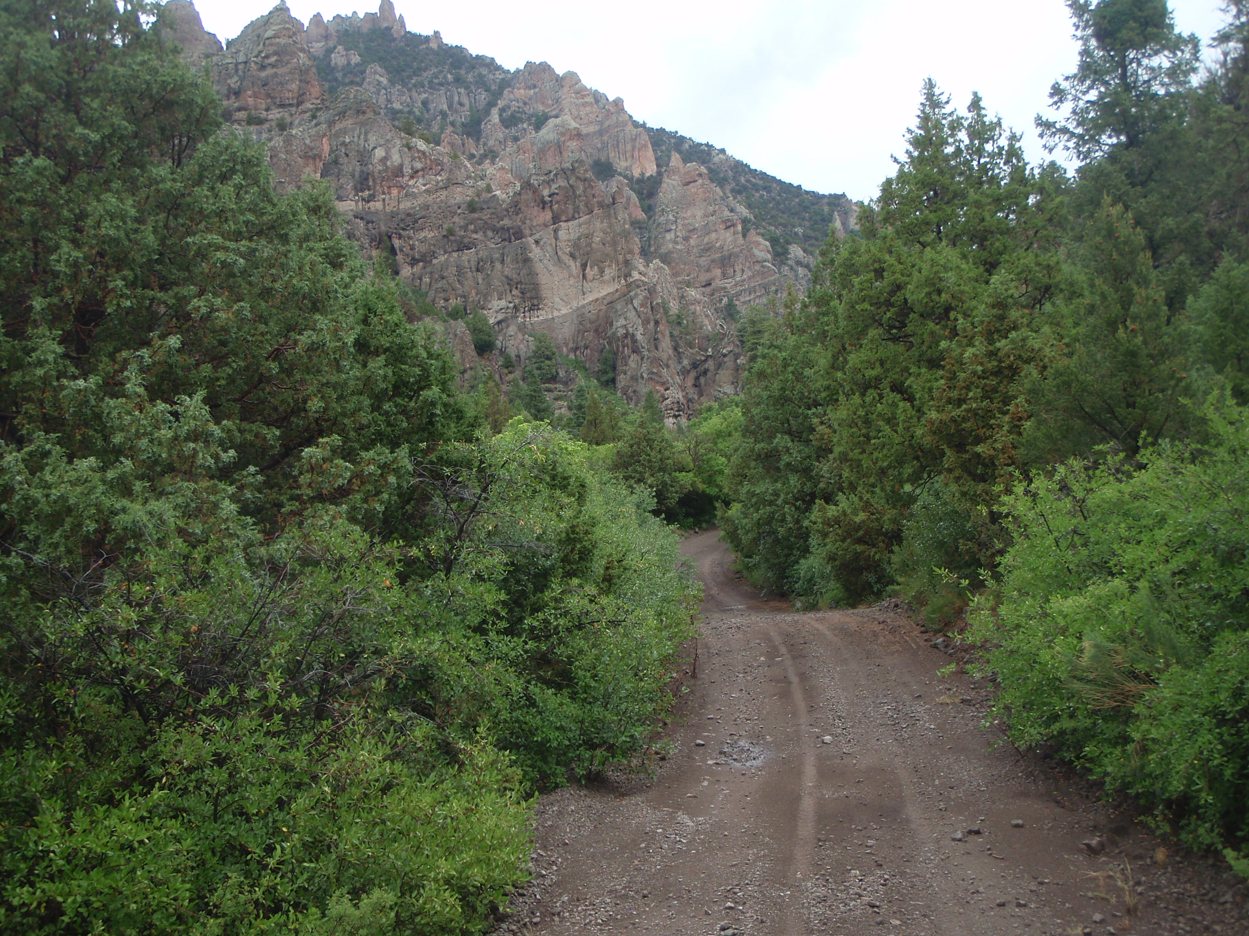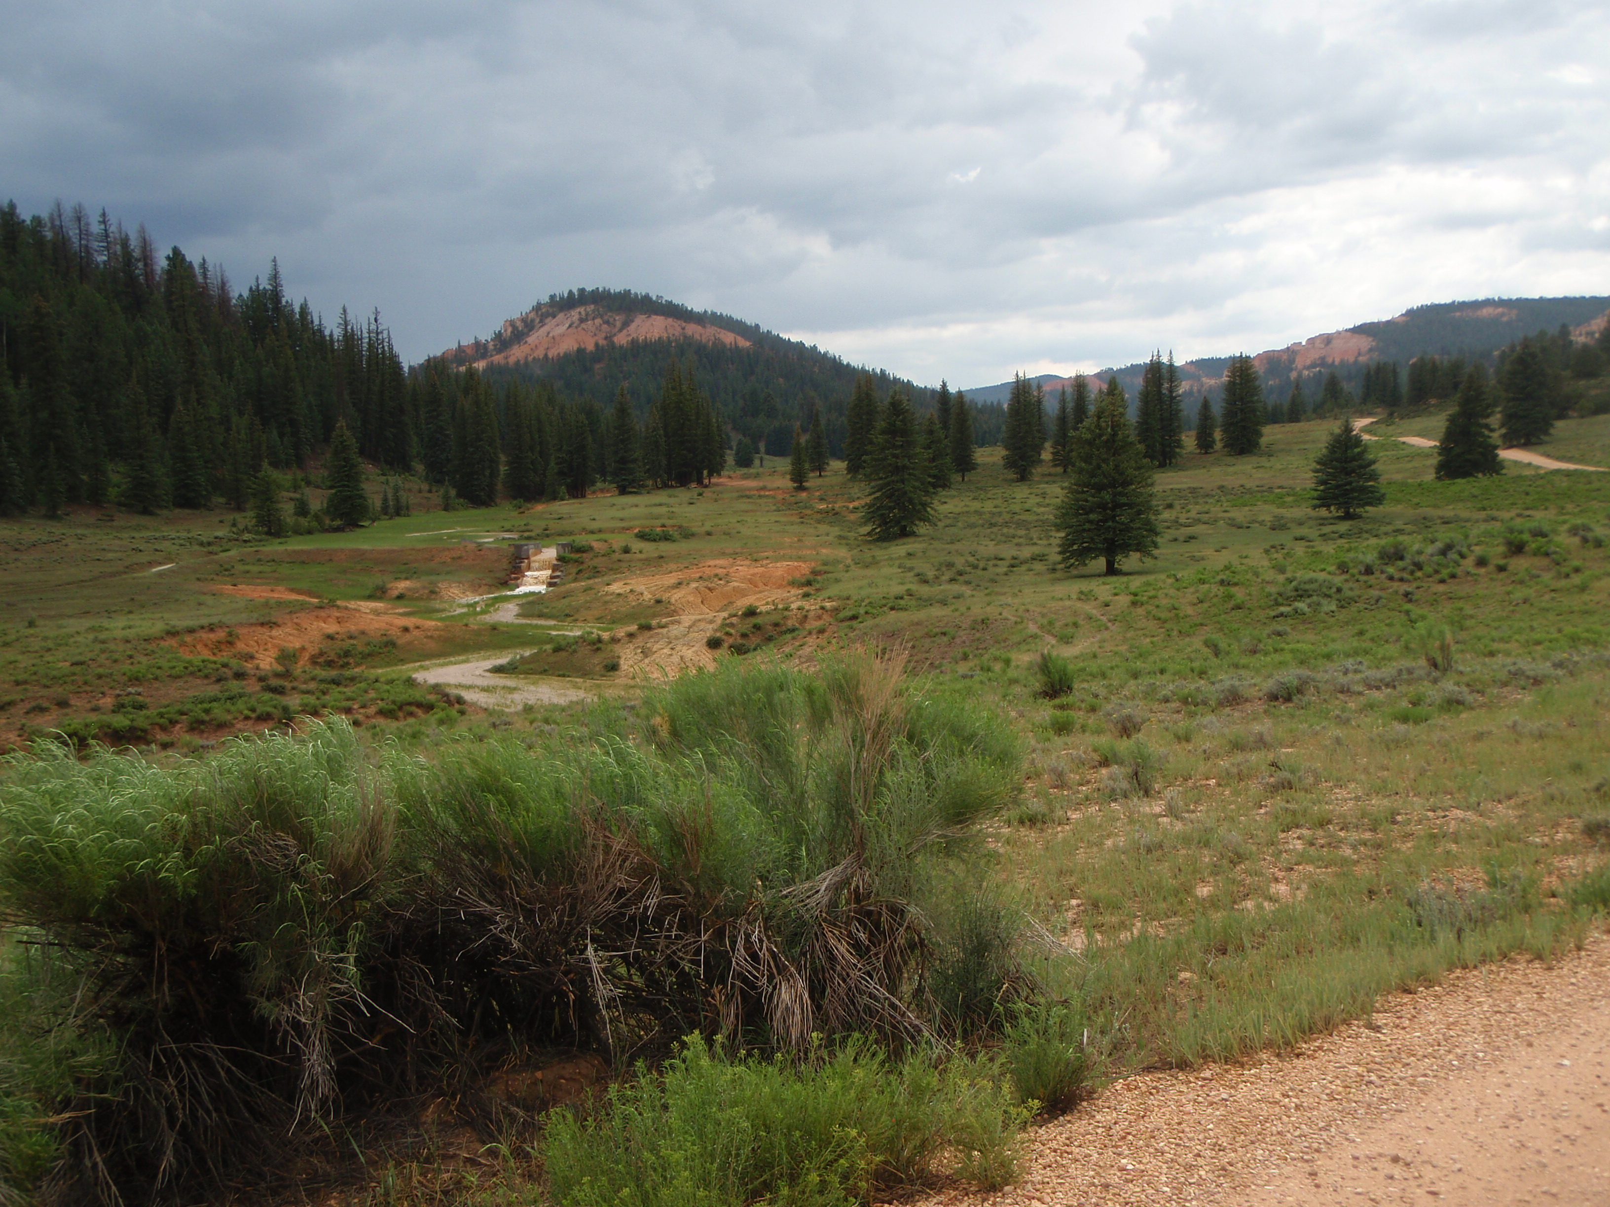

This ride begins in Panguitch at the Triple C Arena parking lot and moves to the West Bench. We’ll arrive at the trail and follow 3 Mile Creek; a big resource for wildlife. Ascending up into the aspens and pines, crossing at the base of Little Creek Peak into high mountain country. Beginning our descent in the shadow of Sandy Peak Mountain. Heading down through pinion and cedar forests you’ll enjoy fabulous views of the valley and Mt Dutton. Pack a lunch as we will be stopping along the trail for a break. There are no vehicle size restrictions for this trail.

