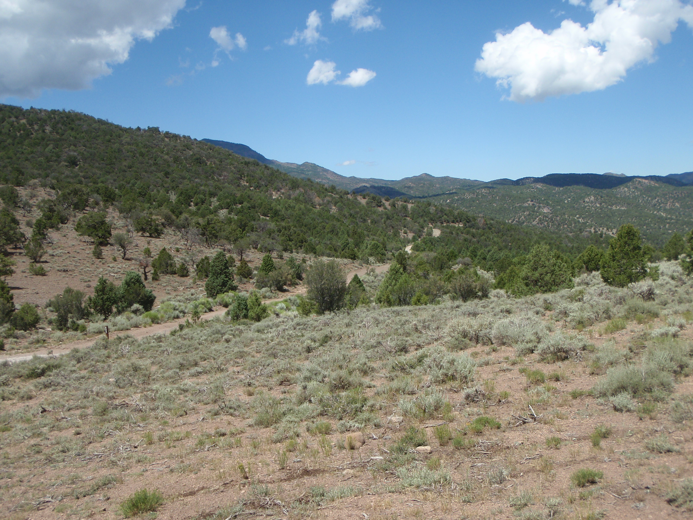
Ride Info:
Length: Approximately 65 miles
Time: Approximately 8 hours
Rider Skill Level: Moderate
Early Departure: 8:00 A.M.

Trail #17 TV Towers

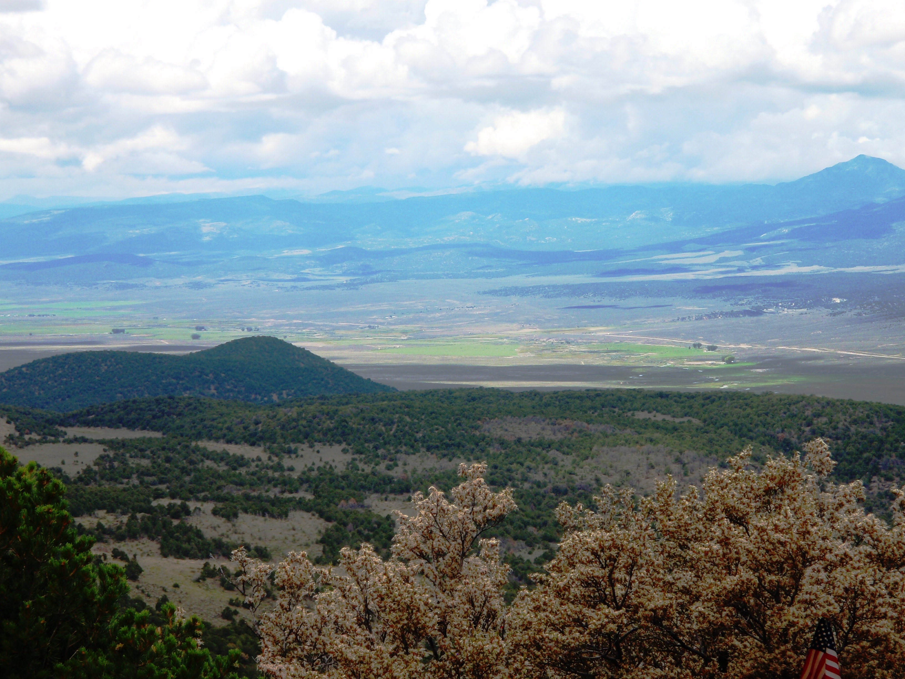
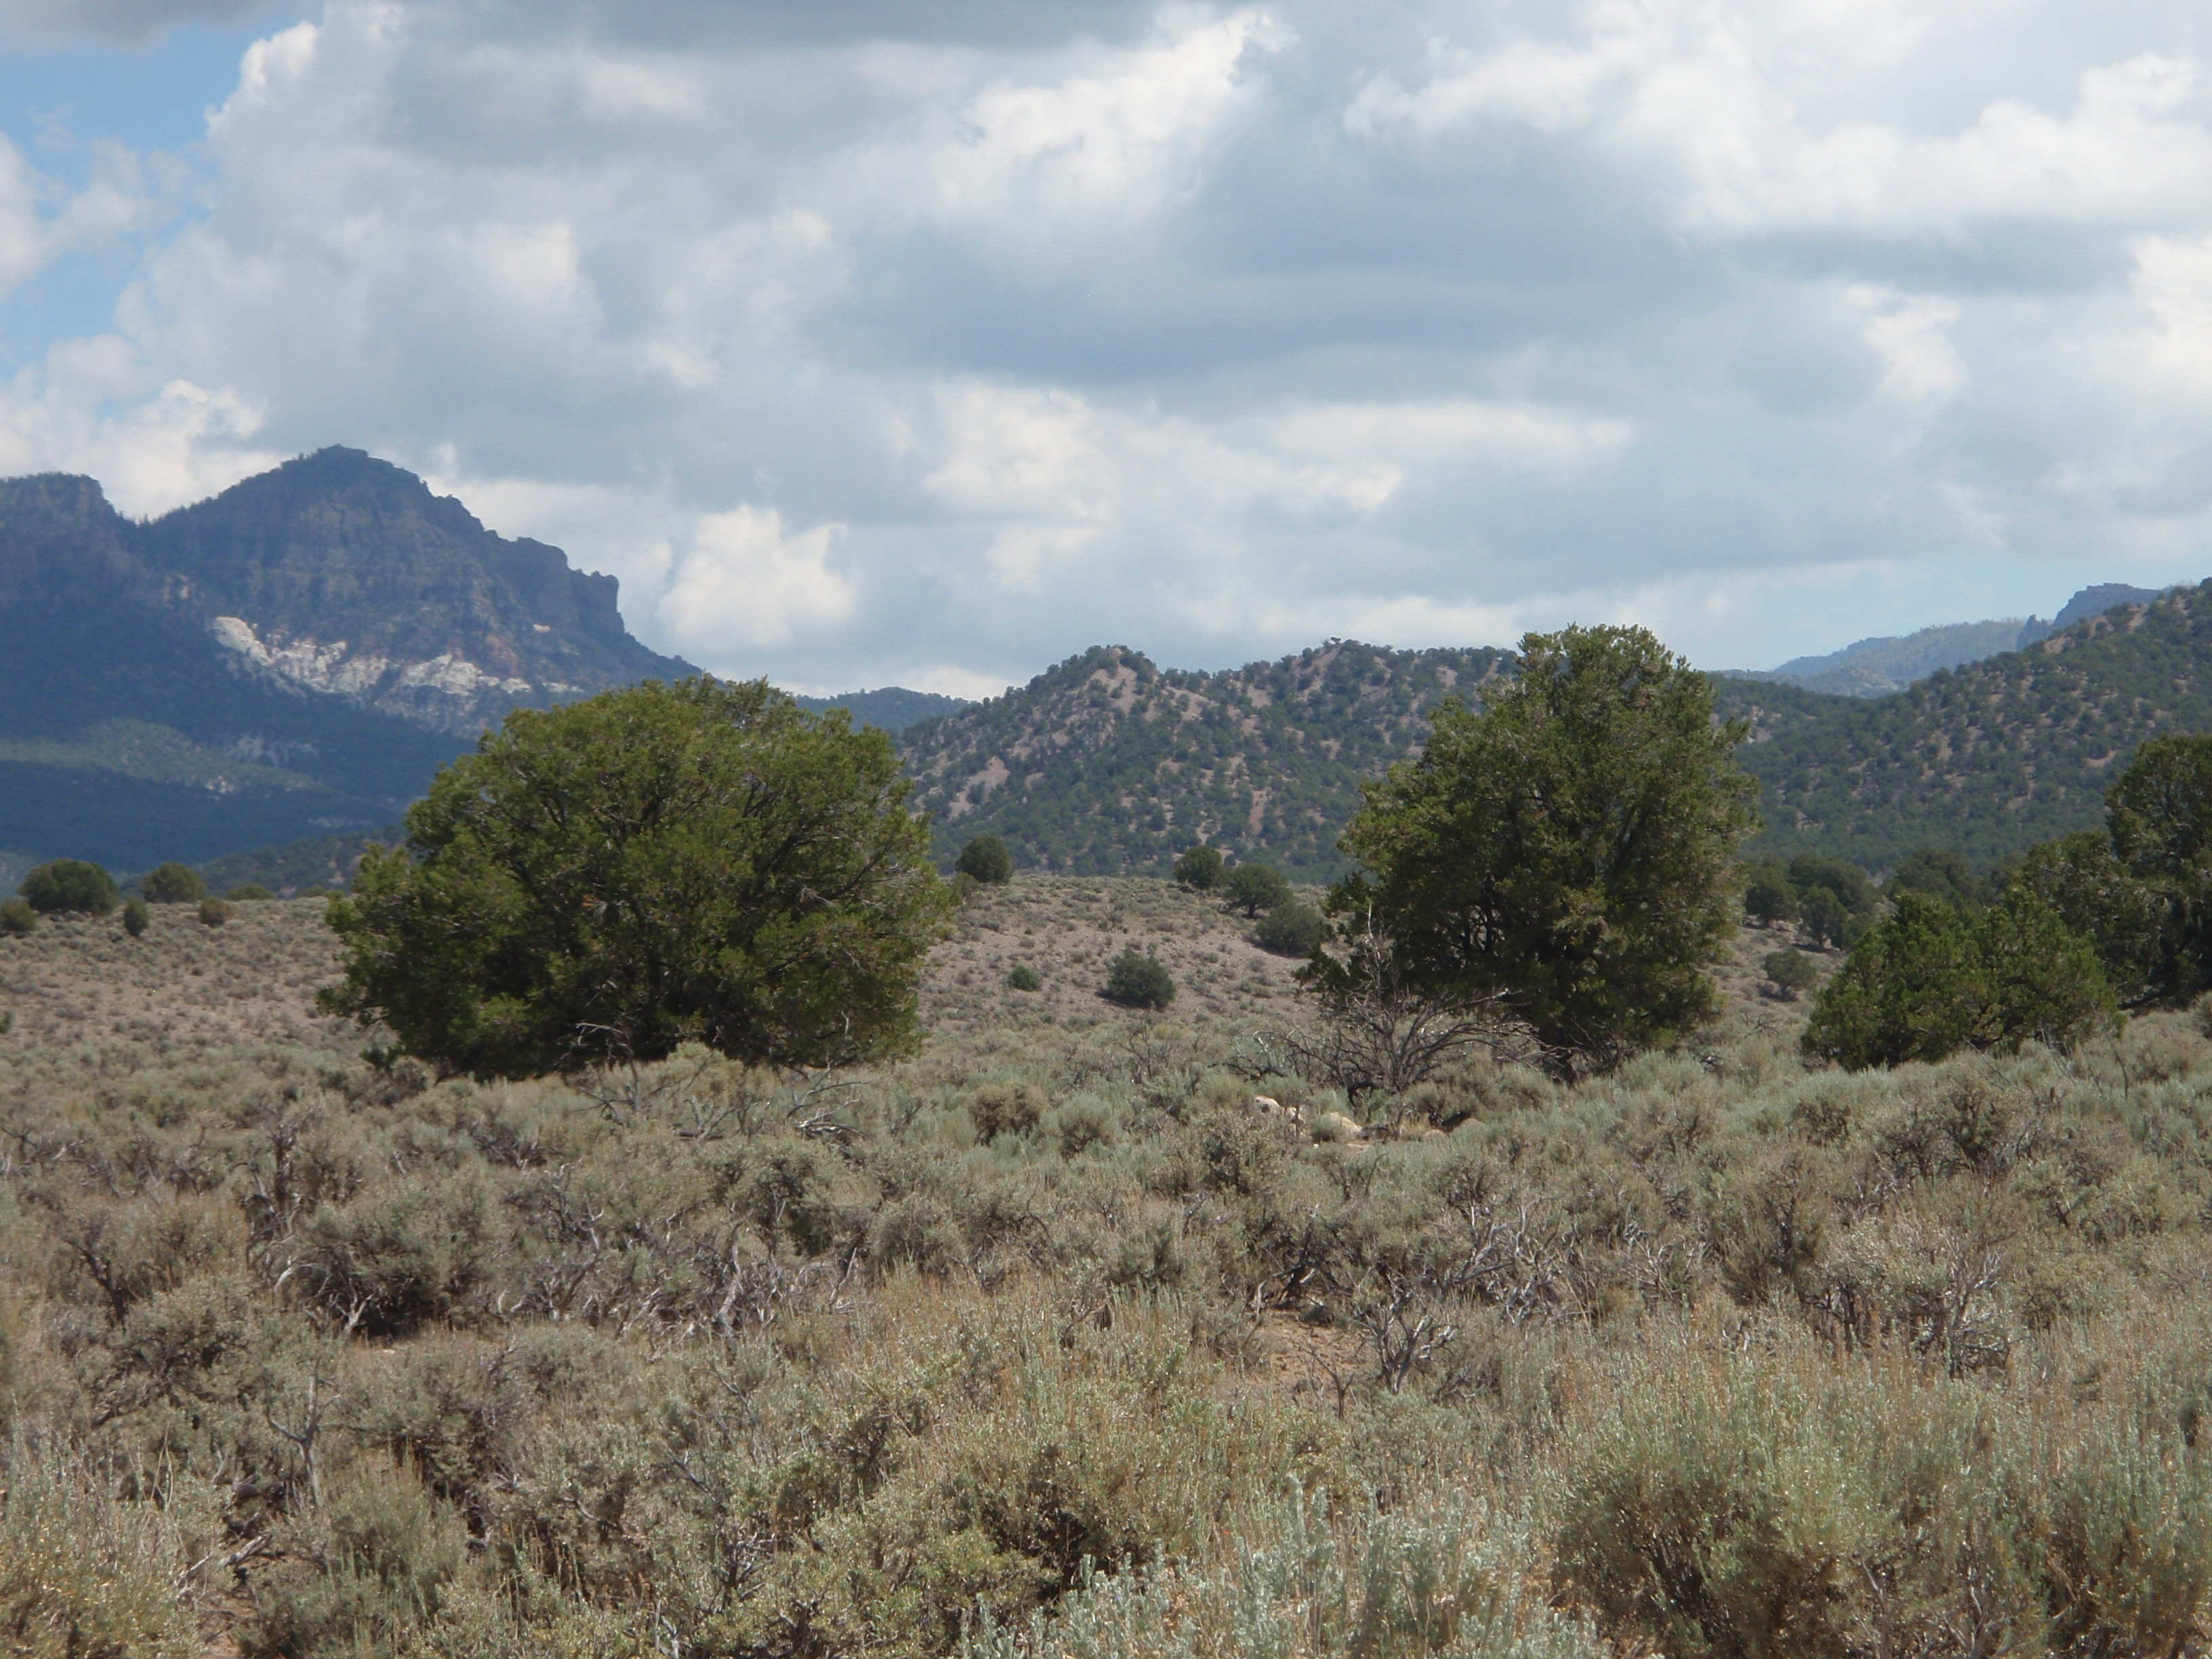

Early Departure: This ride is designed for the more adventurous rider, containing a wide variety of trail conditions. We will be riding through sagebrush covered flats, high mountain trails, up and down some steep rocky slopes and alongside some pretty streams. The ride will start at the Rally Headquarters and proceed north to cross Highway 20 where we will intersect the upper Dog Valley trail as we continue to the Fremont Pass. We will then descent to lower Bear Valley where we will climb over a steep rocky trail to come down into 3 mile creek on our return to Panguitch. Be sure to bring your lunch and extra gas if needed.

