Trail #2 Circleville / Dog Valley Ride

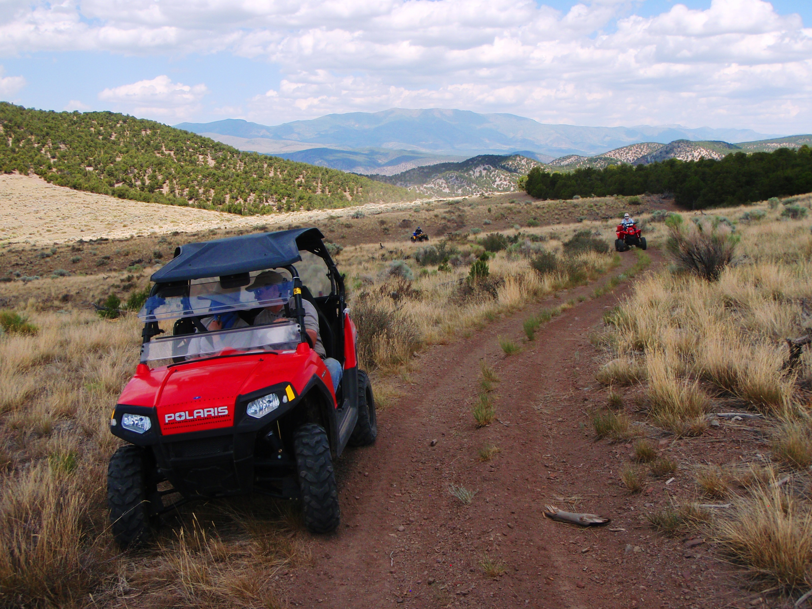
Ride Info:
Length: Approximately 90 miles
Time: Approximately 8 hours
Rider Skill Level: Moderate
Early Departure: 8:00 A.M.
F This will be a faster paced ride

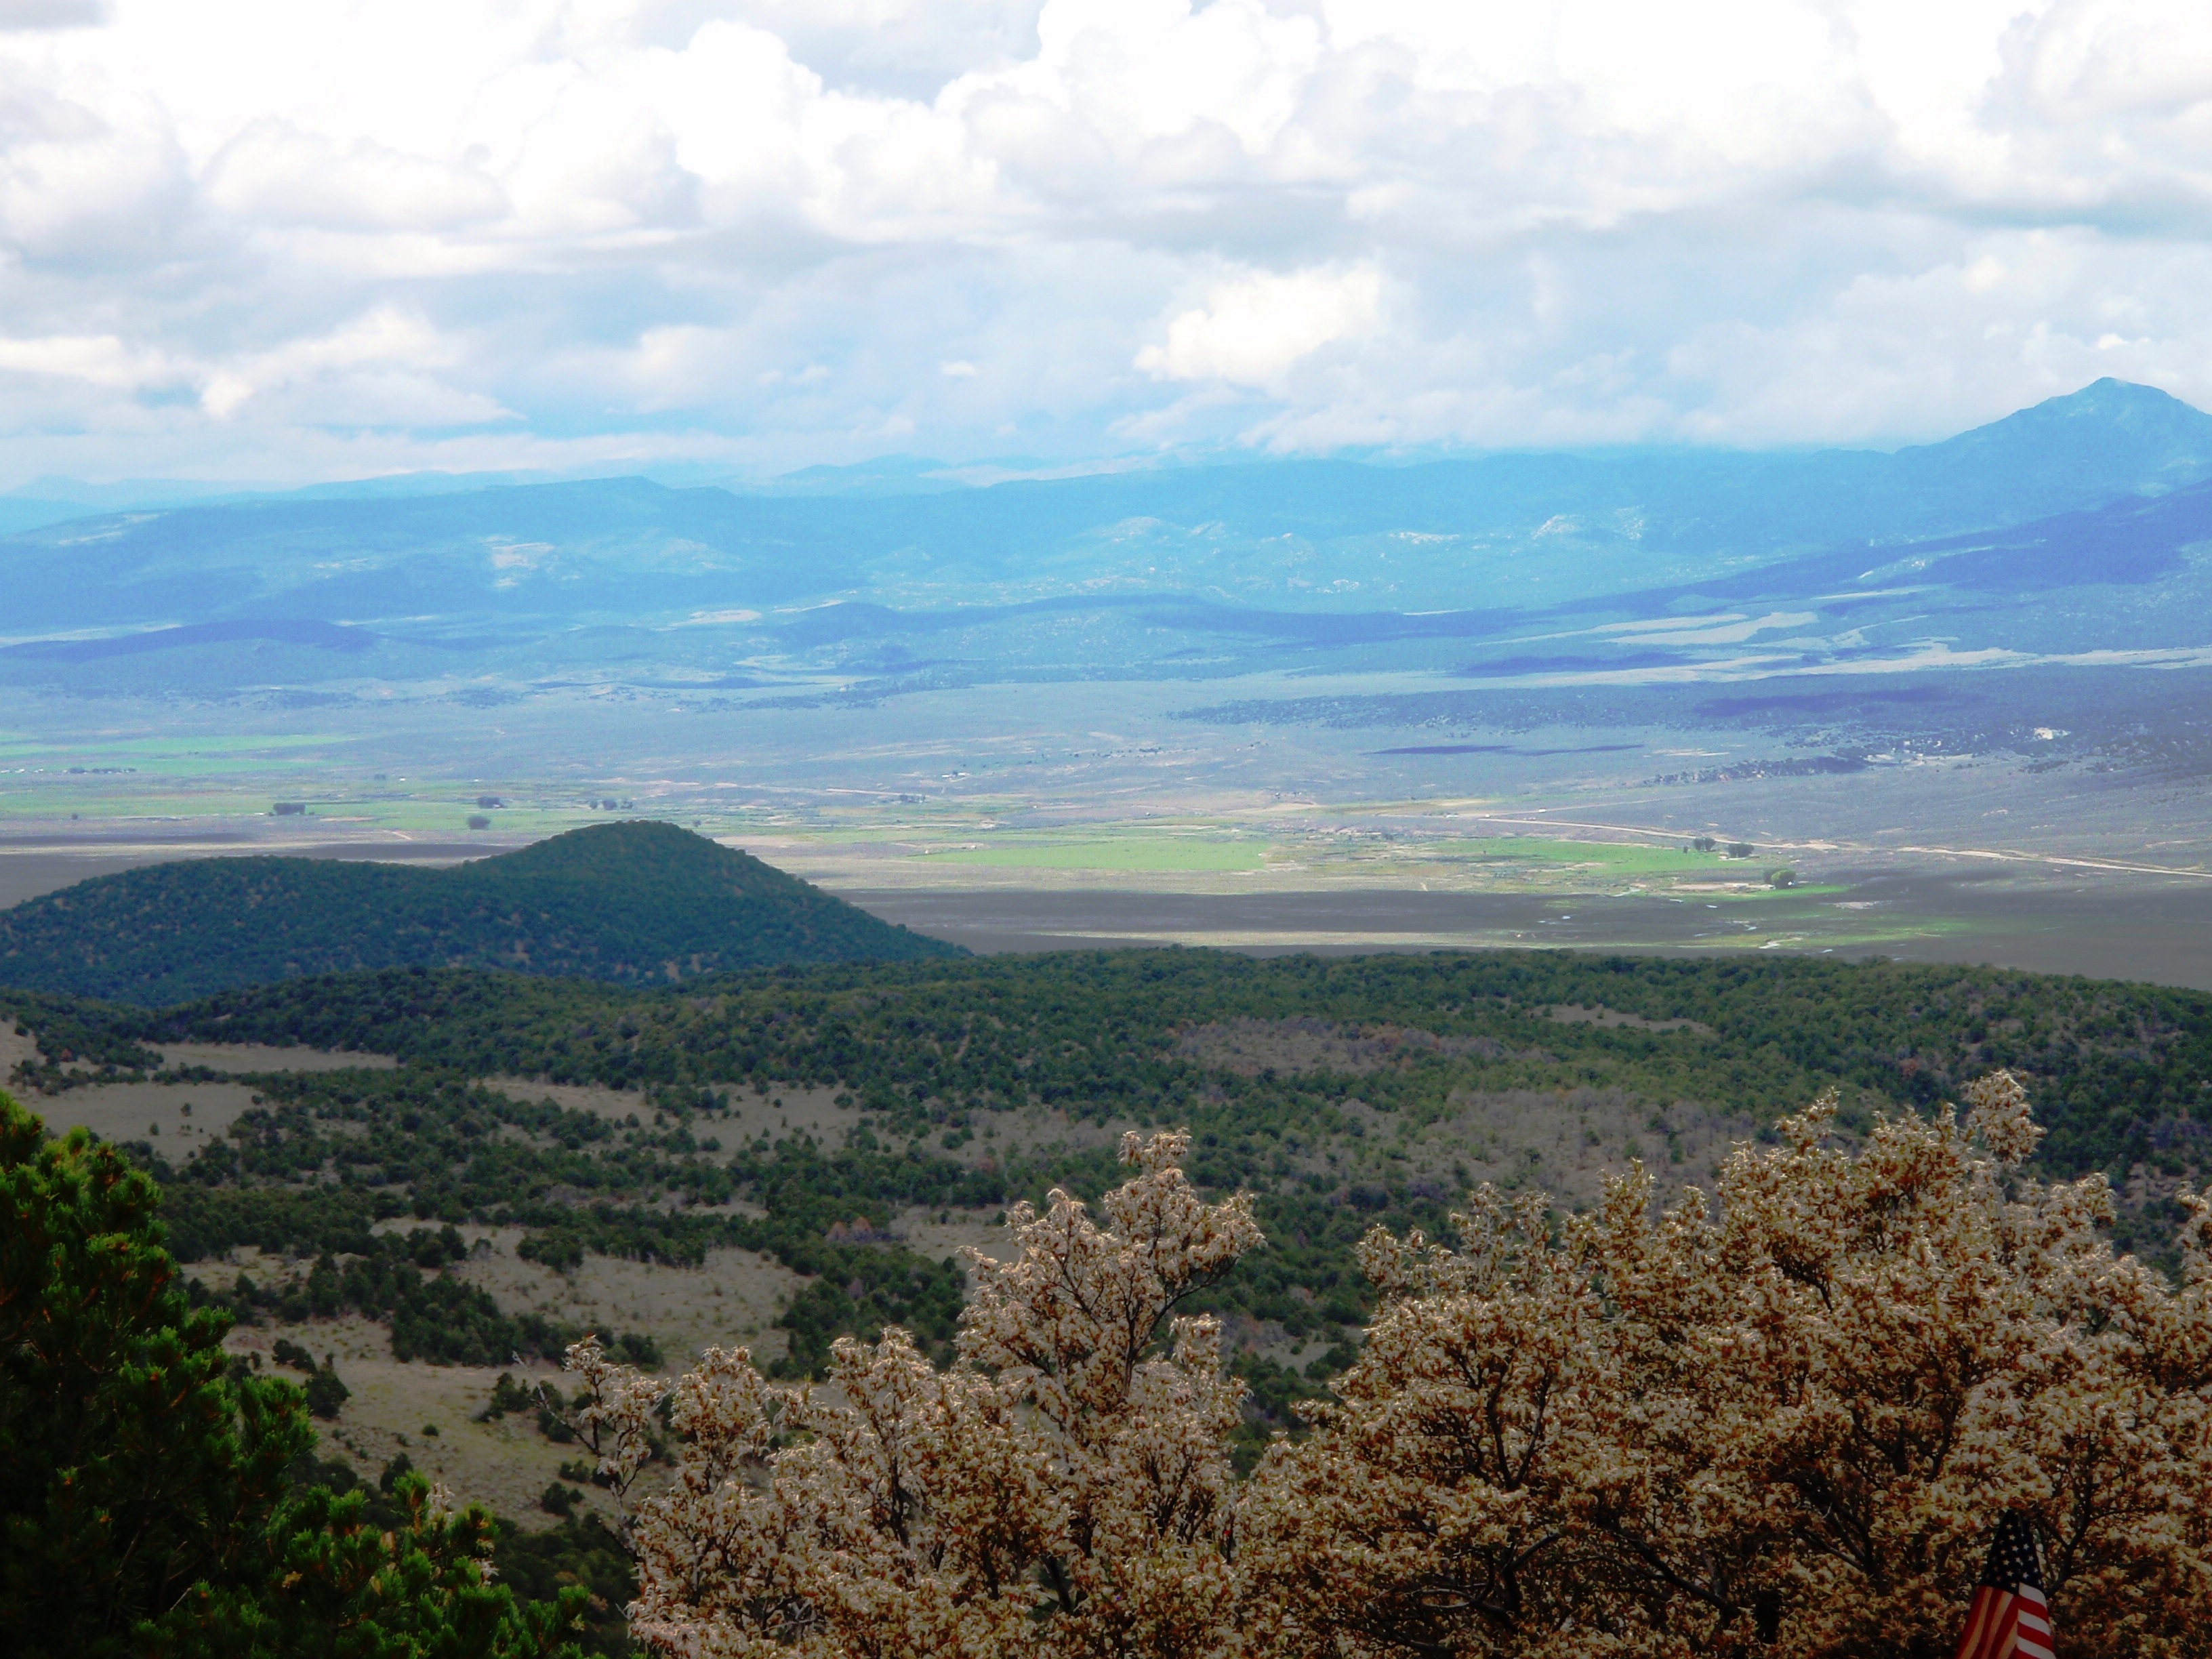
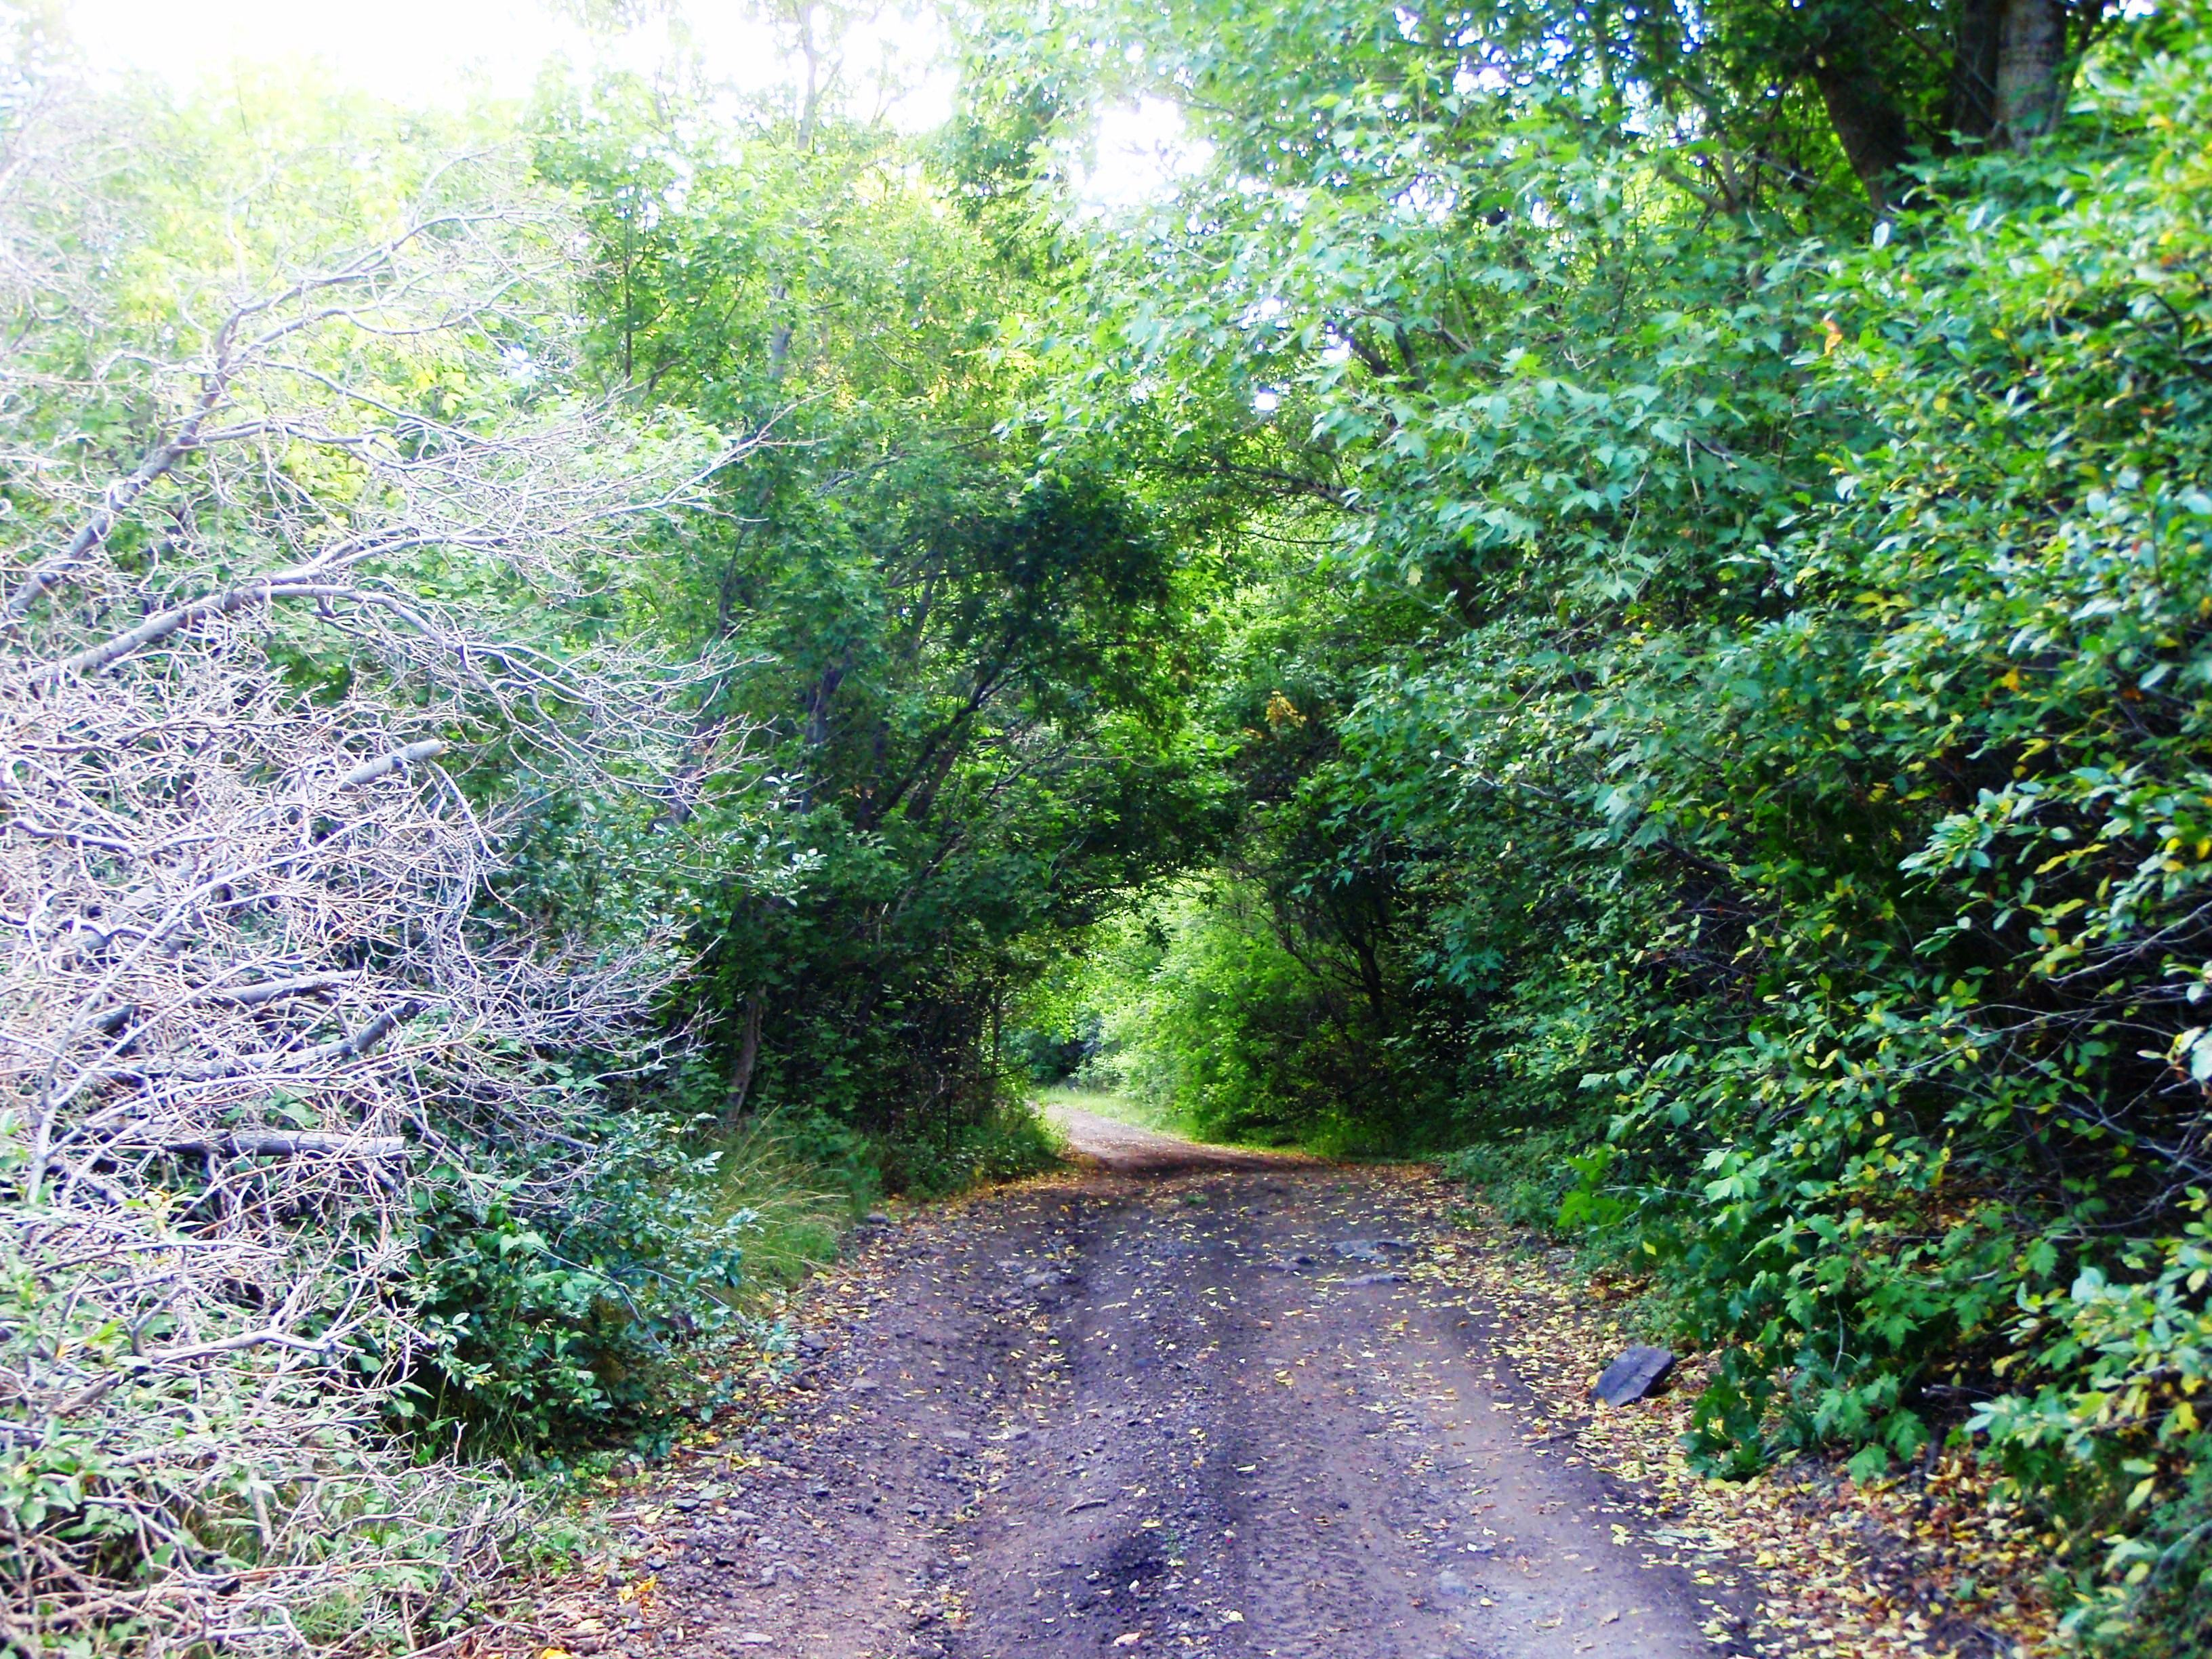
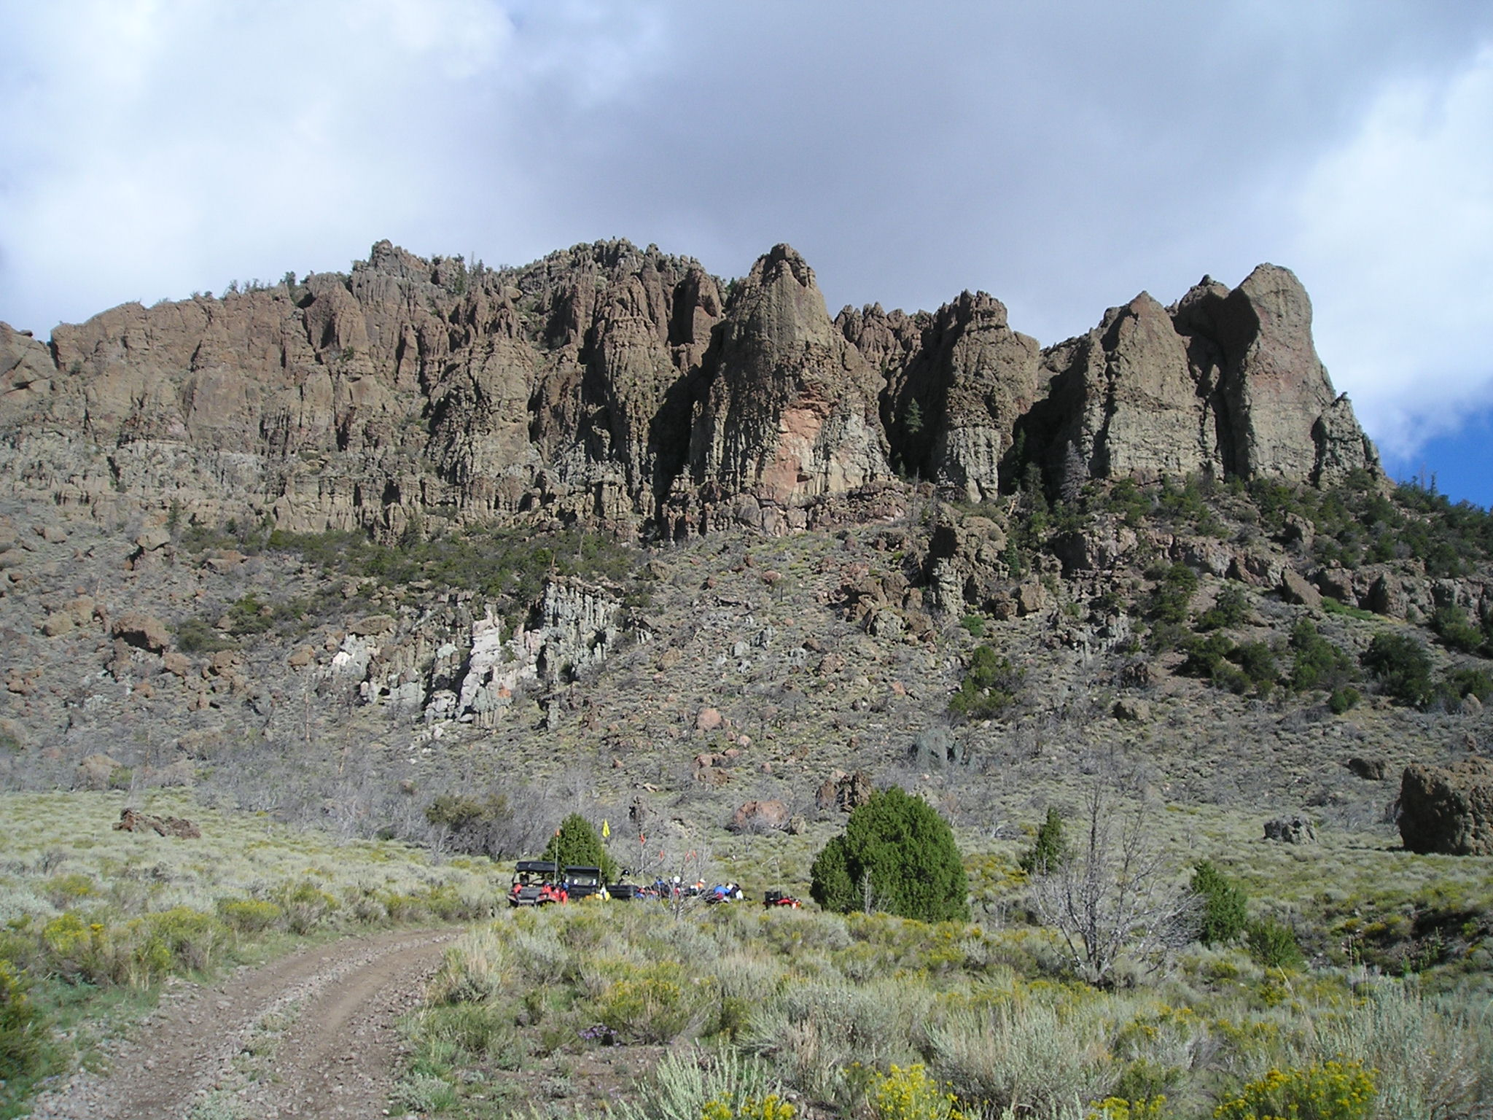

Early Departure: This ride begins in Panguitch and will be a quicker paced ride along the Fremont Trail. Leaving Panguitch we will gradually climb up the beautiful Mt Dutton, then drop down into Circleville. We will be stopping at a restaurant for lunch. On our return home we will travel on the west side of Highway 89 up the Beaver Mountains dropping back into the Panguitch Valley. There are no size restrictions for this ride as the trail follows dirt roads. This is a fun ride that has some western history attached to it as Circleville and the surrounding mountains is where Butch Cassidy spent his teenage years.

