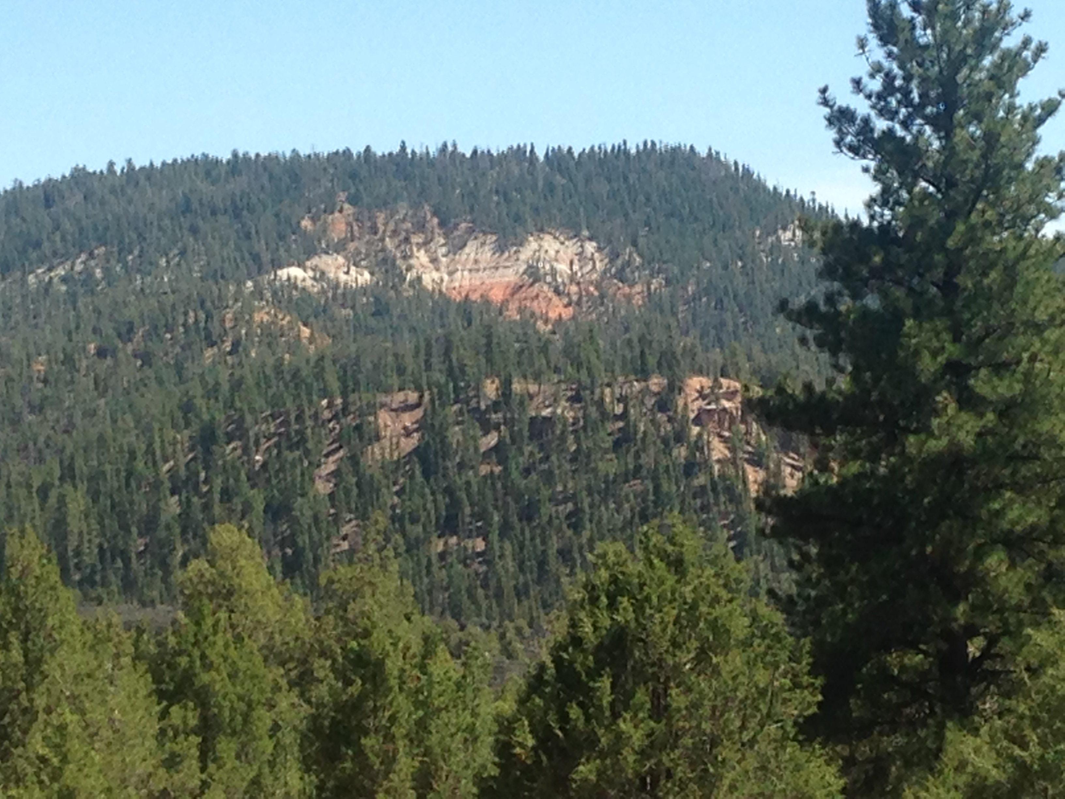
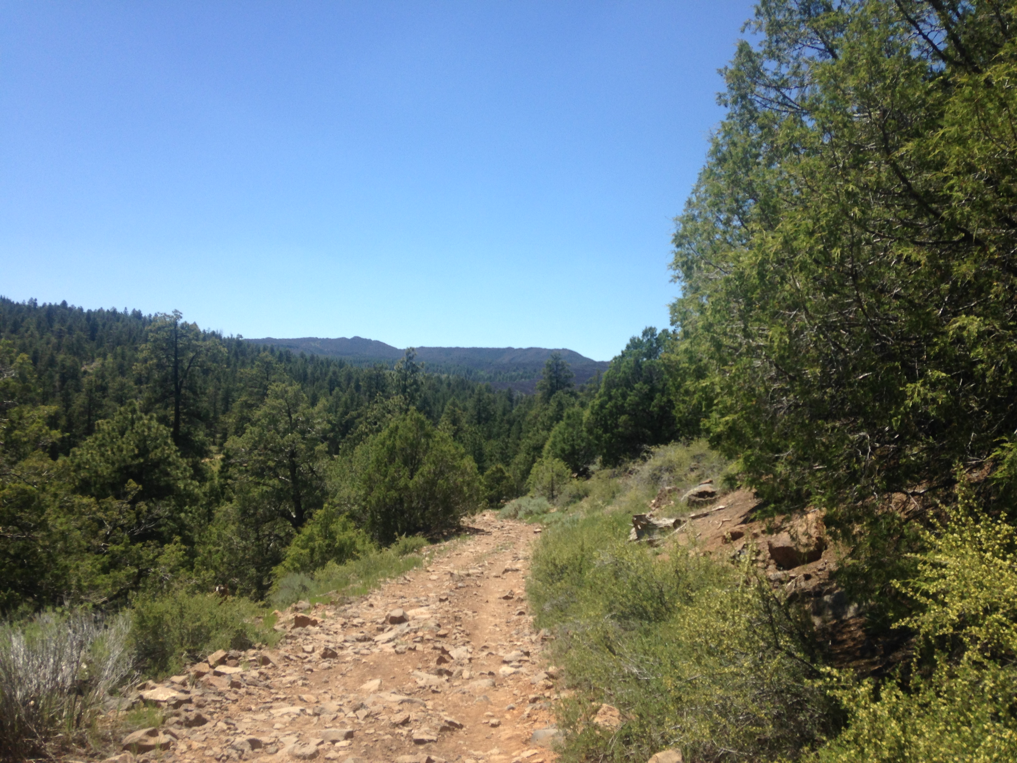
Ride Info:
Length: Approximately 30 miles
Time: Approximately 5 hours
Rider Skill Level: Easy
This ride is trailered
There are no trail restrictions on this ride.
SATURDAY ONLY
Trail #5 Pass Creek Loop
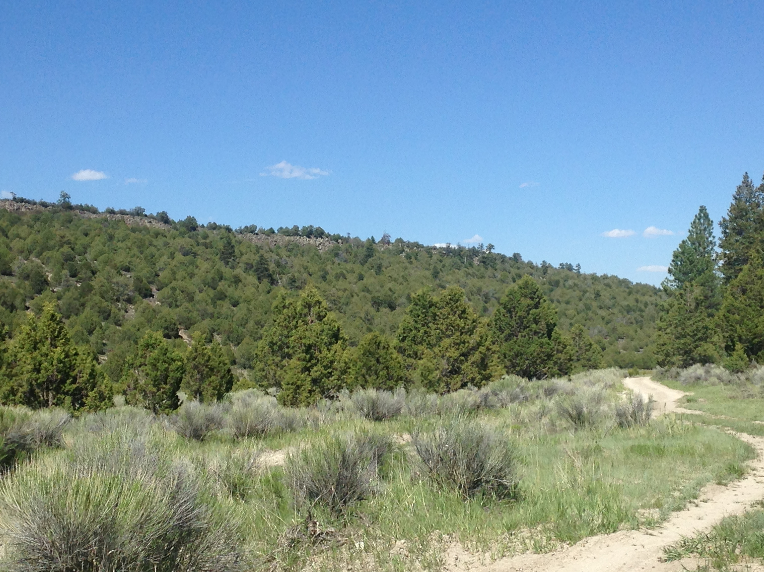

Join us as we climb to elevations above 9,000 feet this ride travels into pine and quaking aspen forests. Here you will desend down the famous goowiggle, travel through Rock Canyon to Aunt Annie’s Cheese House. There are numerous places to stop and survey the beauty along the way. We will stop and take a break next to the lava beds where we will enjoy our lunch, do not be concerned if an antelope comes up for a bite.



