
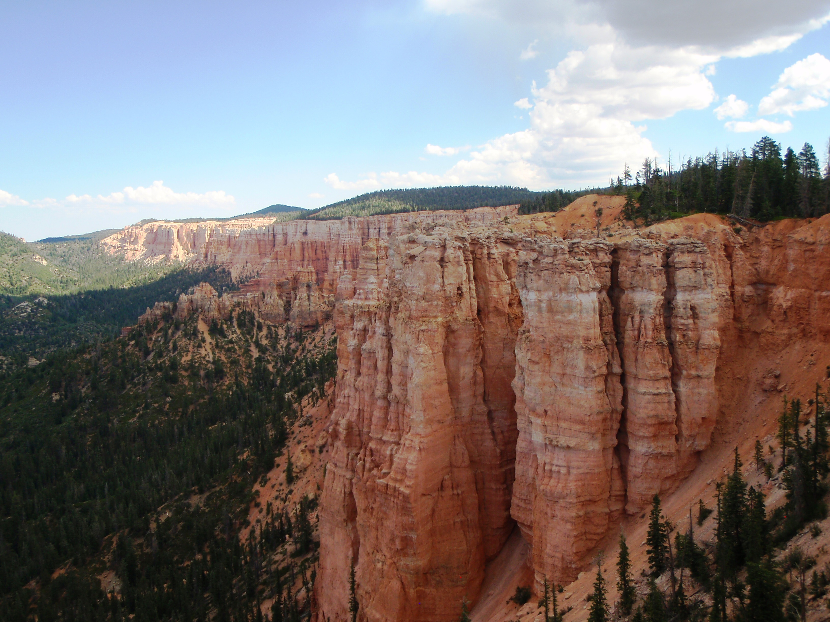

Ride Info
Length: Approximately 85 miles
Time: Approximately 8 hours
Rider Skill Level: Moderate
E Early Departure: 8:00 A.M.
This is a trailered ride
ET Trail Restriction: 50 Inches

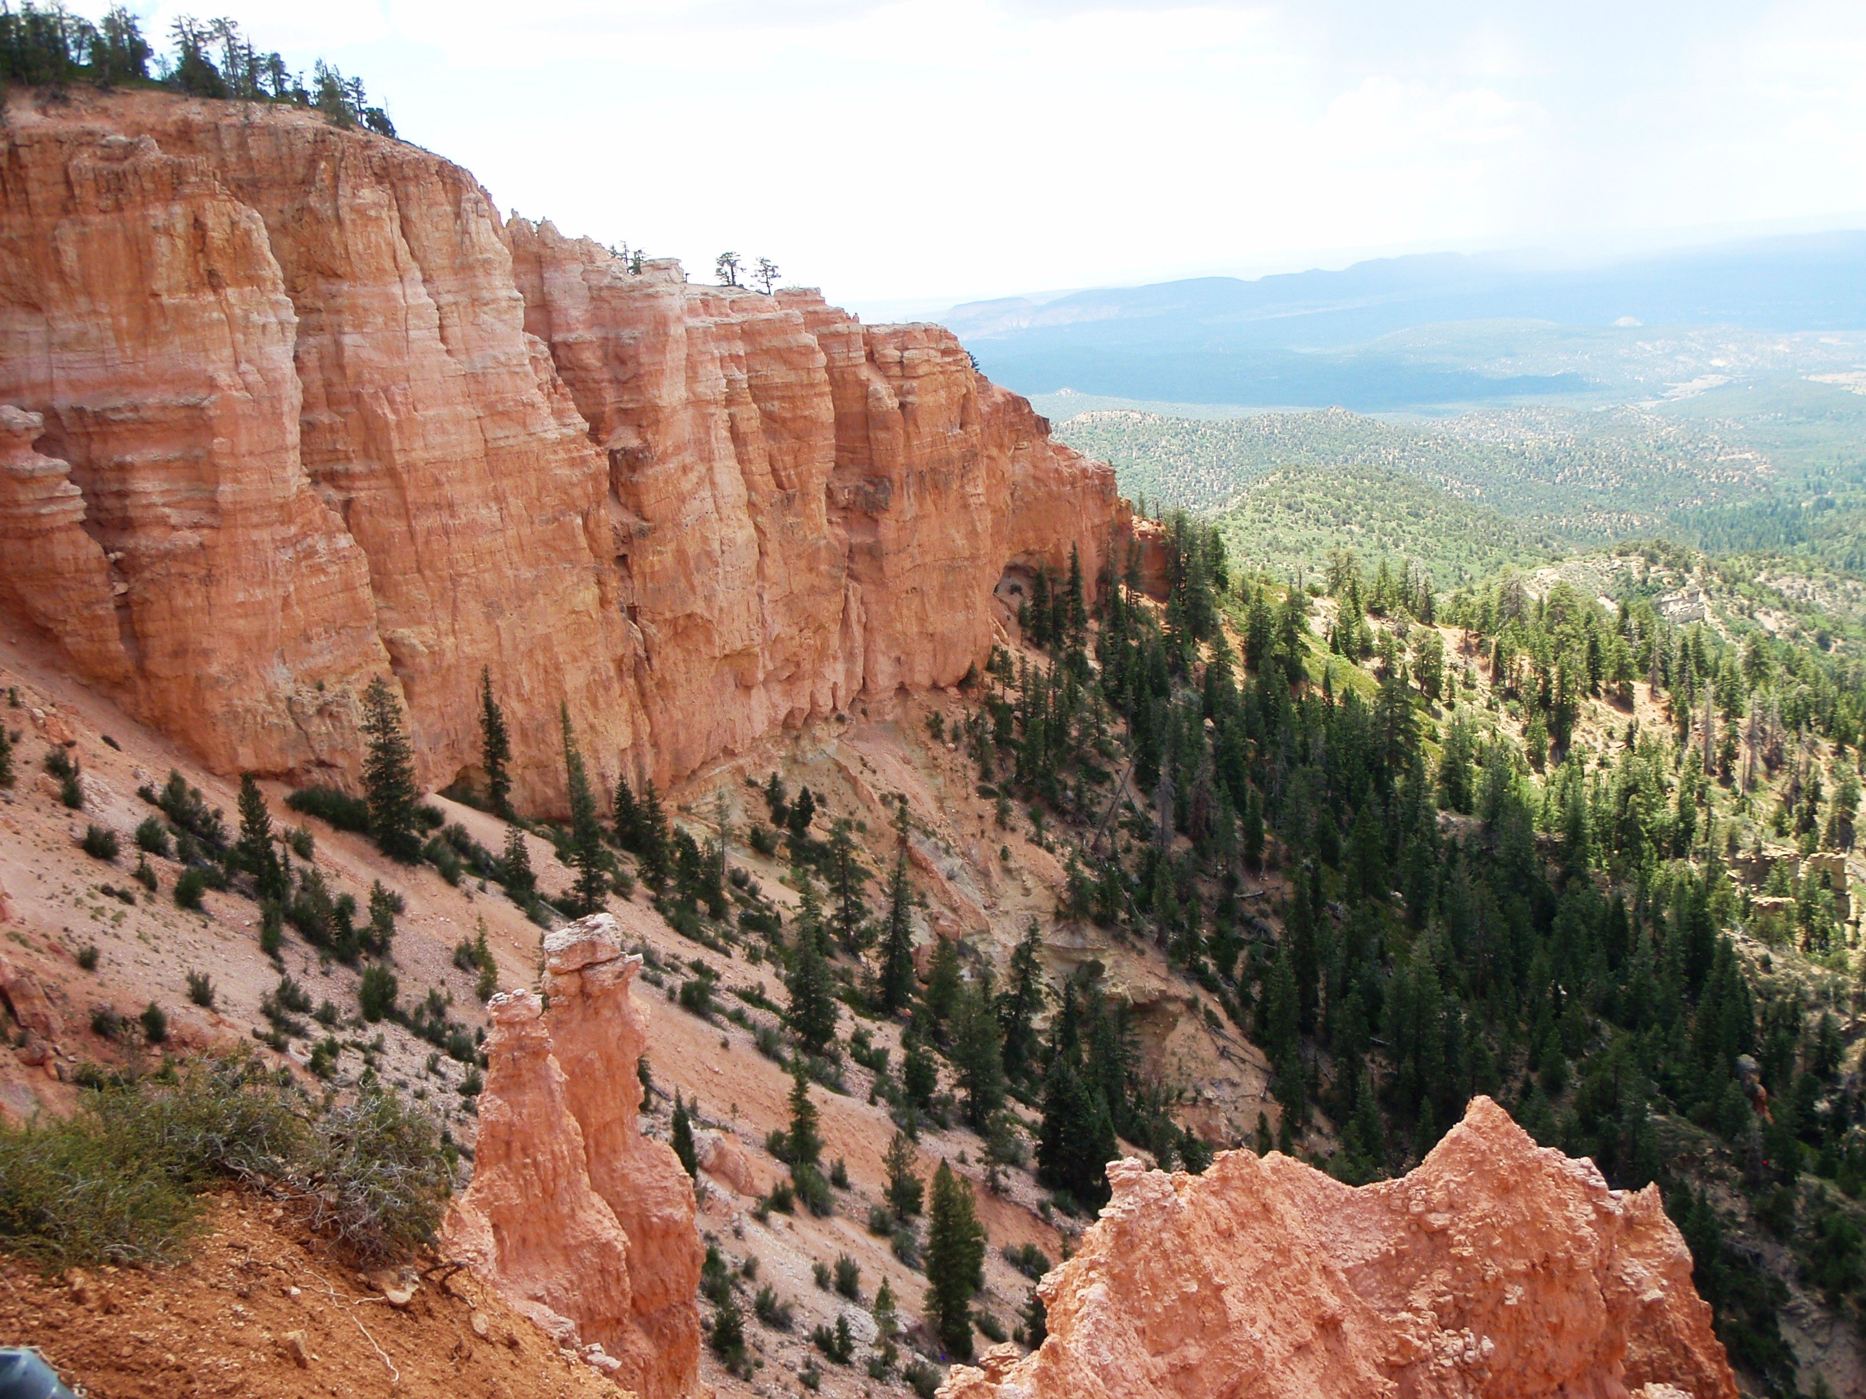
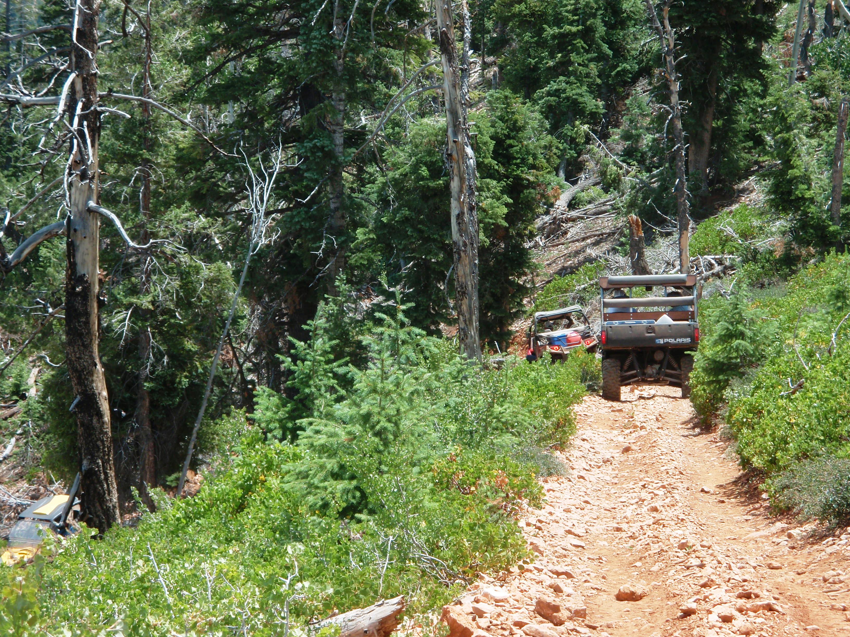
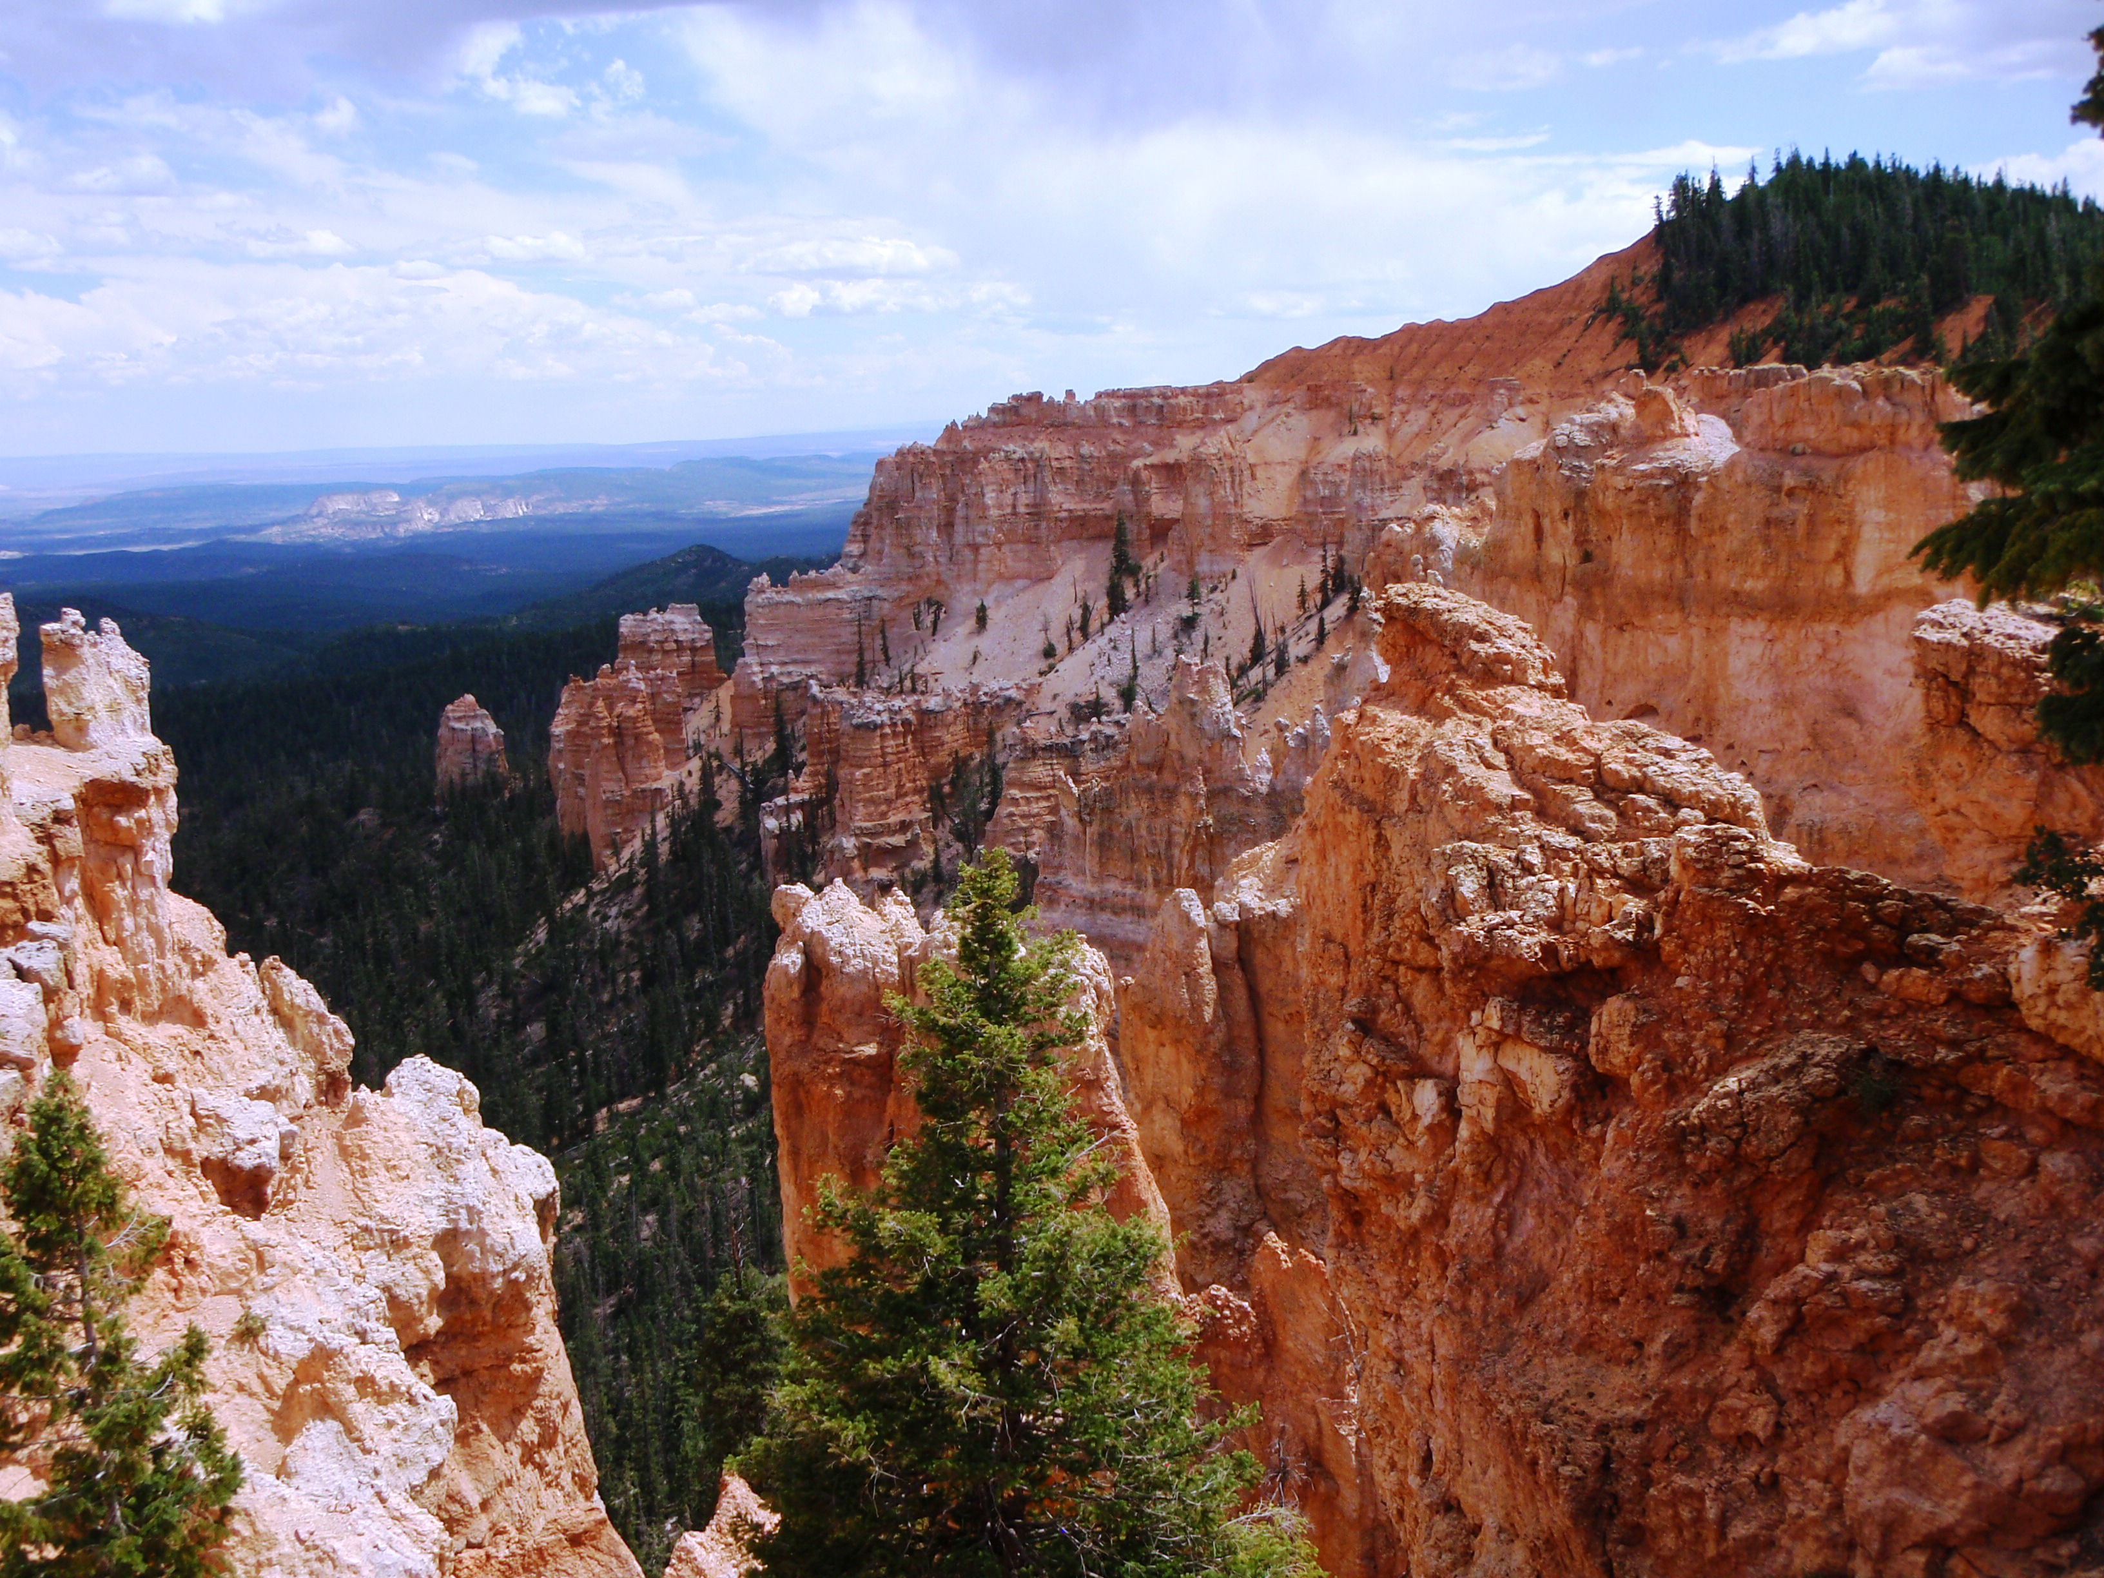

Riders will trailer to Hatch on US 89 located 15 miles south of Panguitch, ride up through Proctor Canyon, drop down to Tropic Reservoir, then run down the East Fork Road to Crawford Pass. Riders will experience the total high mountain traveling experience as we move from peaks to river and Tropic Reservoir. Much of the trip will be spent on the Paunsaugunt Rim with its spectacular overlooks and majestic views. Bring a lunch, camera and extra gas as we will be stopping along the trail for a break.
This is an EARLY DEPARTING ride and there is a 50” trail restriction.

