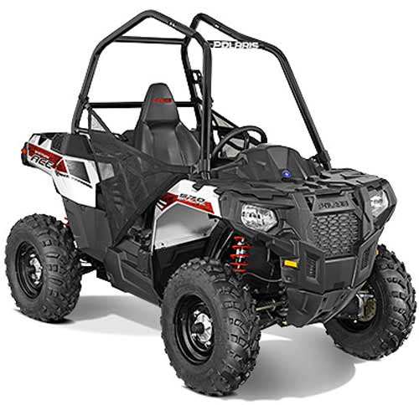

All registered riders are eligible to win a Polaris Ace!