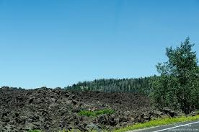
Early Departure 8:00 A.M.
Length: Approximately 60 miles
Time: Approximately 7 hours
Rider Skill Level: Moderate
No Size Restrictions
Trail #16 Mammoth Cave

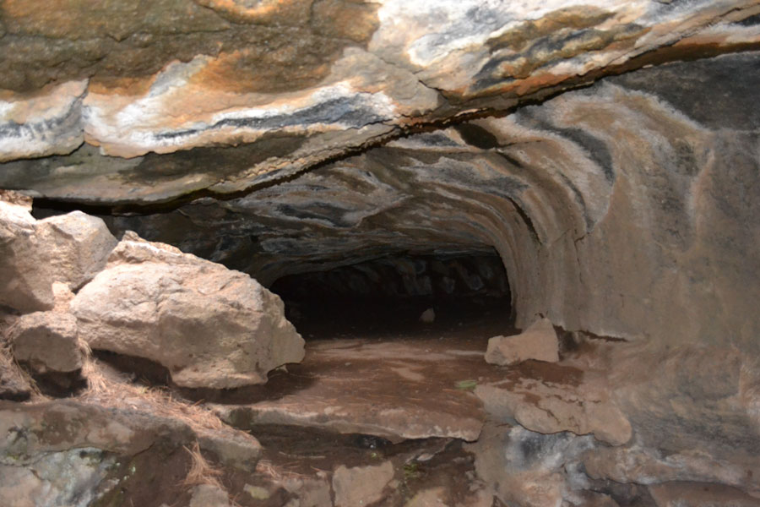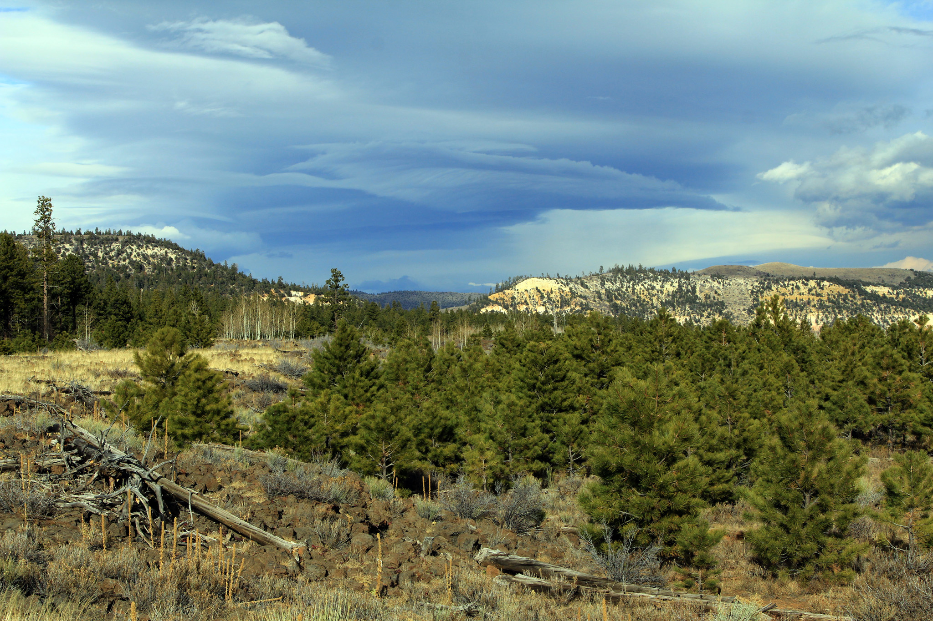

This scenic ride will begin at Rally Headquarters. The ride will proceed through sagebrush covered flats, then up into aspen and pine covered mountains. Riding along a canyon where you will have majestic views of the valley below, then continuing along a large lava flow to Mammoth Creek then to Mammoth Caves. We will enjoy our lunch at this stop and you will be able to explore some of the caves.

