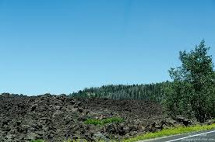
Departure Time: 8:30 AM
Length: Approximately 60 miles
Time: Approximately 7 hours
Rider Skill Level: Moderate
Trail #16 Mammoth Cave

This scenic ride will begin at Rally Headquarters. The ride will proceed through sagebrush covered flats, then up into aspen and pine covered mountains. Riding along a canyon where you will have majestic views of the valley below, then continuing along a large lava flow to Mammoth Creek then back to Mammoth Caves. We will enjoy our lunch at this stop and you will be able to explore some of the caves. We will return to Panguitch via the Town of Hatch.

