TRAIL #4 BULL RUSH / HORSE VALLEY LOOP

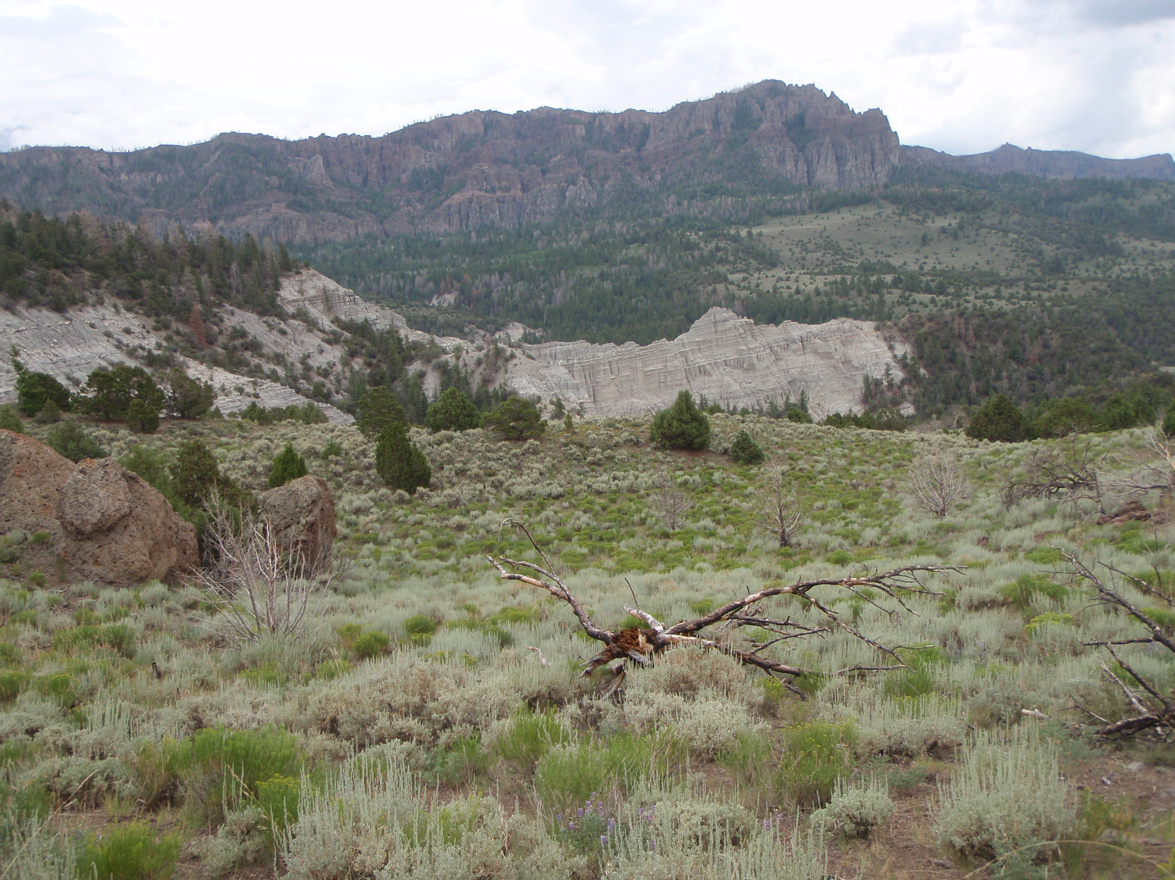

Departure Time 8:30 A.M.
Length: Approximately 65 miles
Time: Approximately 7 hours
Rider Skill Level: Advanced
Trail
Trail Restriction: Limited to 50”

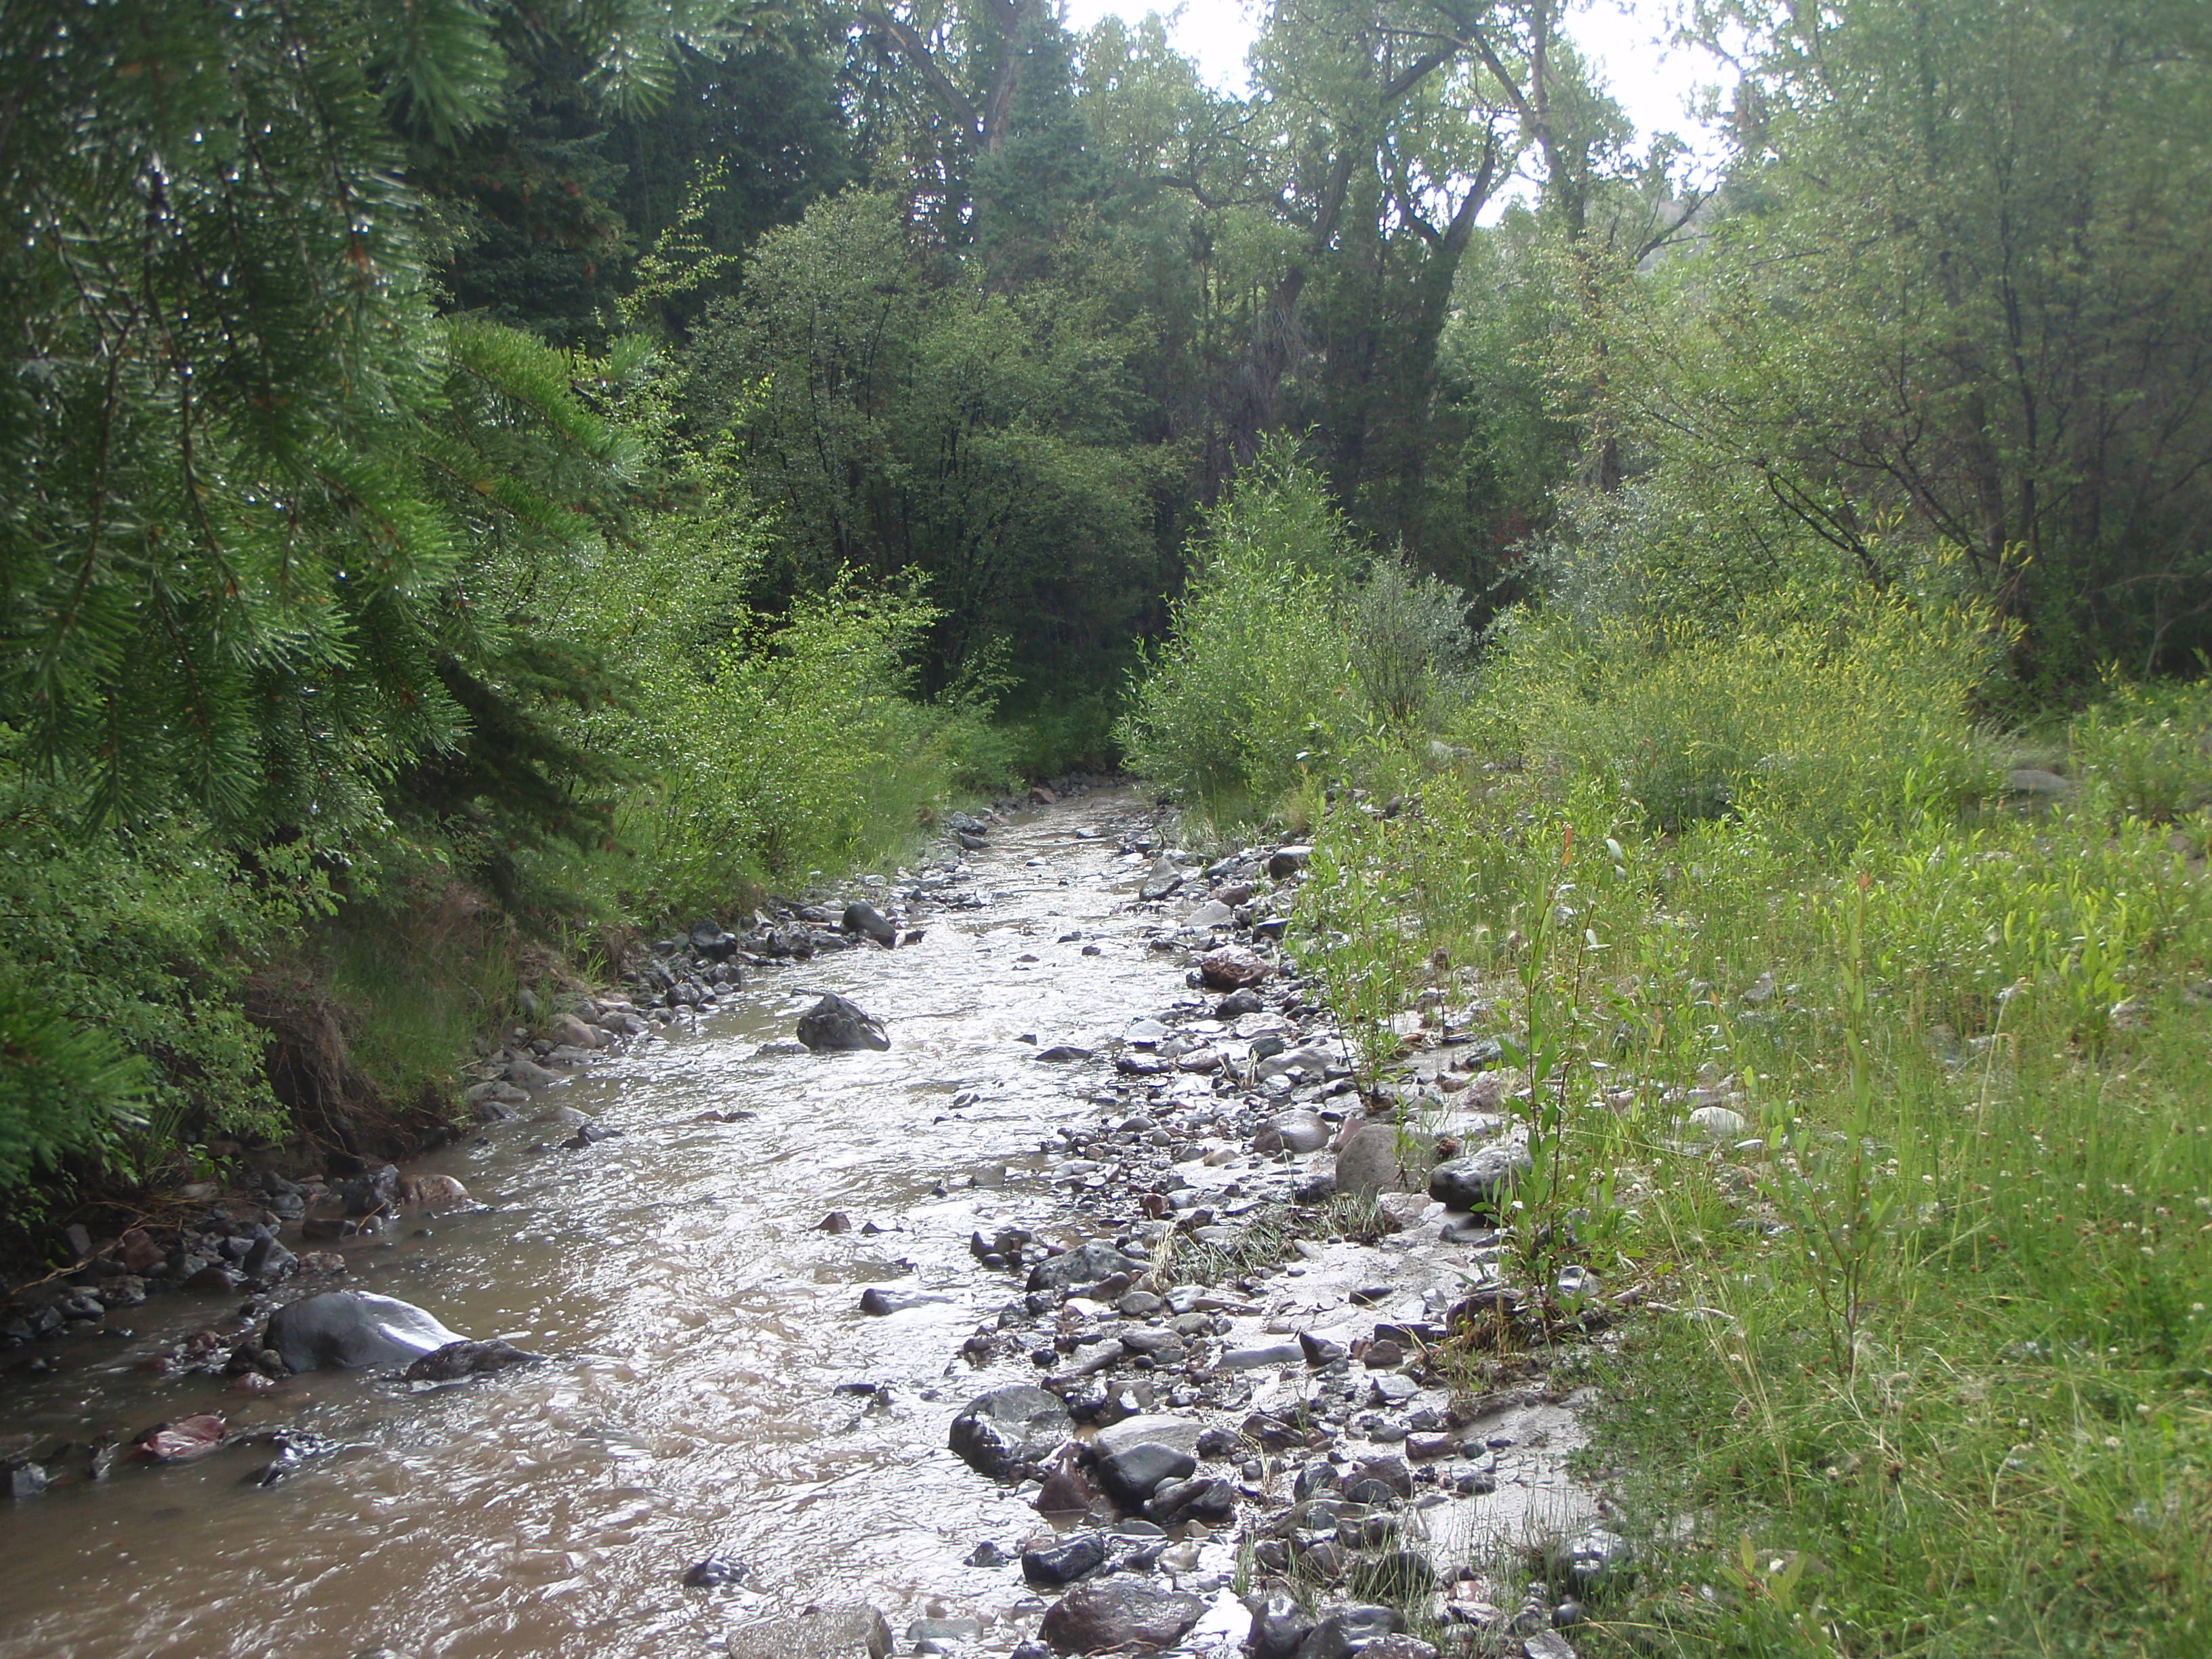
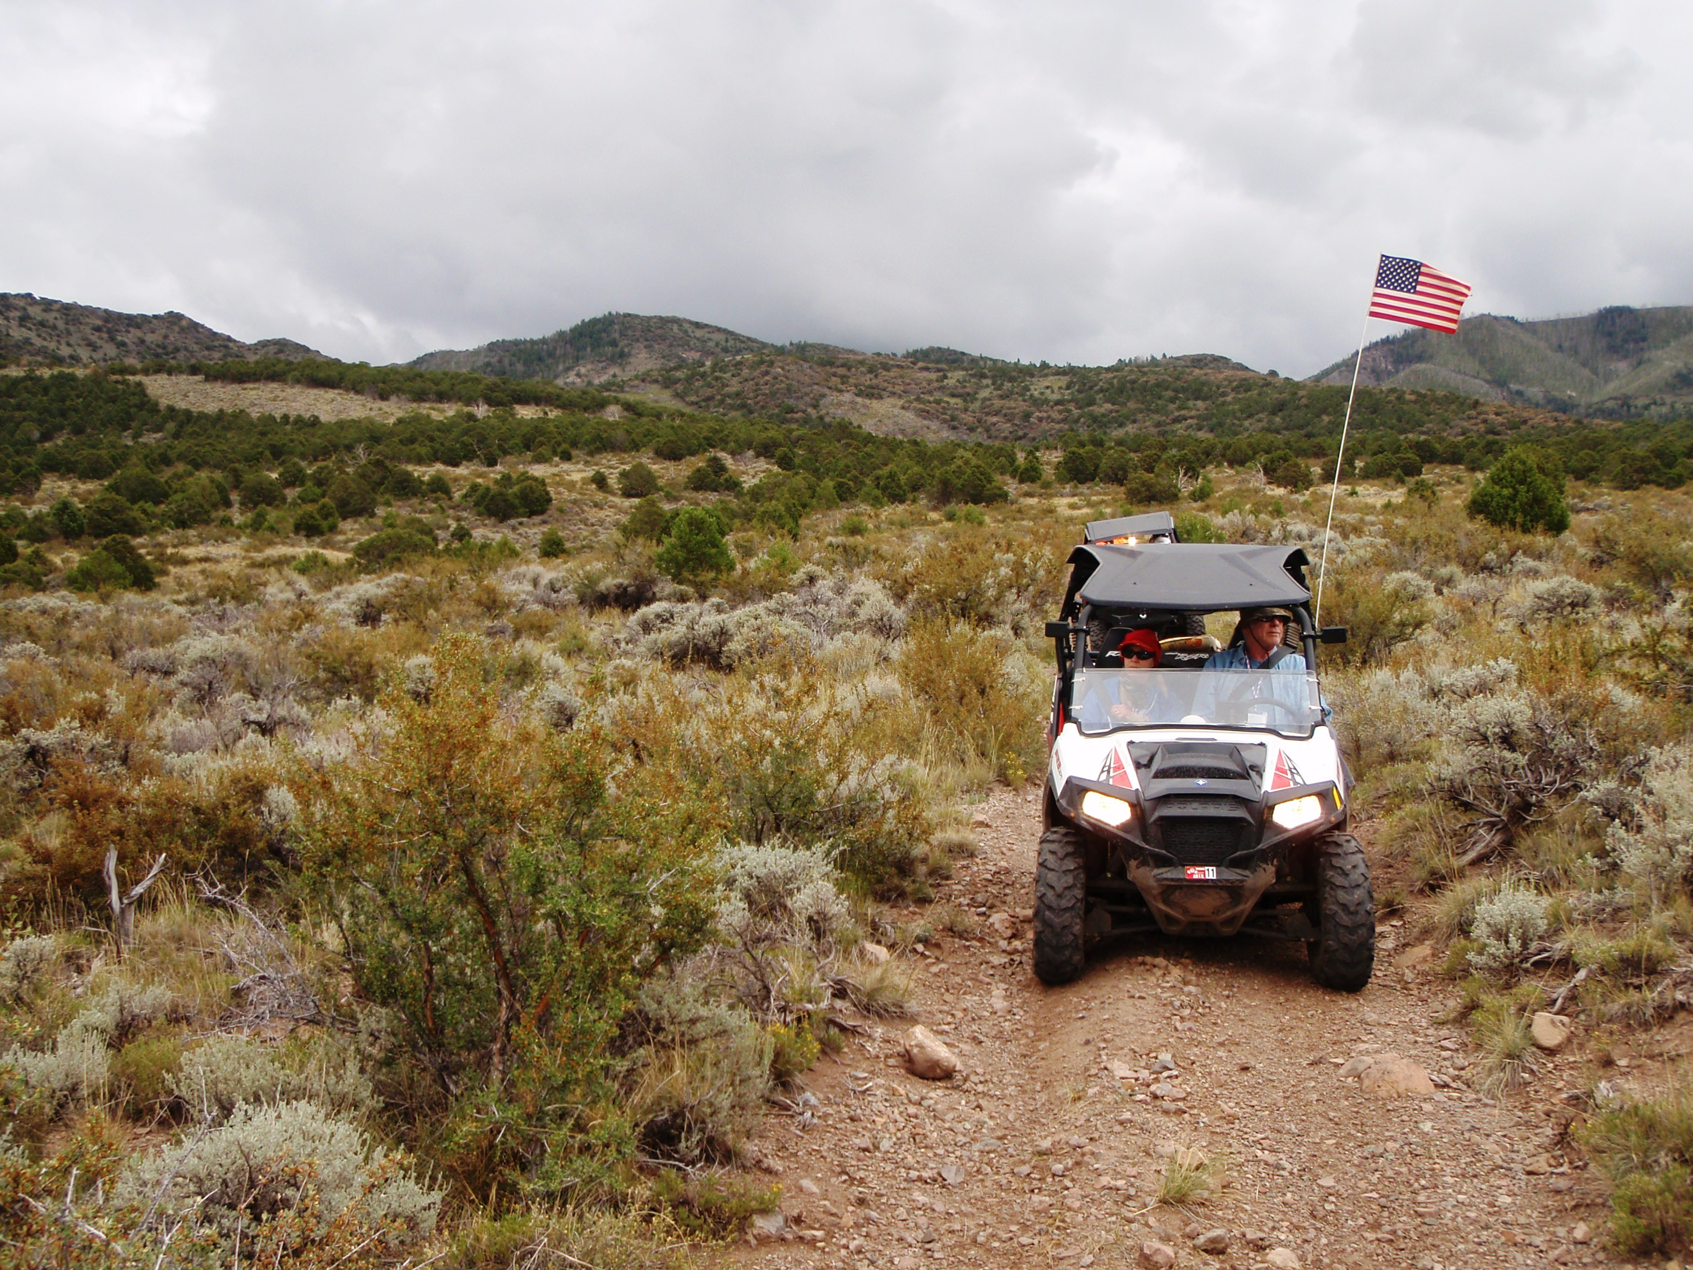
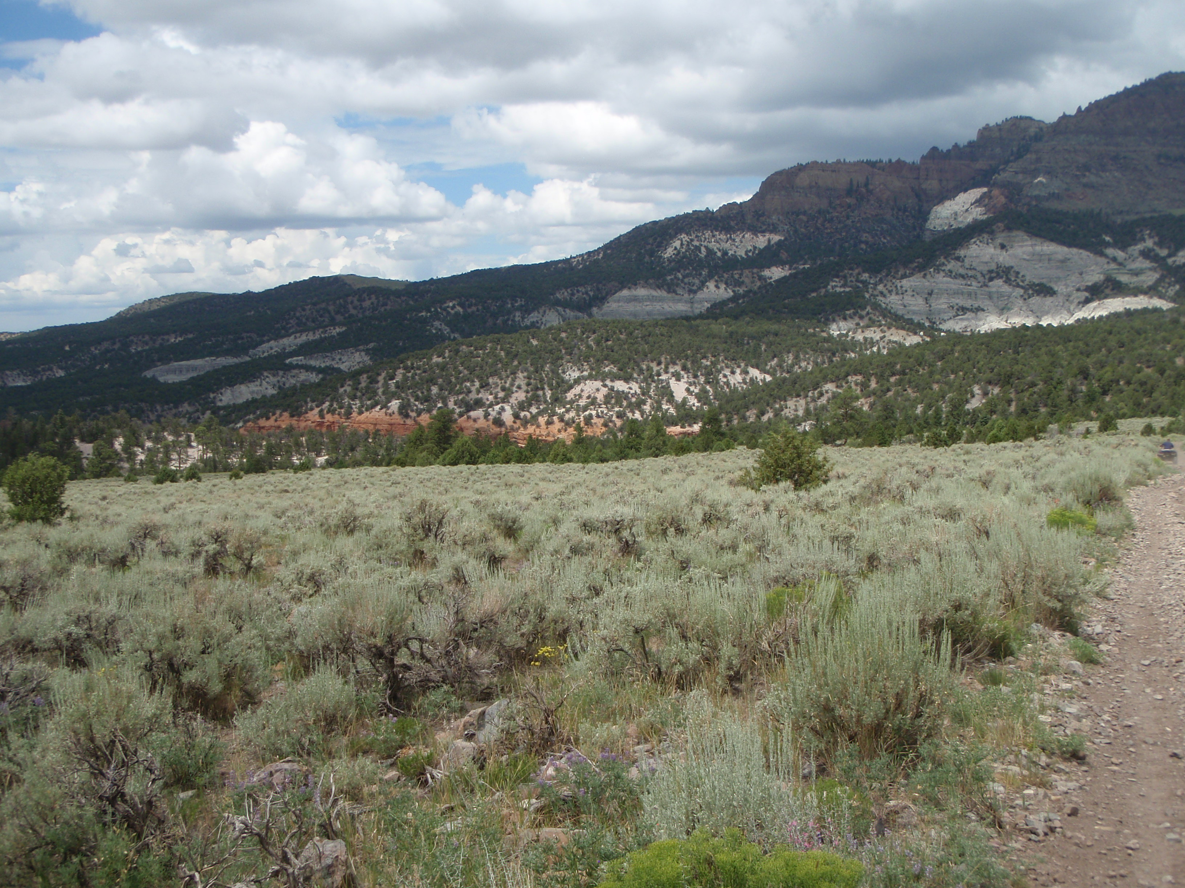

This ride begins in Panguitch and travels along the East Bench’s sage brush flats, before beginning your climb up Mt Dutton. You will ascend through pinion and cedar trees, crossing through a canyon where there is an ancient spring the Indians used. This is where the plant “Bull Rush” grows (Cattail family). After traveling along a stream bed in a beautiful narrow canyon, the trail opens up into Horse Valley where elk can be seen year round. Once up a challenging hill we begin our descent along an old logging road that connects Panguitch to Circleville. The road will travel down through the forest and along a stream bed where it is common to see wildlife. Pack a lunch as we will be stopping along the way for a break.

