
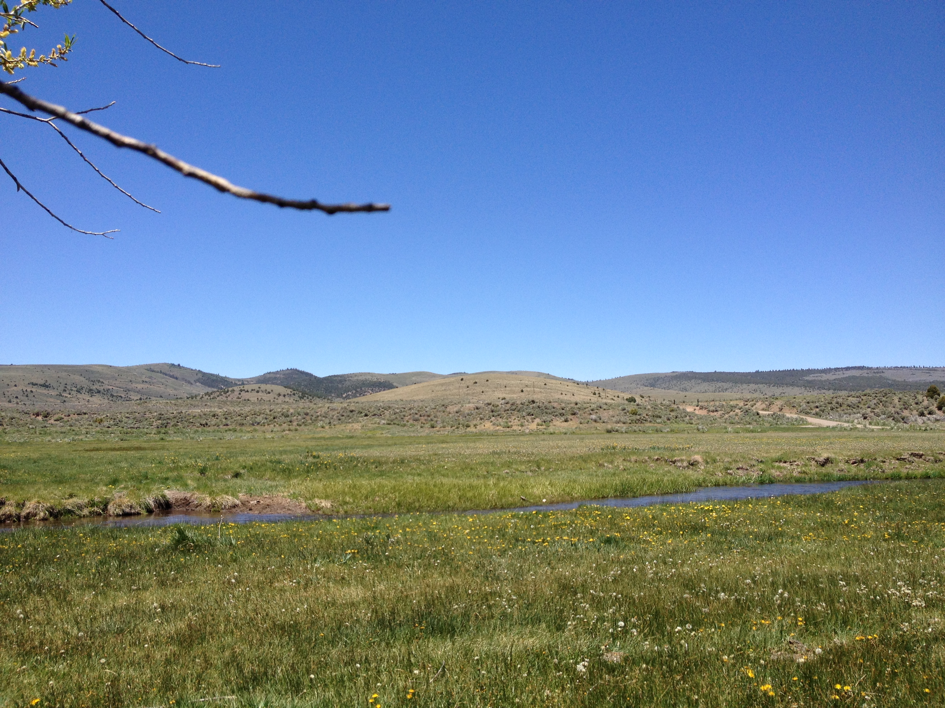

Departure Time: 8:30 A.M.
Length: Approximately 45 miles Time: Approximately 5 hours
Rider Skill Level: Easy

This Ride Has No Size Restrictions

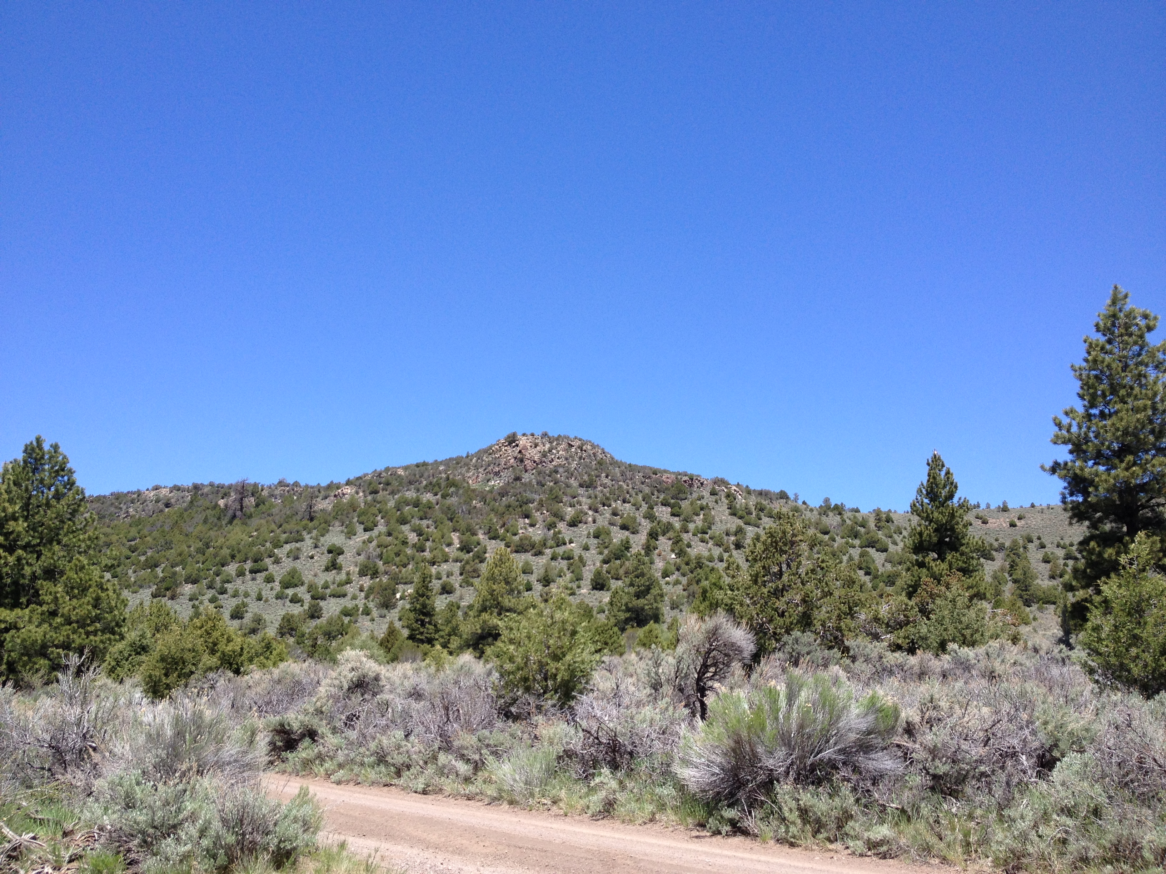
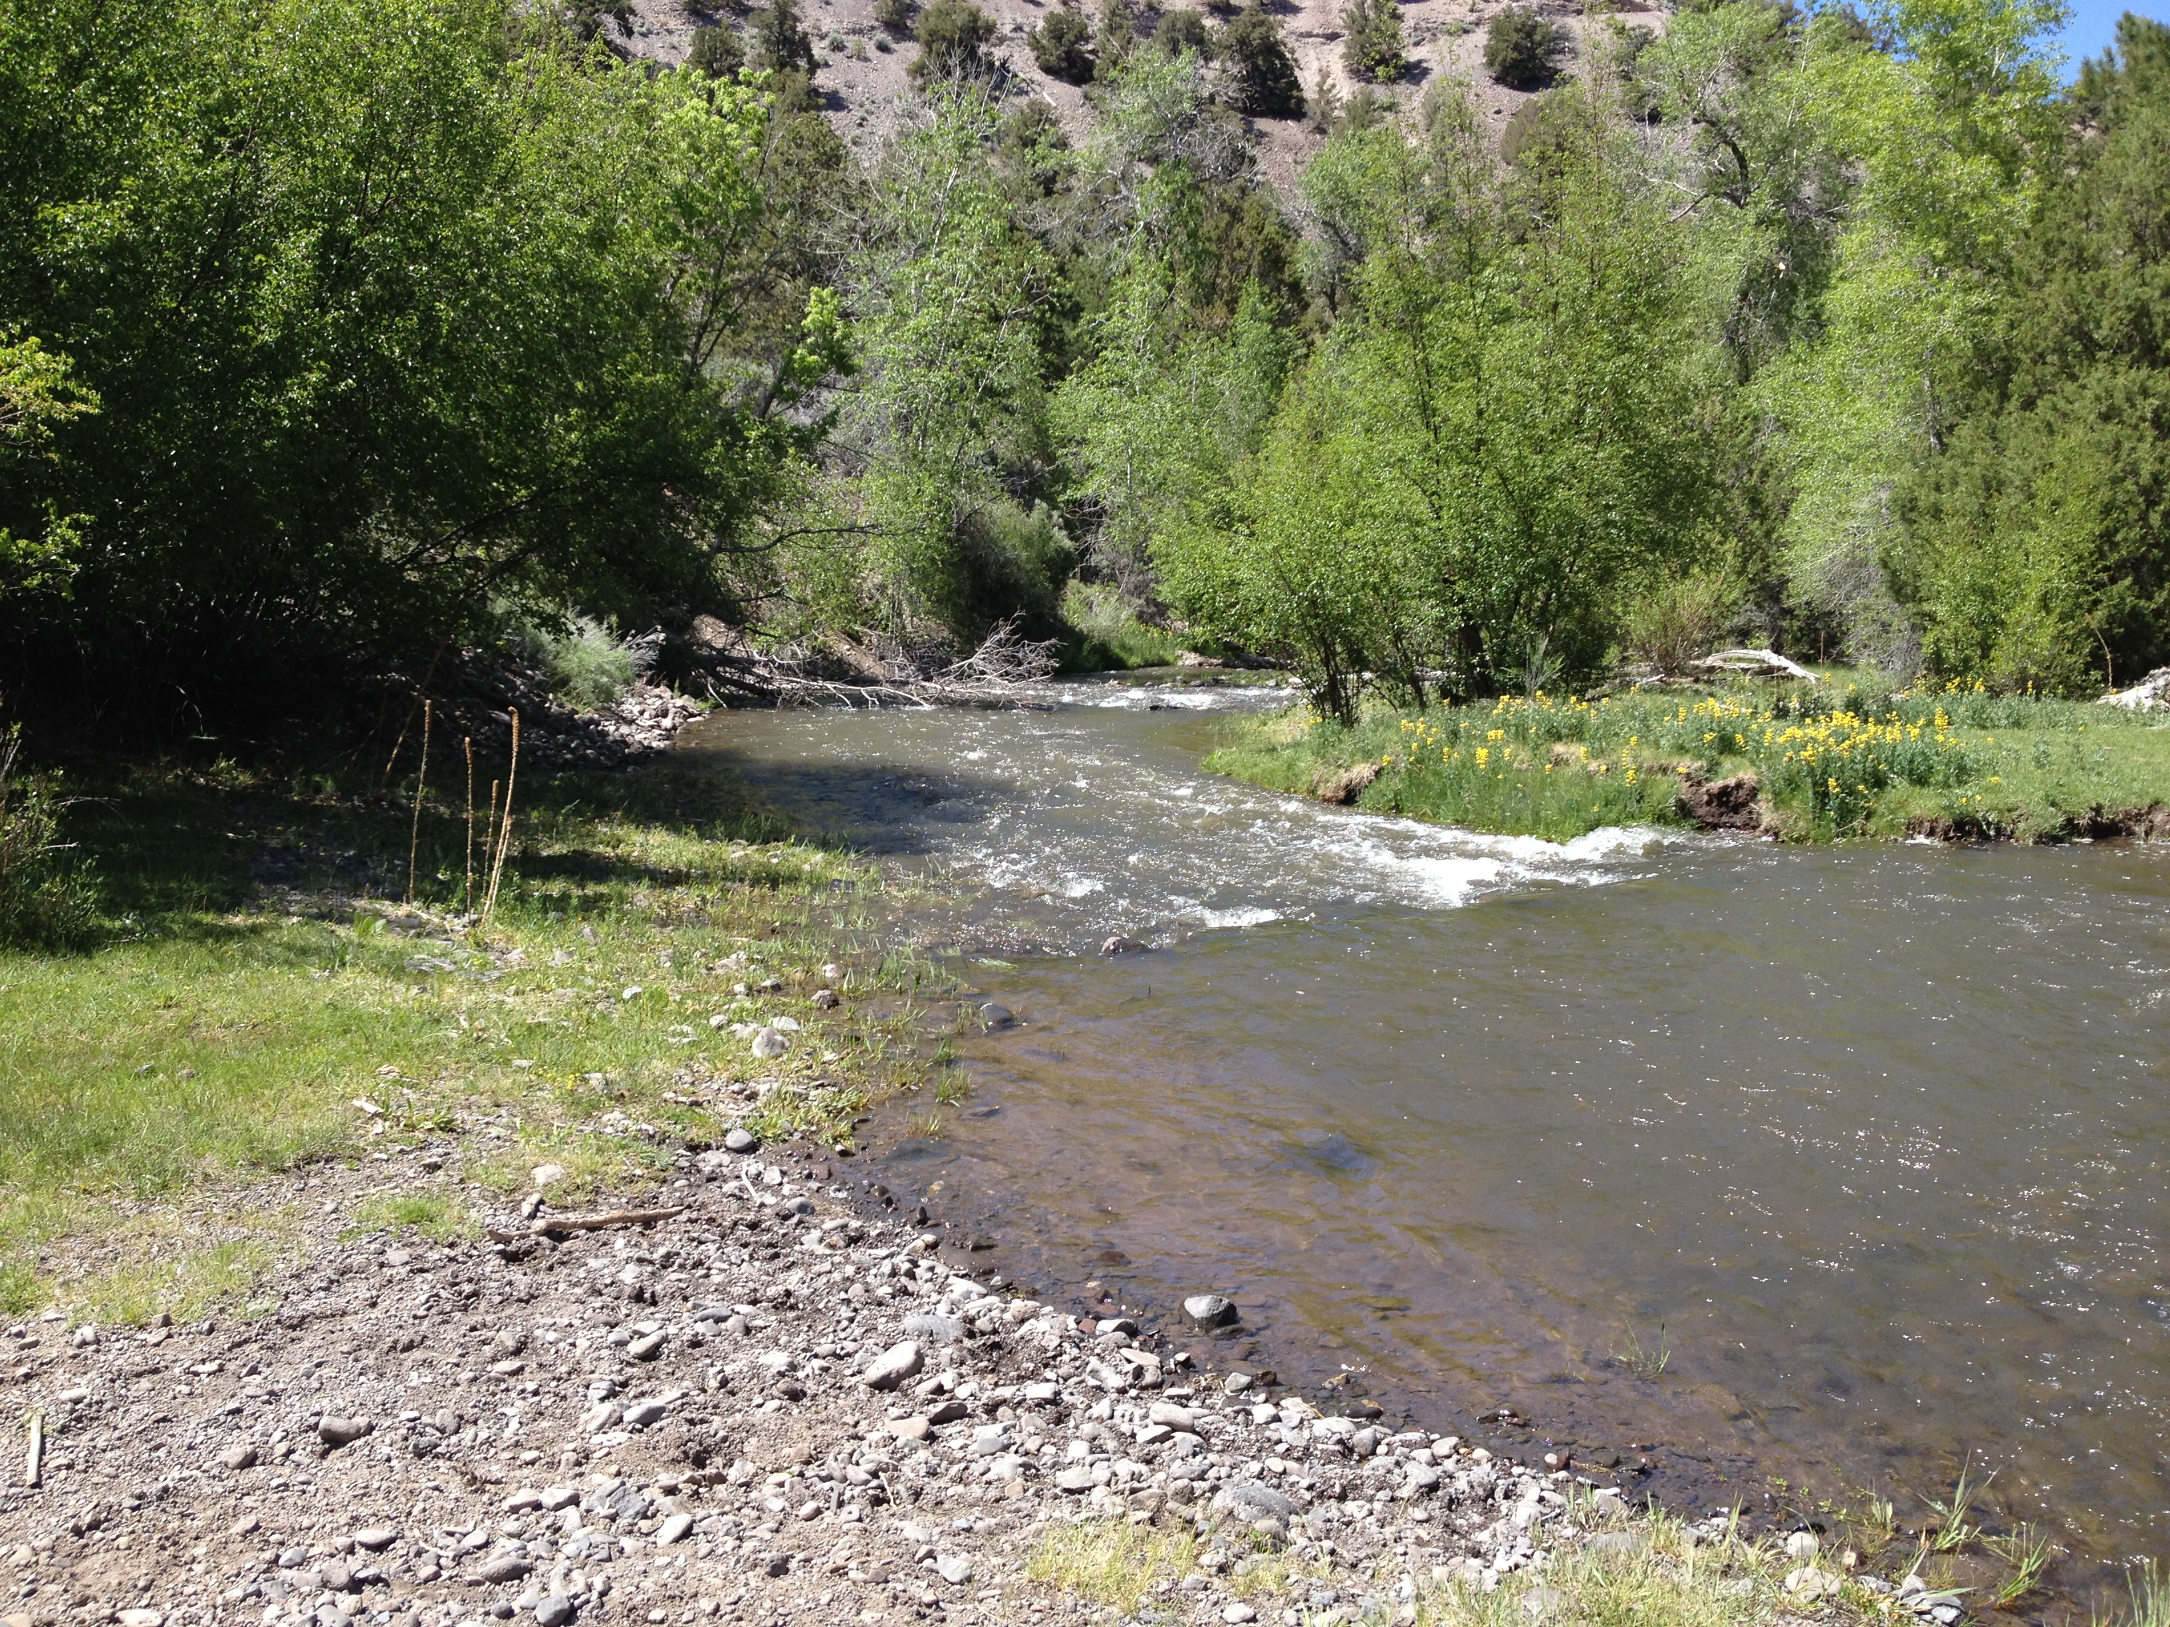
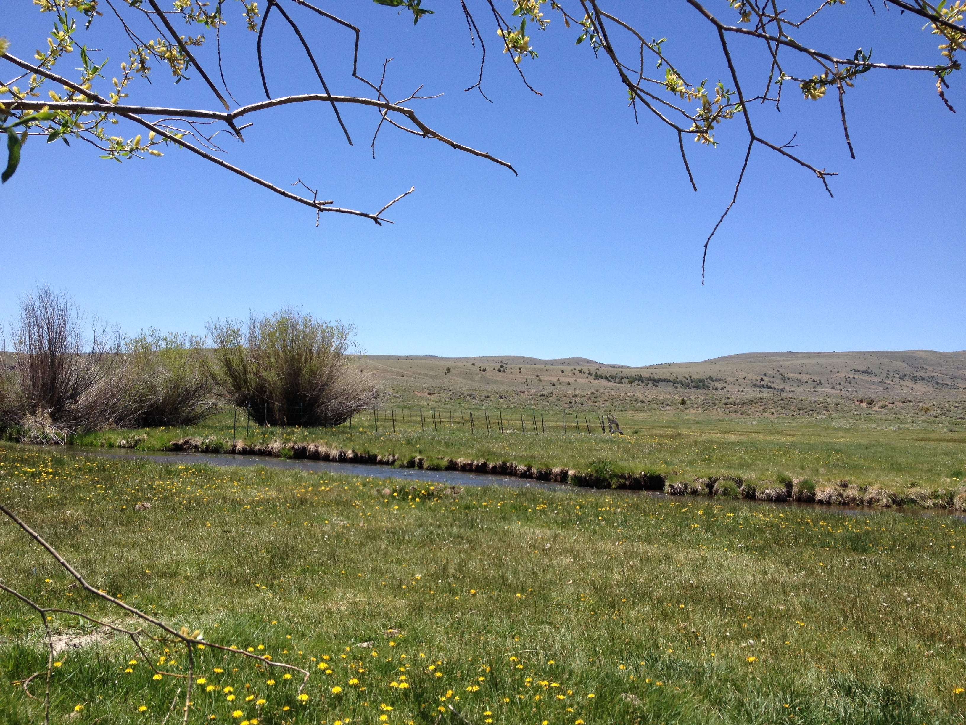

This scenic ride will leave the Fairgrounds in Panguitch and head out to DD Hollow; from there we will pick up the Black Rock Canyon Trail to intersect the Haycock Mountain Loop. Coming down off Haycock Mountain we will follow Pole Hollow around to Schumake and Penny Pond, then we will follow the West Panguitch Loop back to town. There will be several opportunities to take pictures, so bring your camera. This ride is open to both ATV’s and UTV’s. Make sure to pack a lunch as we will be stopping for a break along the trail.

