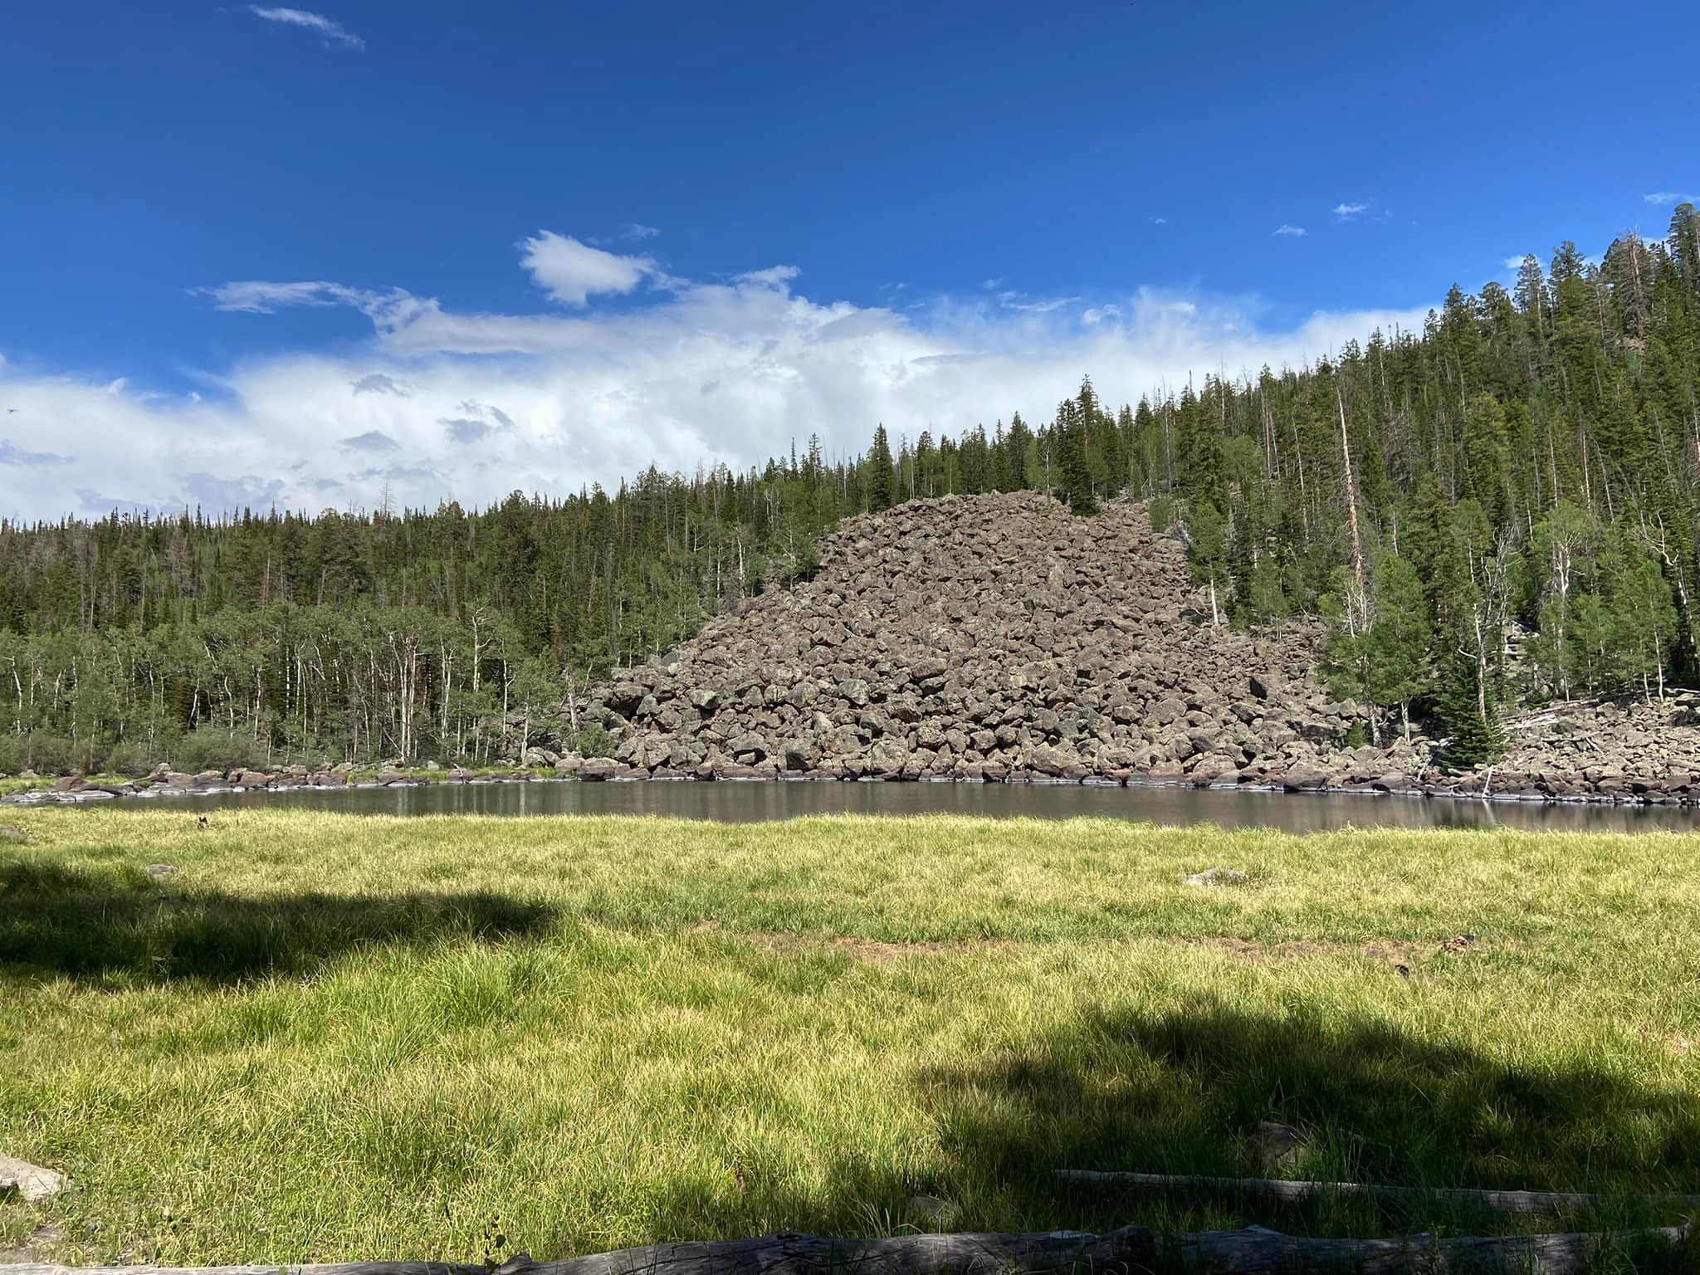
Early Departure 8:00 A.M.
Length: Approximately 75 miles
Time: Approximately 8 hours
Rider Skill Level: Advanced
This will be a trailered ride
Trail #15 Mt. Dutton
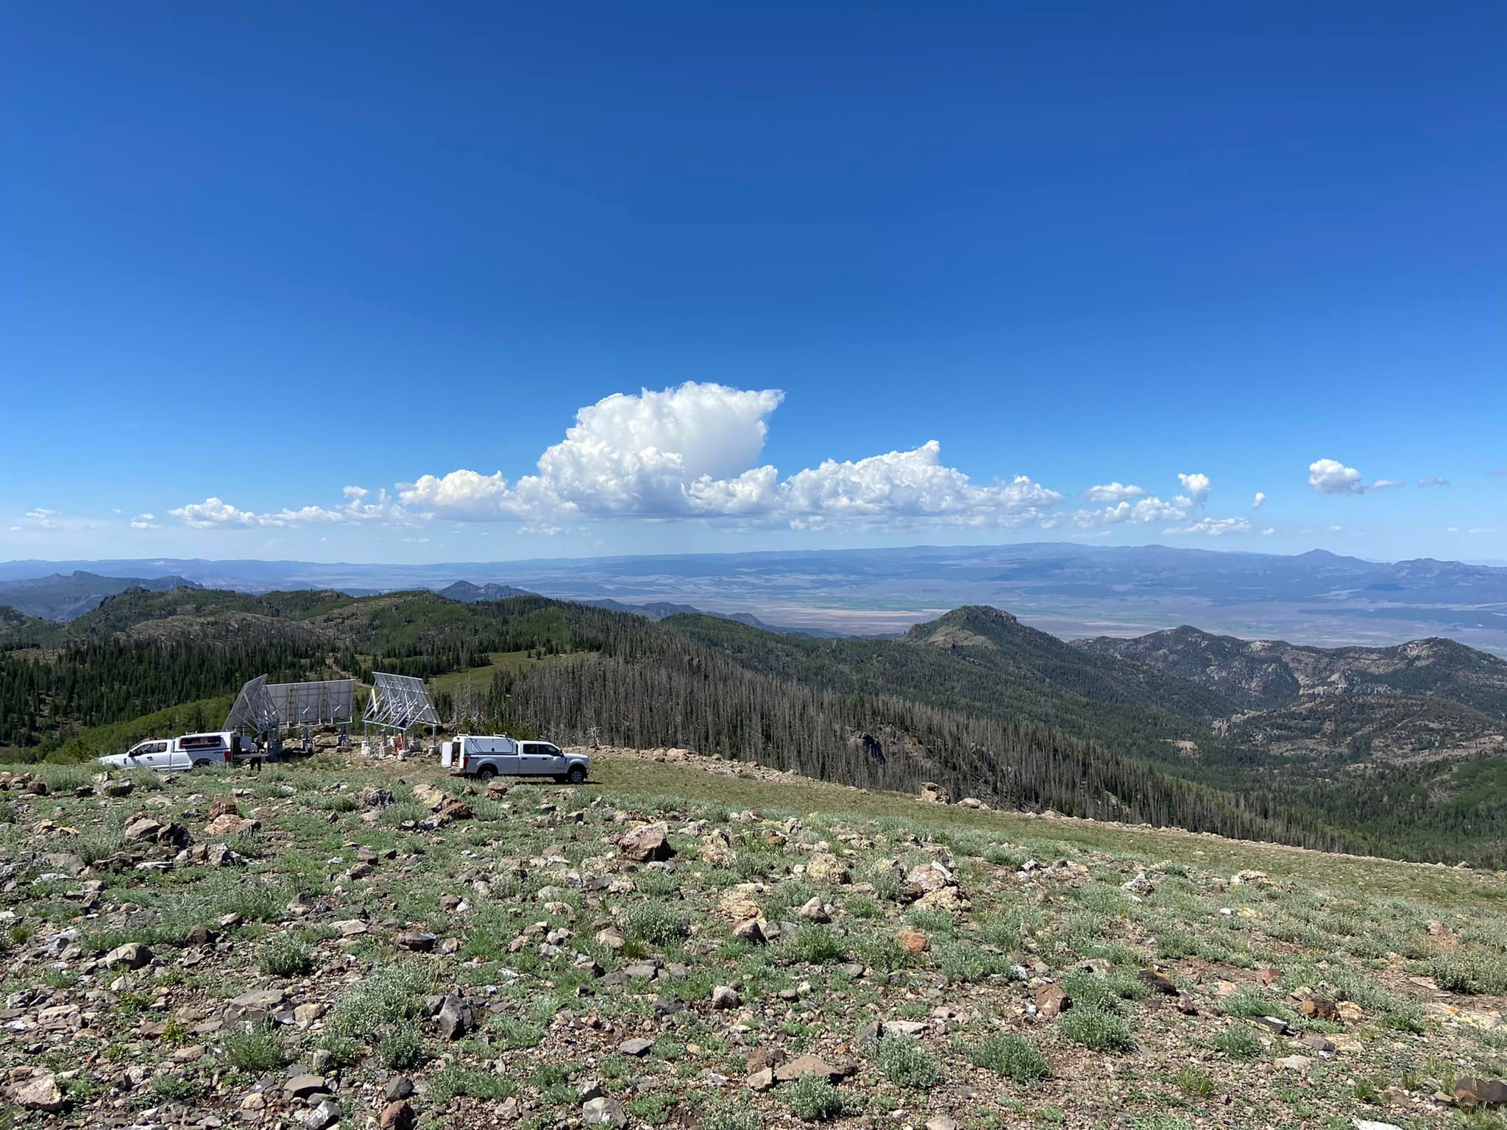
Join us for a ride that will take you from the valley floor to the top of Mt. Dutton where we will reach 11,000 feet. Riders will trailer their vehicles approximately 38 miles from Panguitch, through Red Canyon then onto the John’s Valley Road to the Mouth of Cottonwood Canyon. We unload our machines and proceed up Cottonwood Canyon to the top of Mt. Dutton. Along they way we will view Aspen Trees, scenic overviews of the valley below and if we are lucky, we may even stop some Mountain Goats. We will stop in Antimony for lunch, we will transition over to the lower side of the Escalante Mountains. This route will take us by some mountain lakes, there will be some rocky vertical ascents and descents.

