TRAIL #3 CASTO CANYON

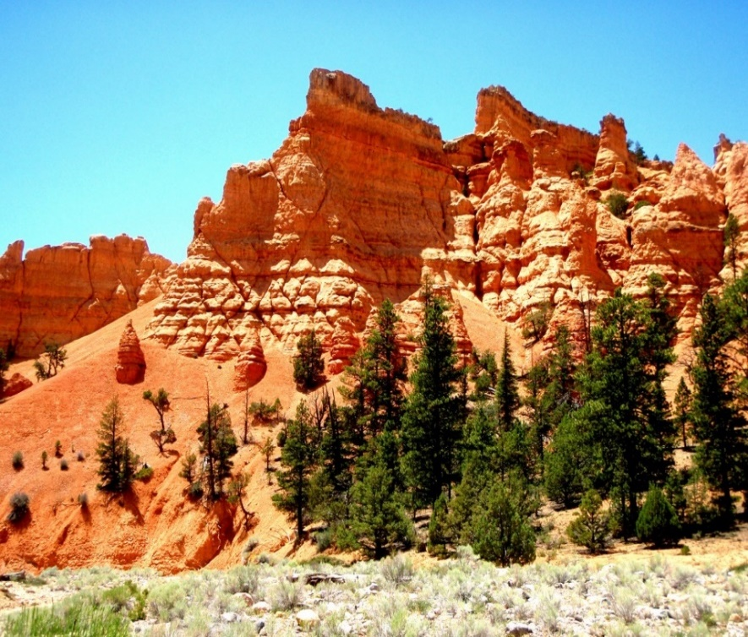
Departure Time: 8:30 A.M.
Length: Approximately 36 miles
Time: Approximately 5 hours
Rider Skill: Moderate

Trail Restriction: Limited to 50”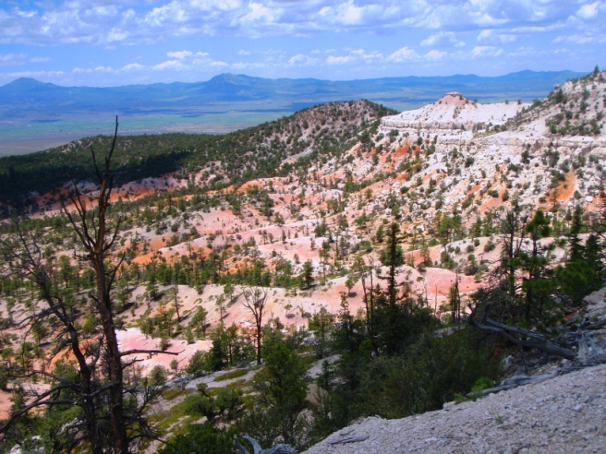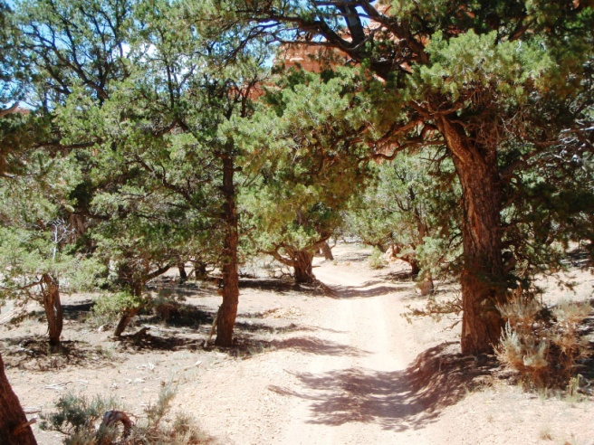

This is one of our prettiest rides. You will travel up through the sagebrush flats into pinions and cedar trees. Your assent will take you through multi colored rock formations, tall pine trees and some incredible rock faced mountains. Our lunch stop at Peterson Point will give you great views of Panguitch City, the surrounding valley and mountains. As our decent begins you will enter Red Canyon. Bring your camera because this gorgeous trail will follow along and through the stream bed. It’s rumored that Butch Cassidy hid some gold in one of the caves in this area. With red cliffs and green trees you are sure to get some great pictures. Please make sure to bring a lunch with you.

[Grab your reader’s attention with a great quote from the document or use this space to emphasize a key point. To place this text box anywhere on the page, just drag it.]

