
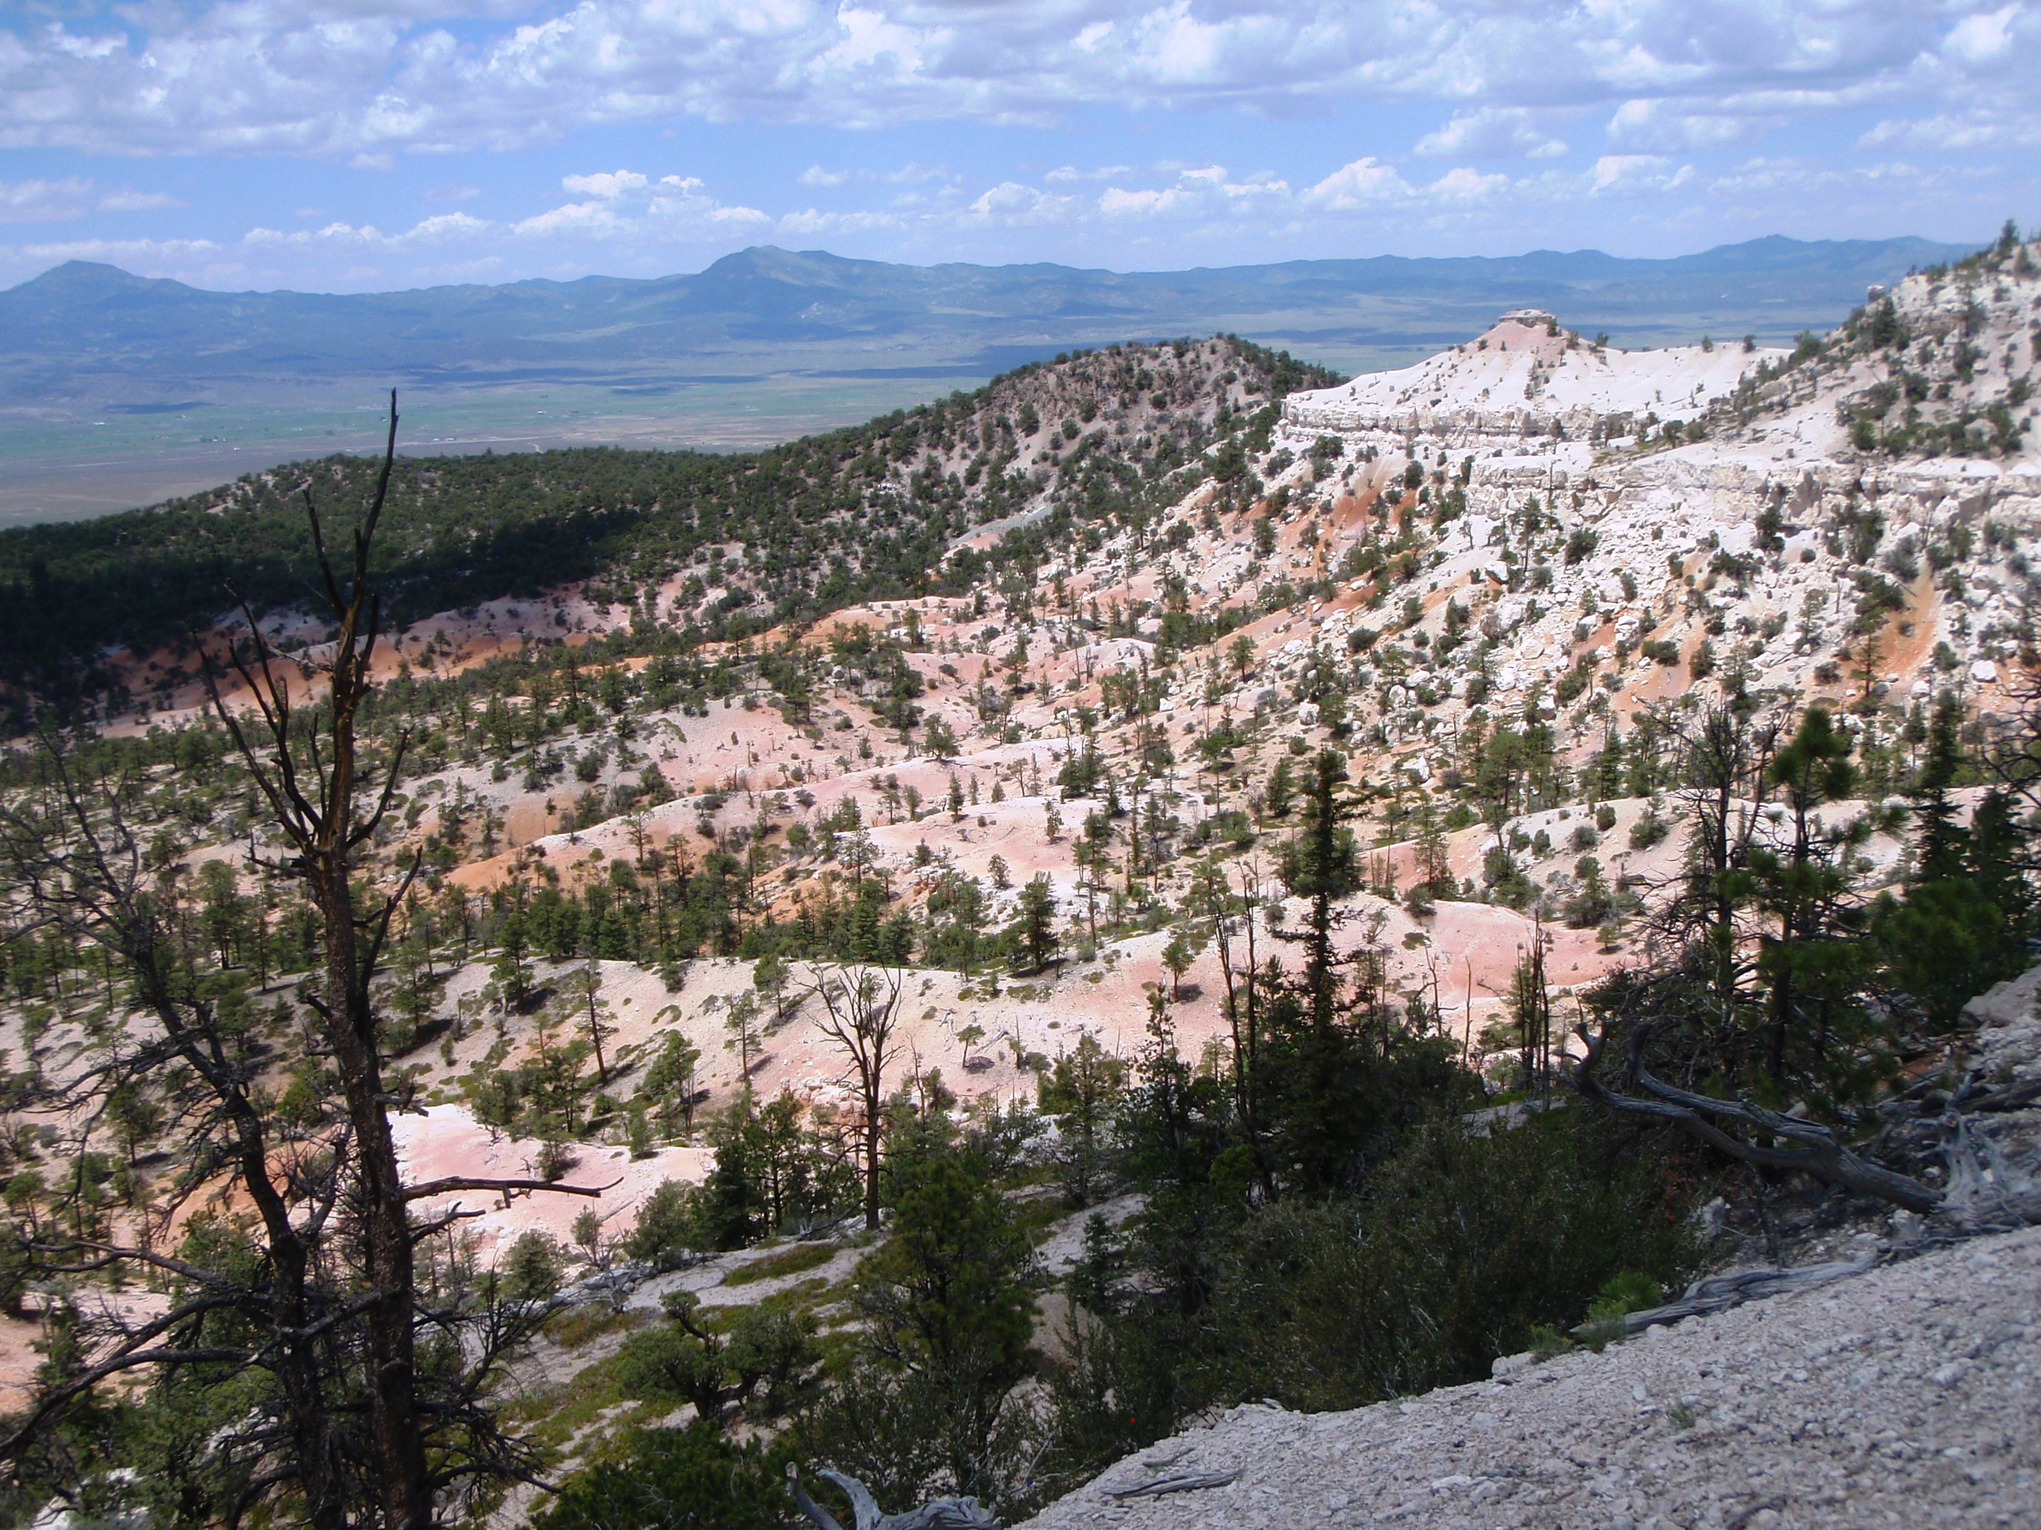

Early Departure: 8:00 A.M. Length: Approximately 75 miles
Time: Approximately 9 hours
Rider Skill Level: Intermediate
This will be a faster paced ride.

This Ride Has No Size Restrictions

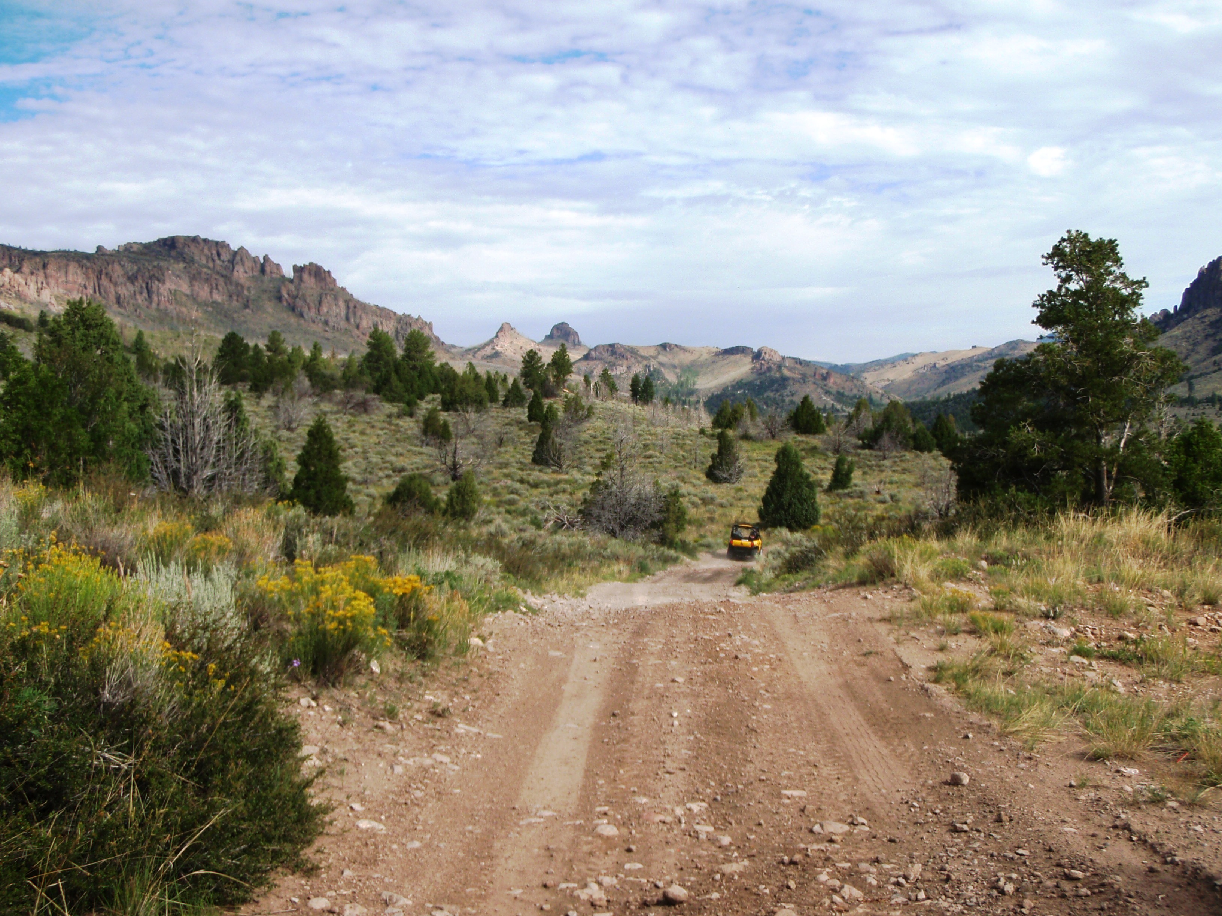
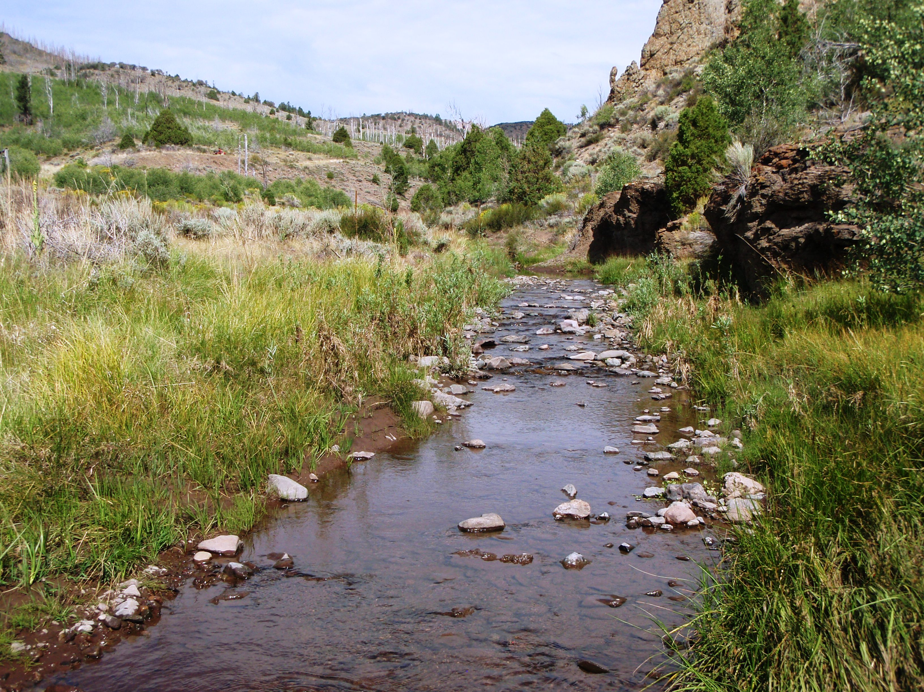
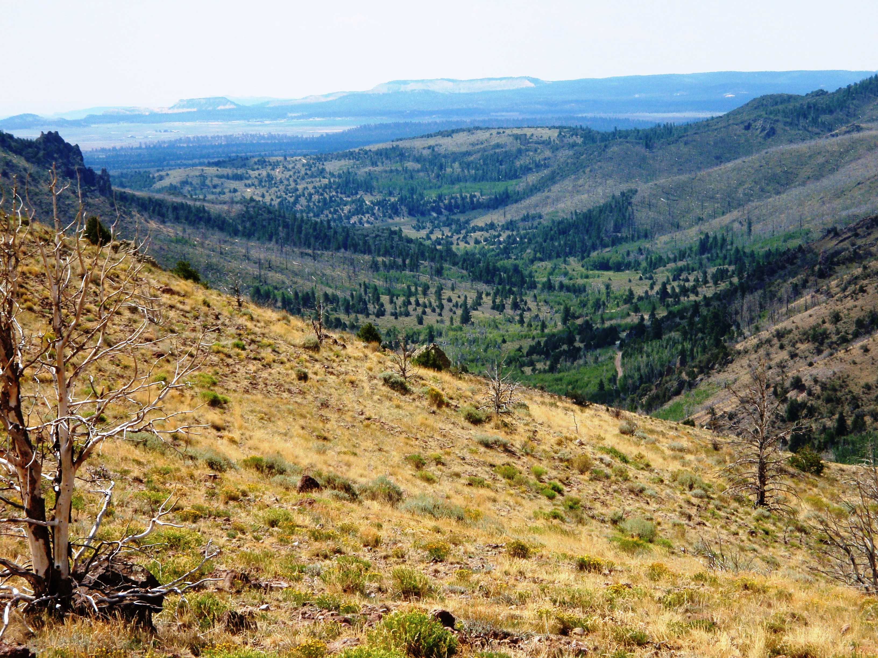

Early Departure: This ride begins in Panguitch and climbs up and through Limekiln, to the Fremont Trail then down into the West Hunt Creek drainage. Enjoy sagebrush flats, pine forests, majestic views and a nice long ride. Water crossings are shallow. Bring a lunch as we will be stopping along the trail for a break. This ride has it all: Length, elevation, water, trees and sagebrush. There are some steep climbs and a few rocky spots.

