TRAIL #8 DAVE’S HOLLOW/KING’S CREEK RIDE
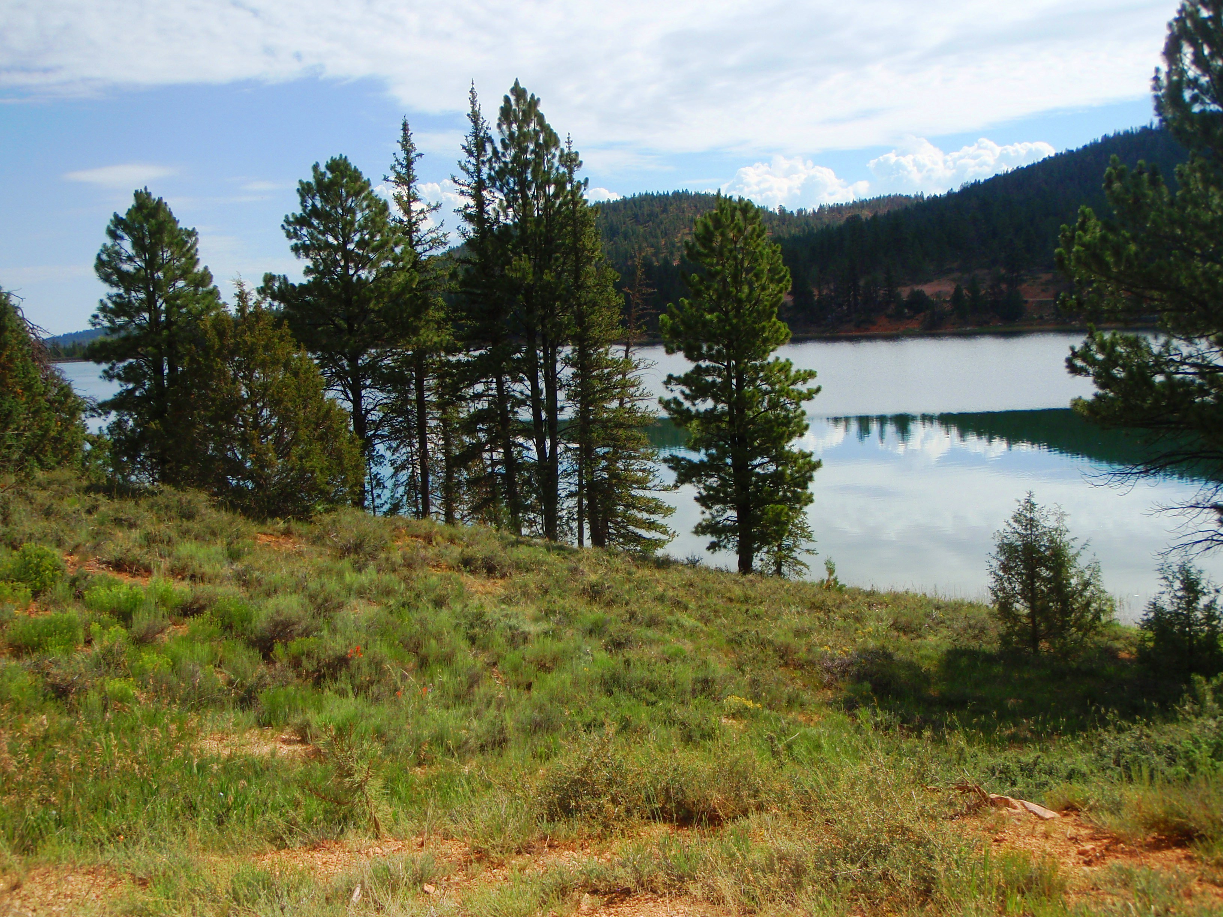

Early Departure: 8:00 A.M.
Length: Approximately 50 miles
Time: Approximately 5 hours
Rider Skill Level: Easy This Ride Has No Size Restriction

This Ride Is Trailered

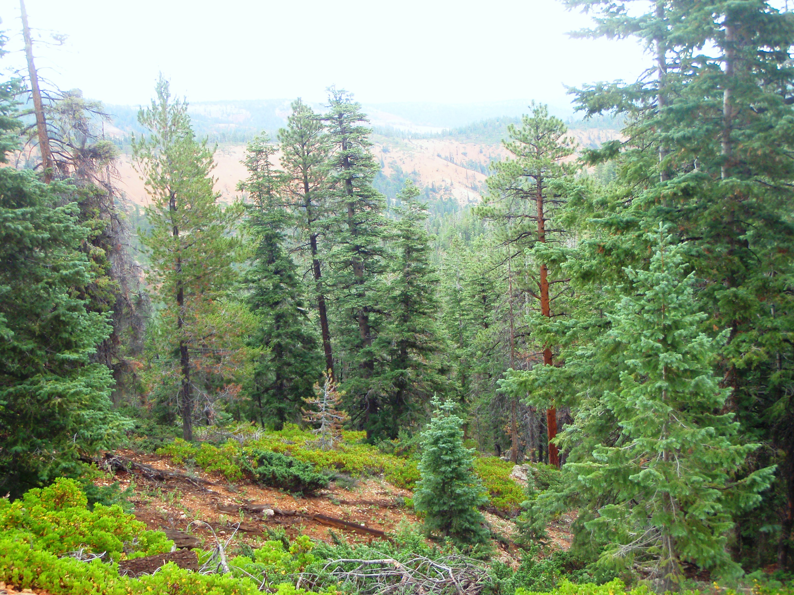
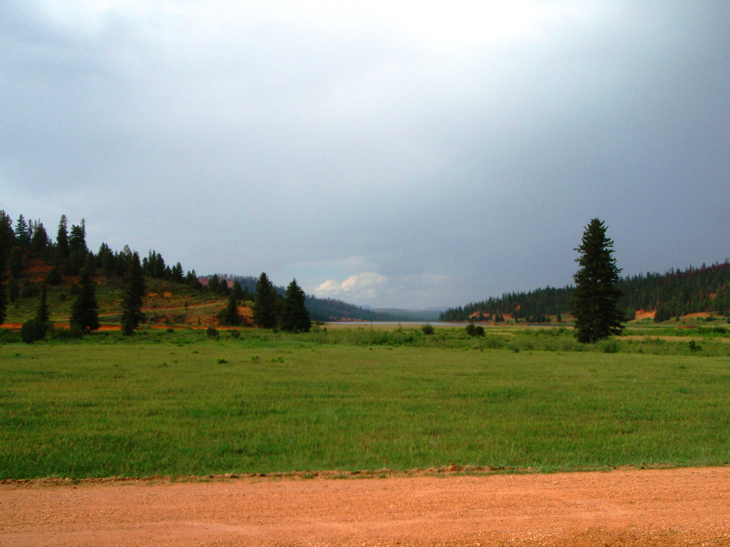
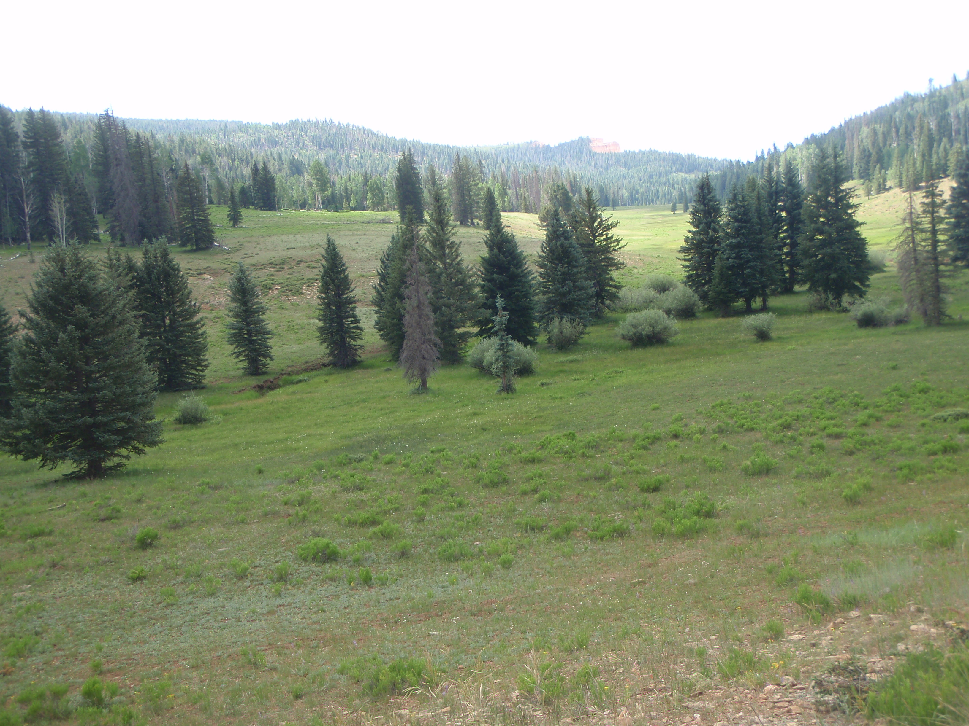

Early Departure: This trip begins and ends at the beautiful Tropic Reservoir. Ride through pink hills, green forests, hoodoos and past big meadows while traveling in some of the most picturesque country around. Portions of this ride will border Bryce Canyon National Park. Riders will trailer their ATV’s/UTV’s to the reservoir which is located 25 miles from Panguitch via US 89 and Scenic Highway 12 near Bryce Canyon National Park. Take the Tropic Reservoir road south to the launching point at the Reservoir Parking Lot. Bring a lunch with you as we will be stopping along the way for a break. Travel time will be approximately 1 and ½ hours roundtrip from and to Panguitch.

