

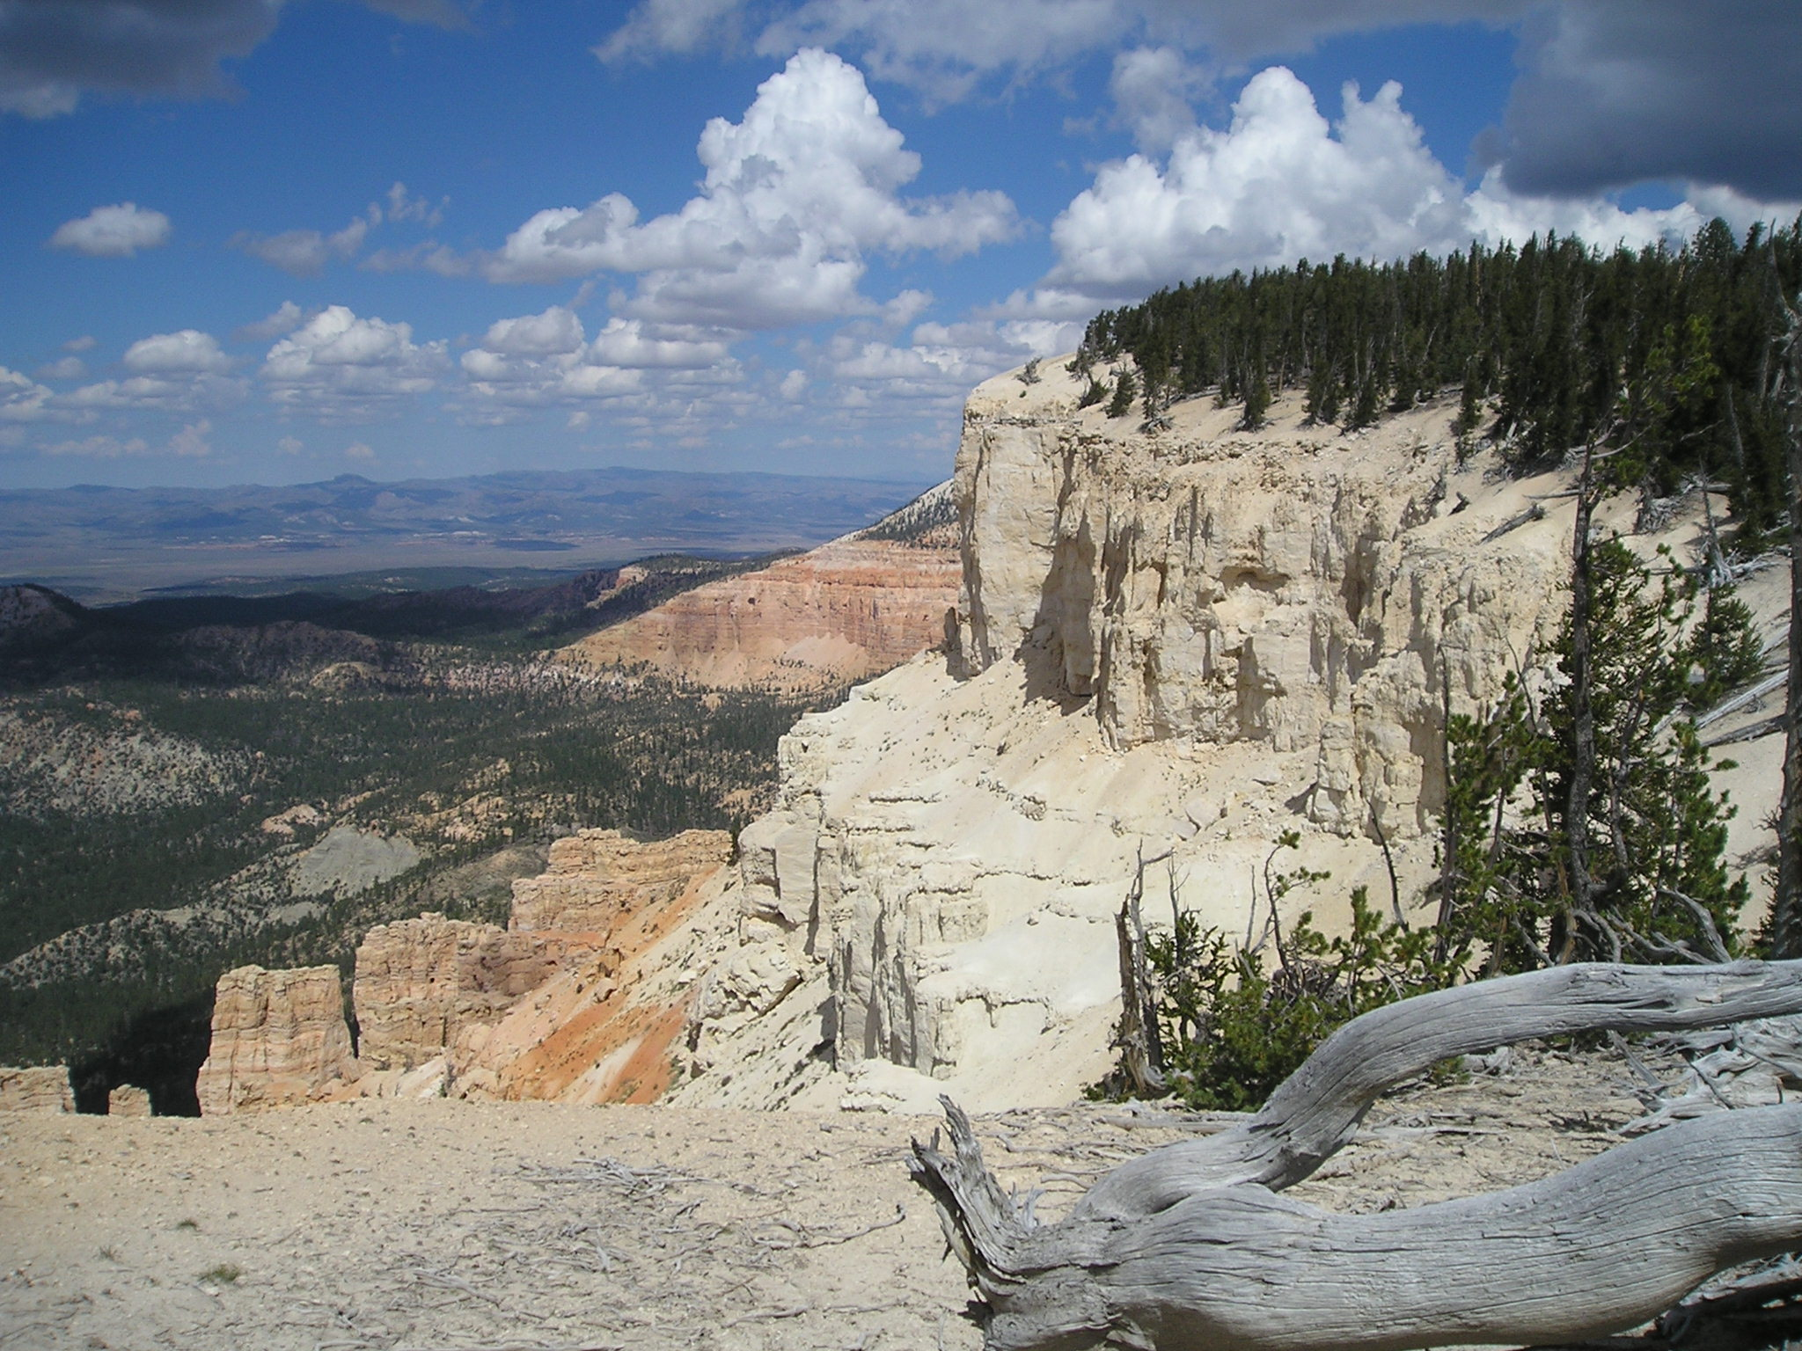

Early Departure: 8:00 A.M.
Length: Approximately 30 miles
Time: Approximately 8 ½ hours
Skill Level: Easy

This is a trailered ride

FRIDAY ONLY

This Ride Has No Size Restrictions

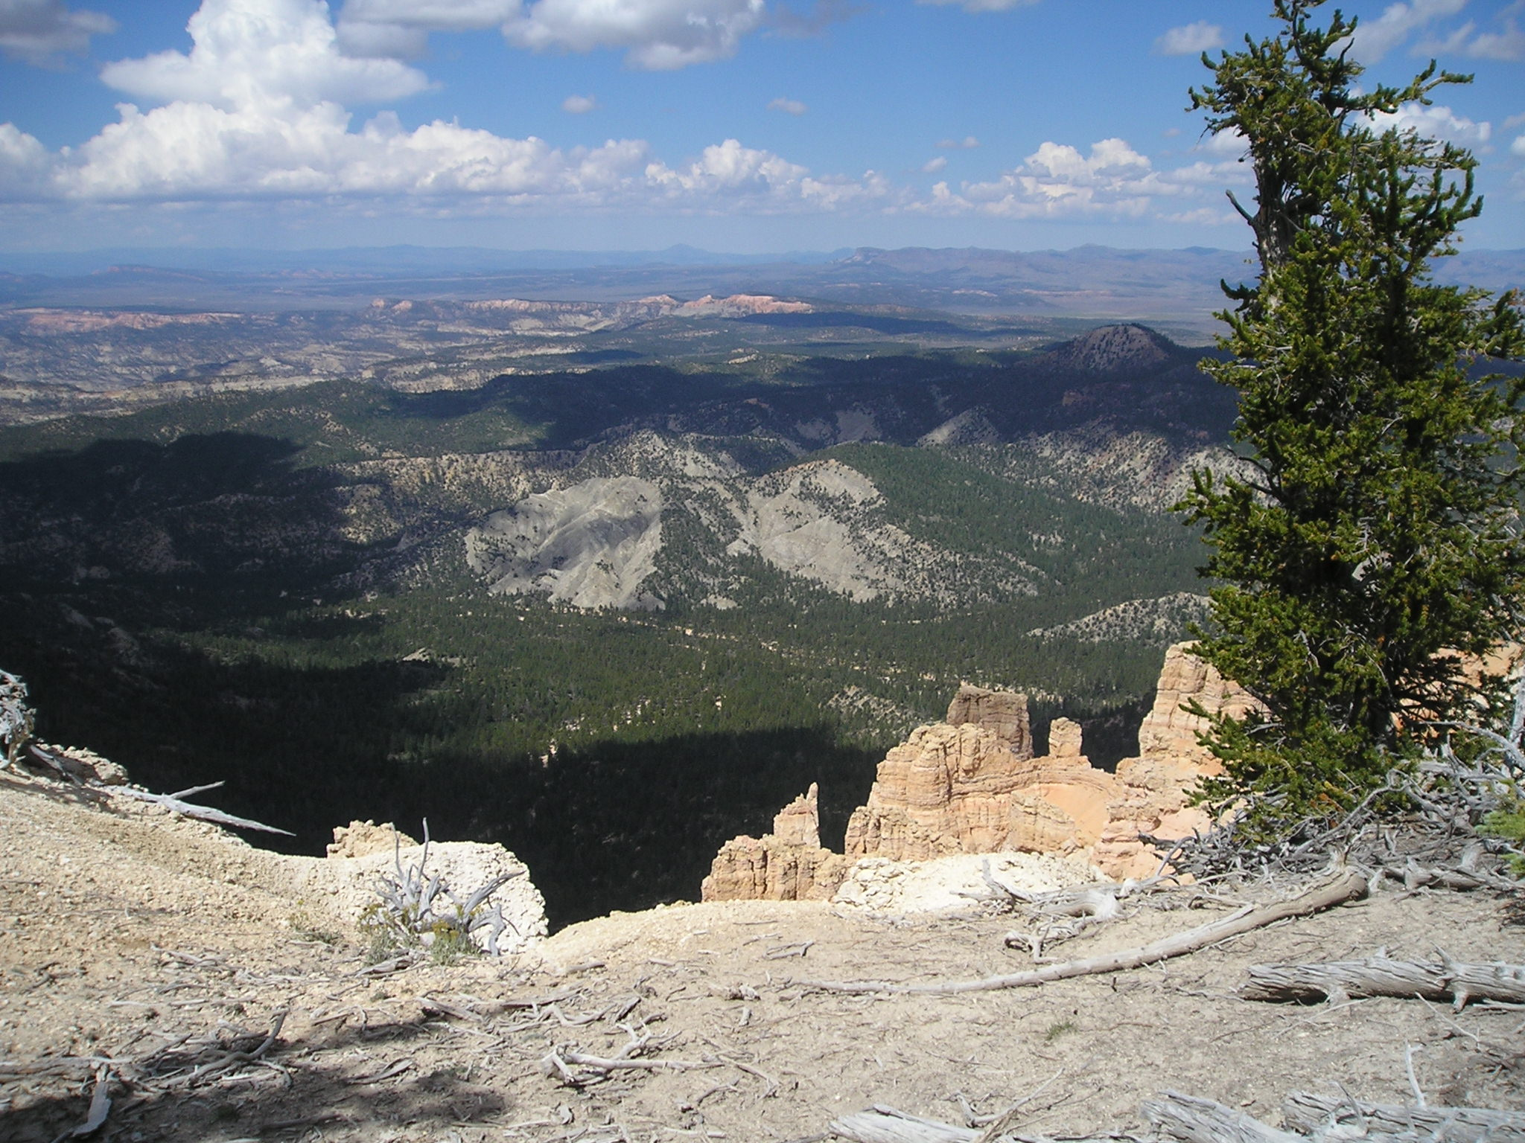
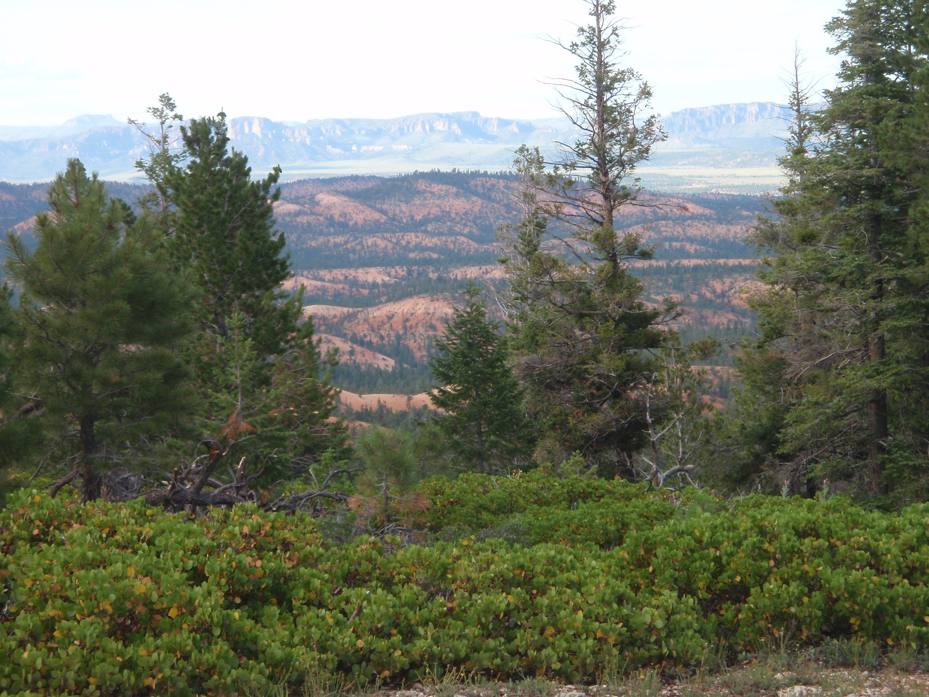

Early Departure: Powell Point is located approximately 55 miles from downtown Panguitch. The views from the top of Powell Point are majestic and certainly worth the trip. Riders will trailer their ATV’s to the staging area and trailhead at Pine Lake. Take US 89 South from Panguitch to SR12 East through Red Canyon. Turn left on Johns Valley Road at the Bryce Canyon turnoff at SR63. Take Johns Valley Road approximately 15 miles and turn right at the Pine Lake turnoff. Roads are clearly marked. The staging area is another 10 miles past Pine Lake. Riders will enjoy the ¾ mile hike at the top, to Powell Point. The elevation here is well over 10,000 feet. The ATV ride then travels onto the Barney Top and down to the Widtsoe Cemetery and back to the staging area passing Pine Lake. Please bring a lunch as we will be stopping along the trail for a break.

