
#12 Sandy Loop Trail

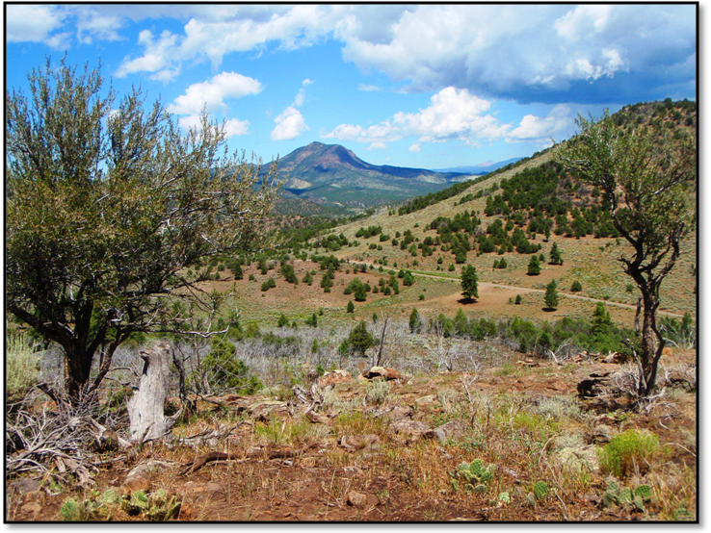
Departure Time: 8:30 A.M.
Length: Approximately 40 miles
Time: Approximately 5 hours
Rider Skill Level: Easy

This Ride Has No Size Restrictions

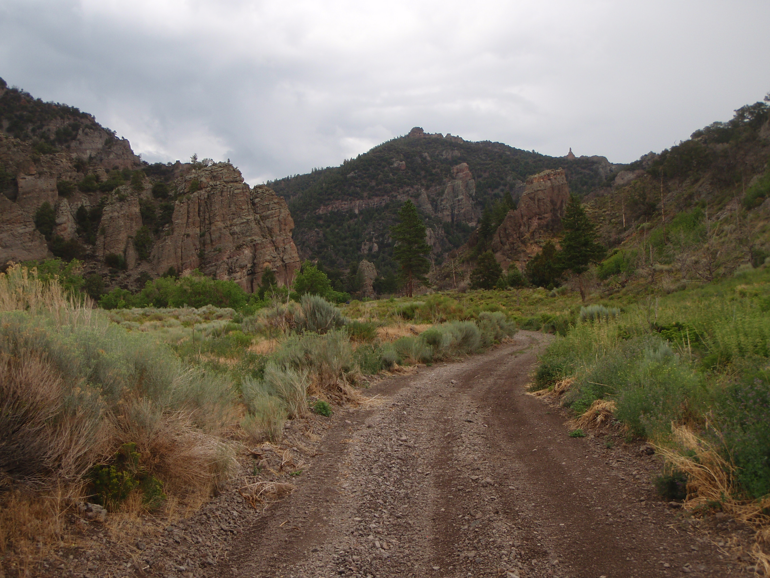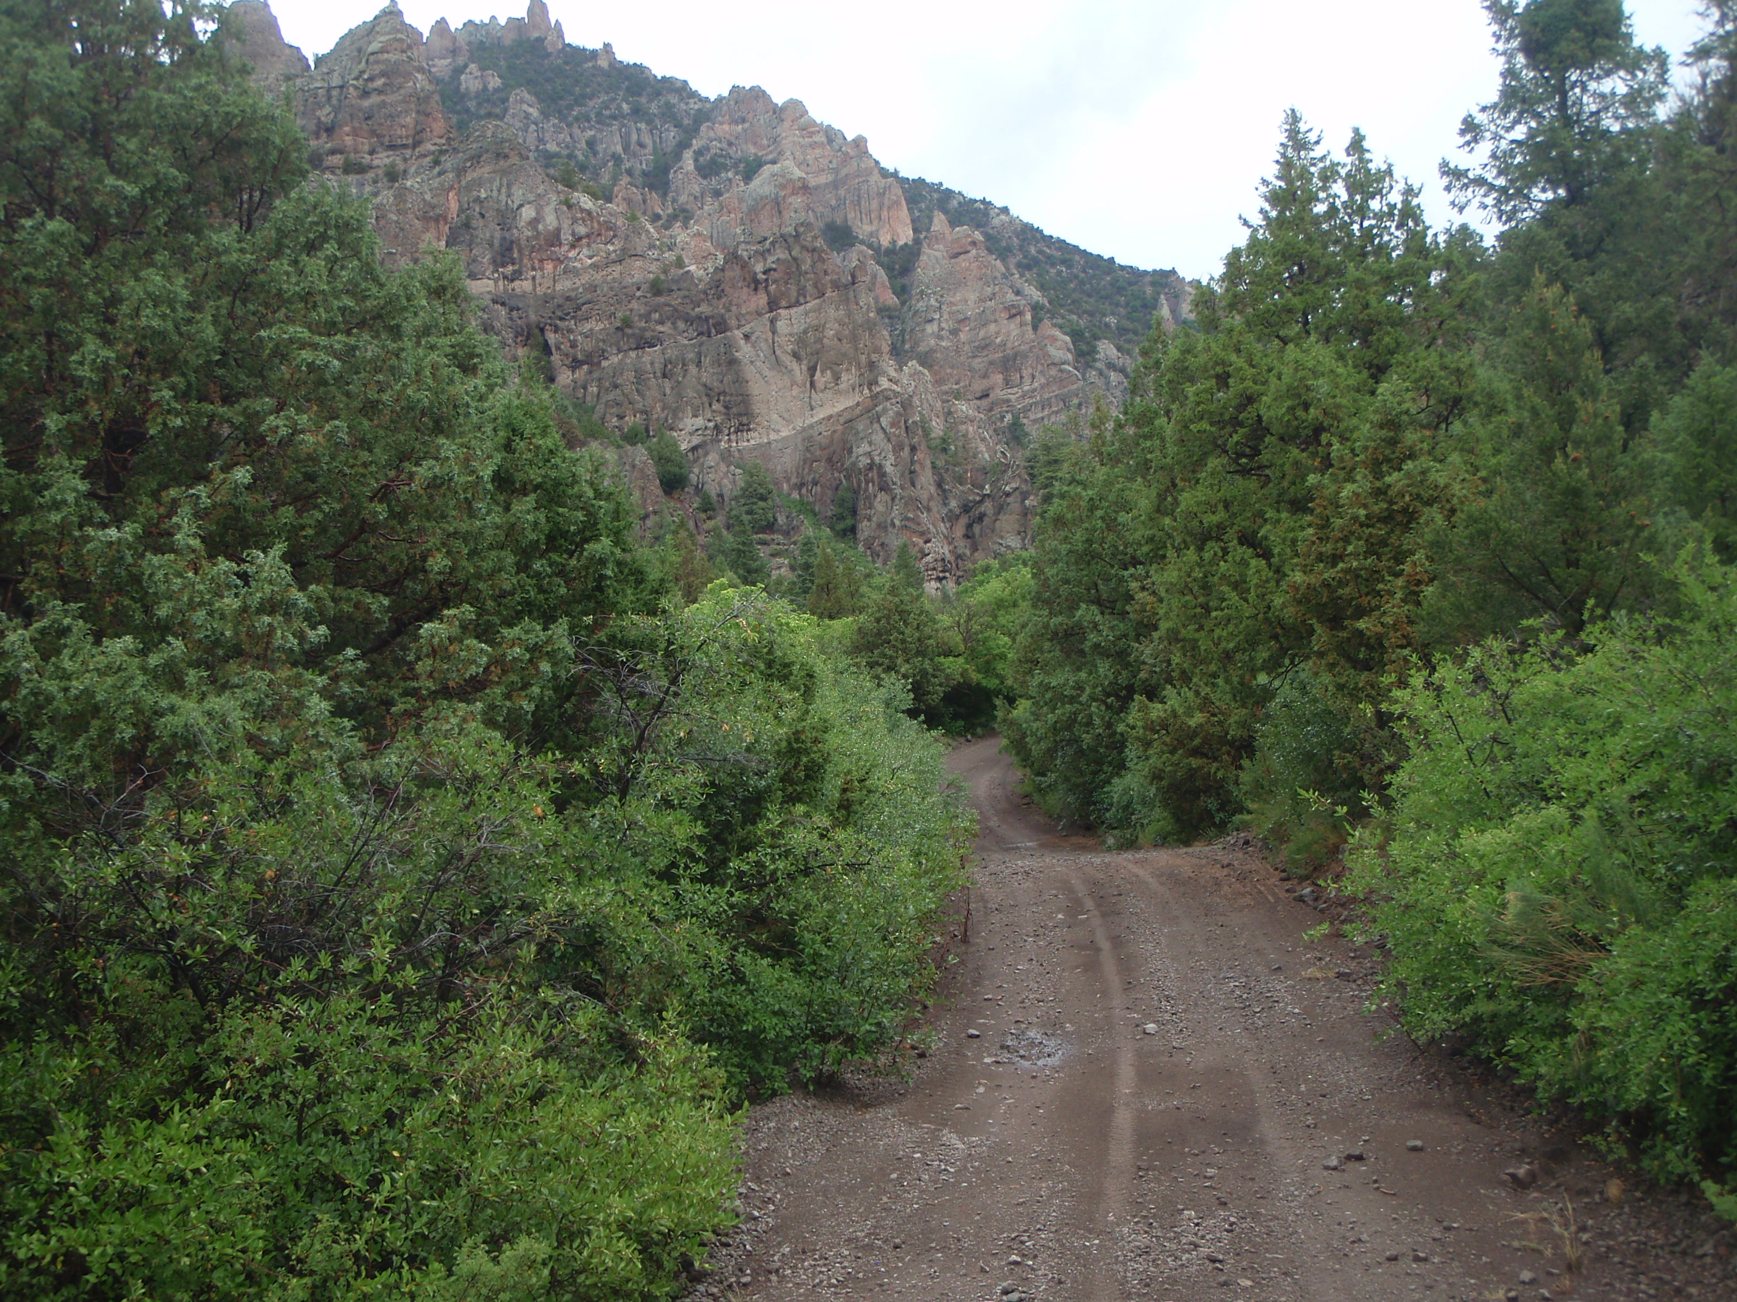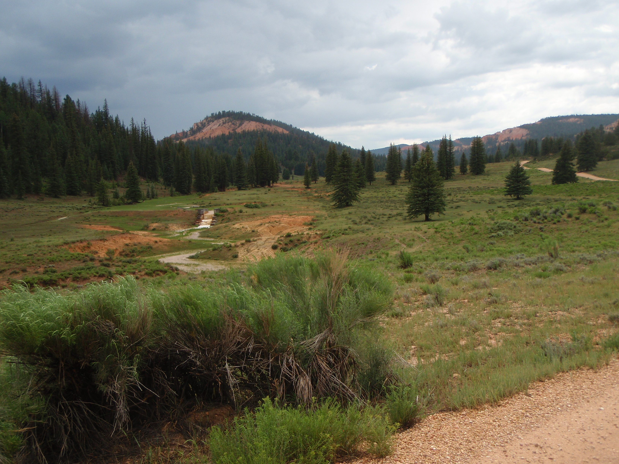

This ride begins in Panguitch at the Triple C Arena parking lot and moves North East, up onto the West Bench. We’ll arrive at the trail and follow 3 Mile Creek; a big resource for wildlife. Ascending up into the aspens and pines we’ll cross to the north at the base of Little Creek Peak through high mountain country. From there, and following an easterly turn we’ll begin our descent in the shadow of Sandy Peak Mountain. Heading down through pinion and cedar forests you’ll enjoy fabulous views of the valley and Mt Dutton. Pack a lunch as we will be stopping along the trail for a break. There are no vehicle size restrictions for this trail.

