TRAIL #6 BEAR VALLEY LOOP

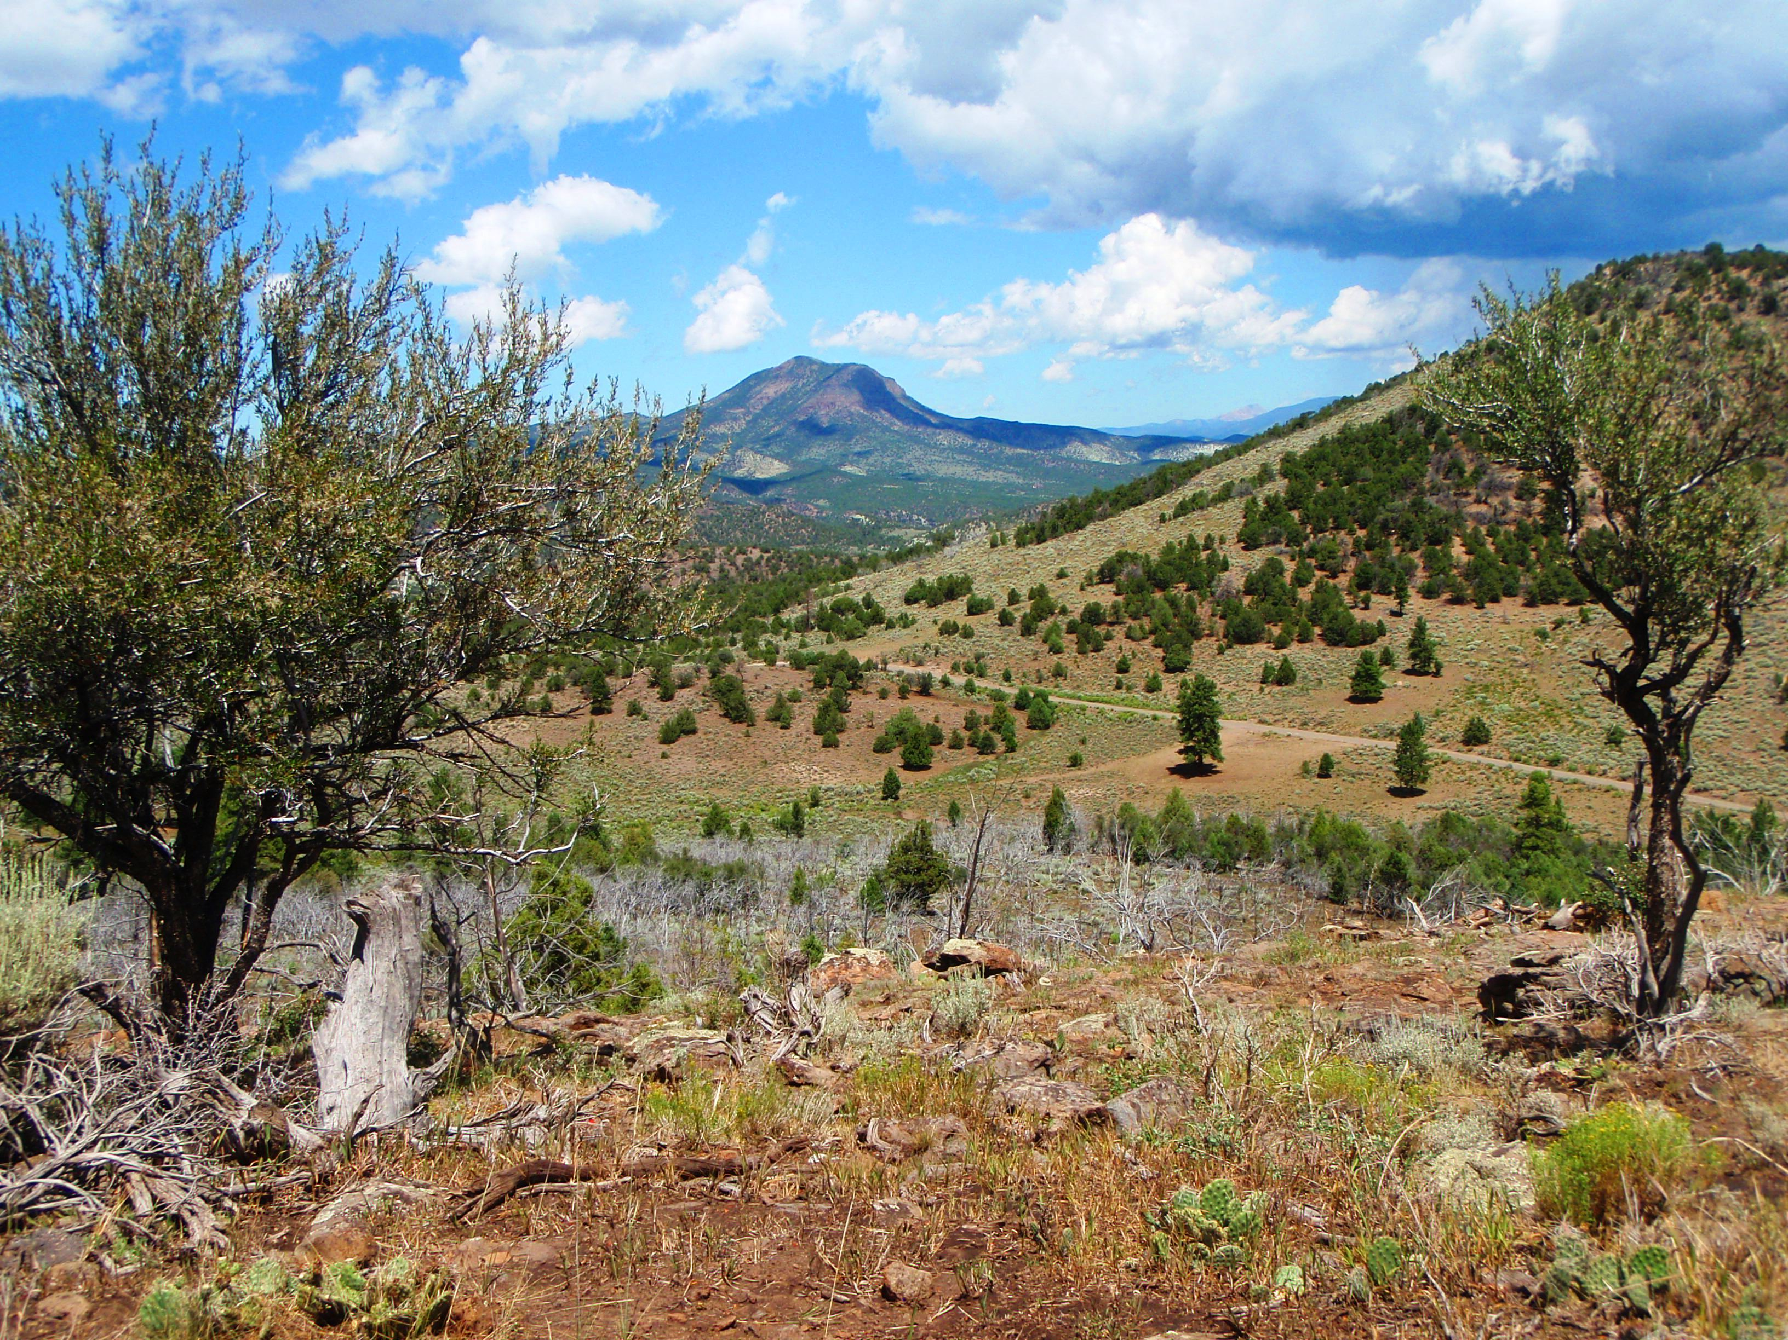
Departure Time 8:00 A.M.
Length: Approximately 50 miles
Time: Approximately 6 hours
Rider Skill Level: Advanced

This Ride Has No Size Restrictions

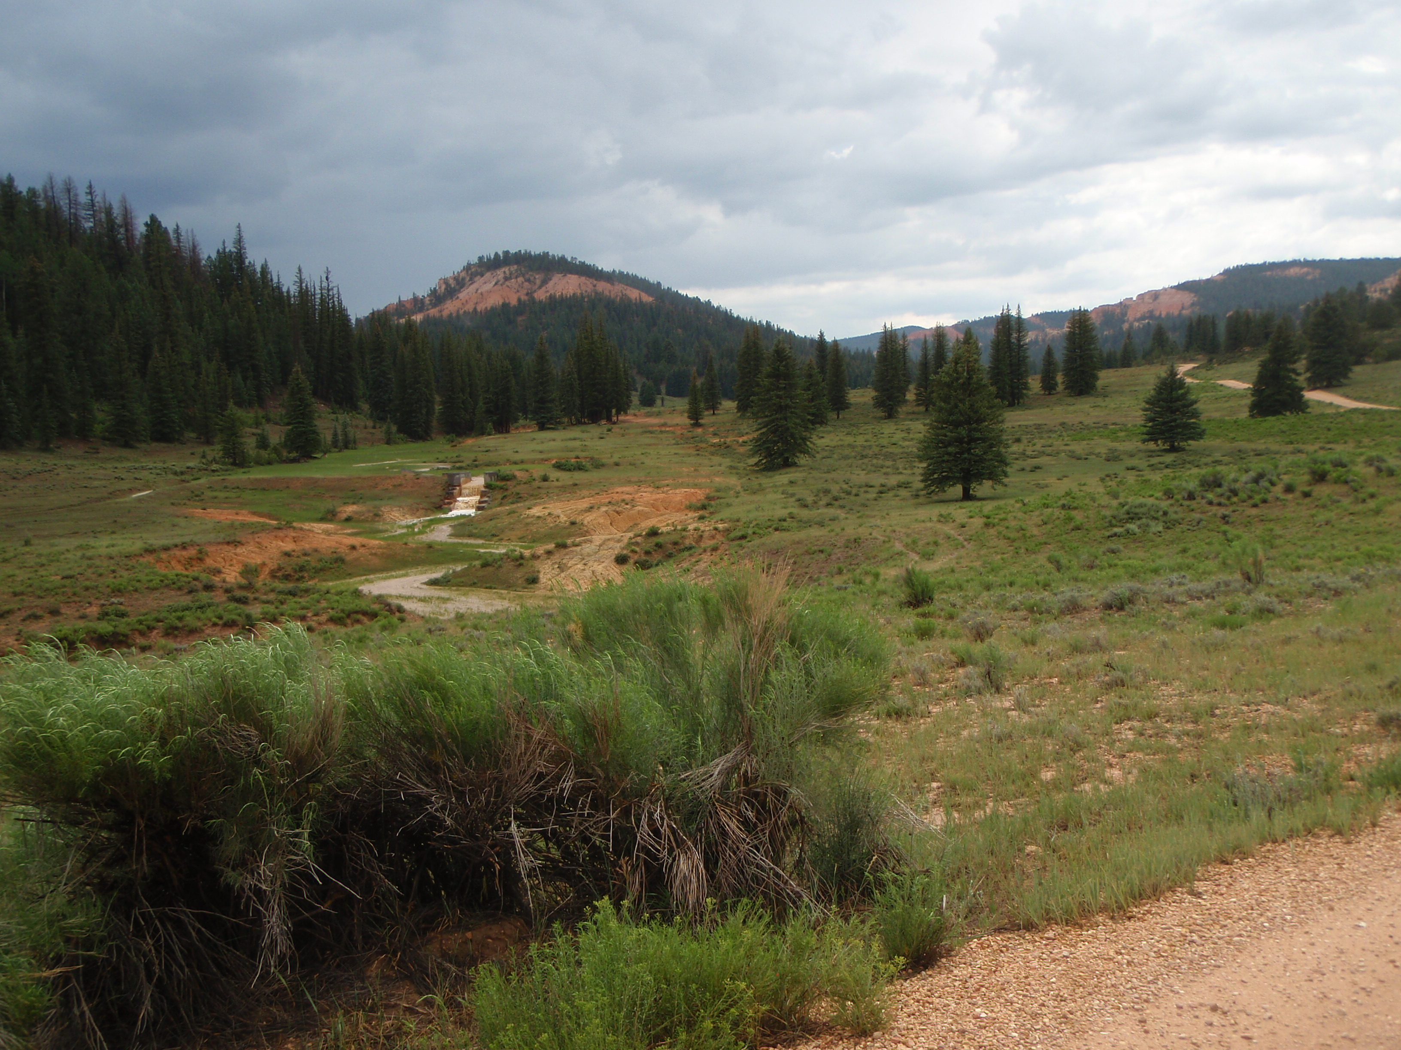
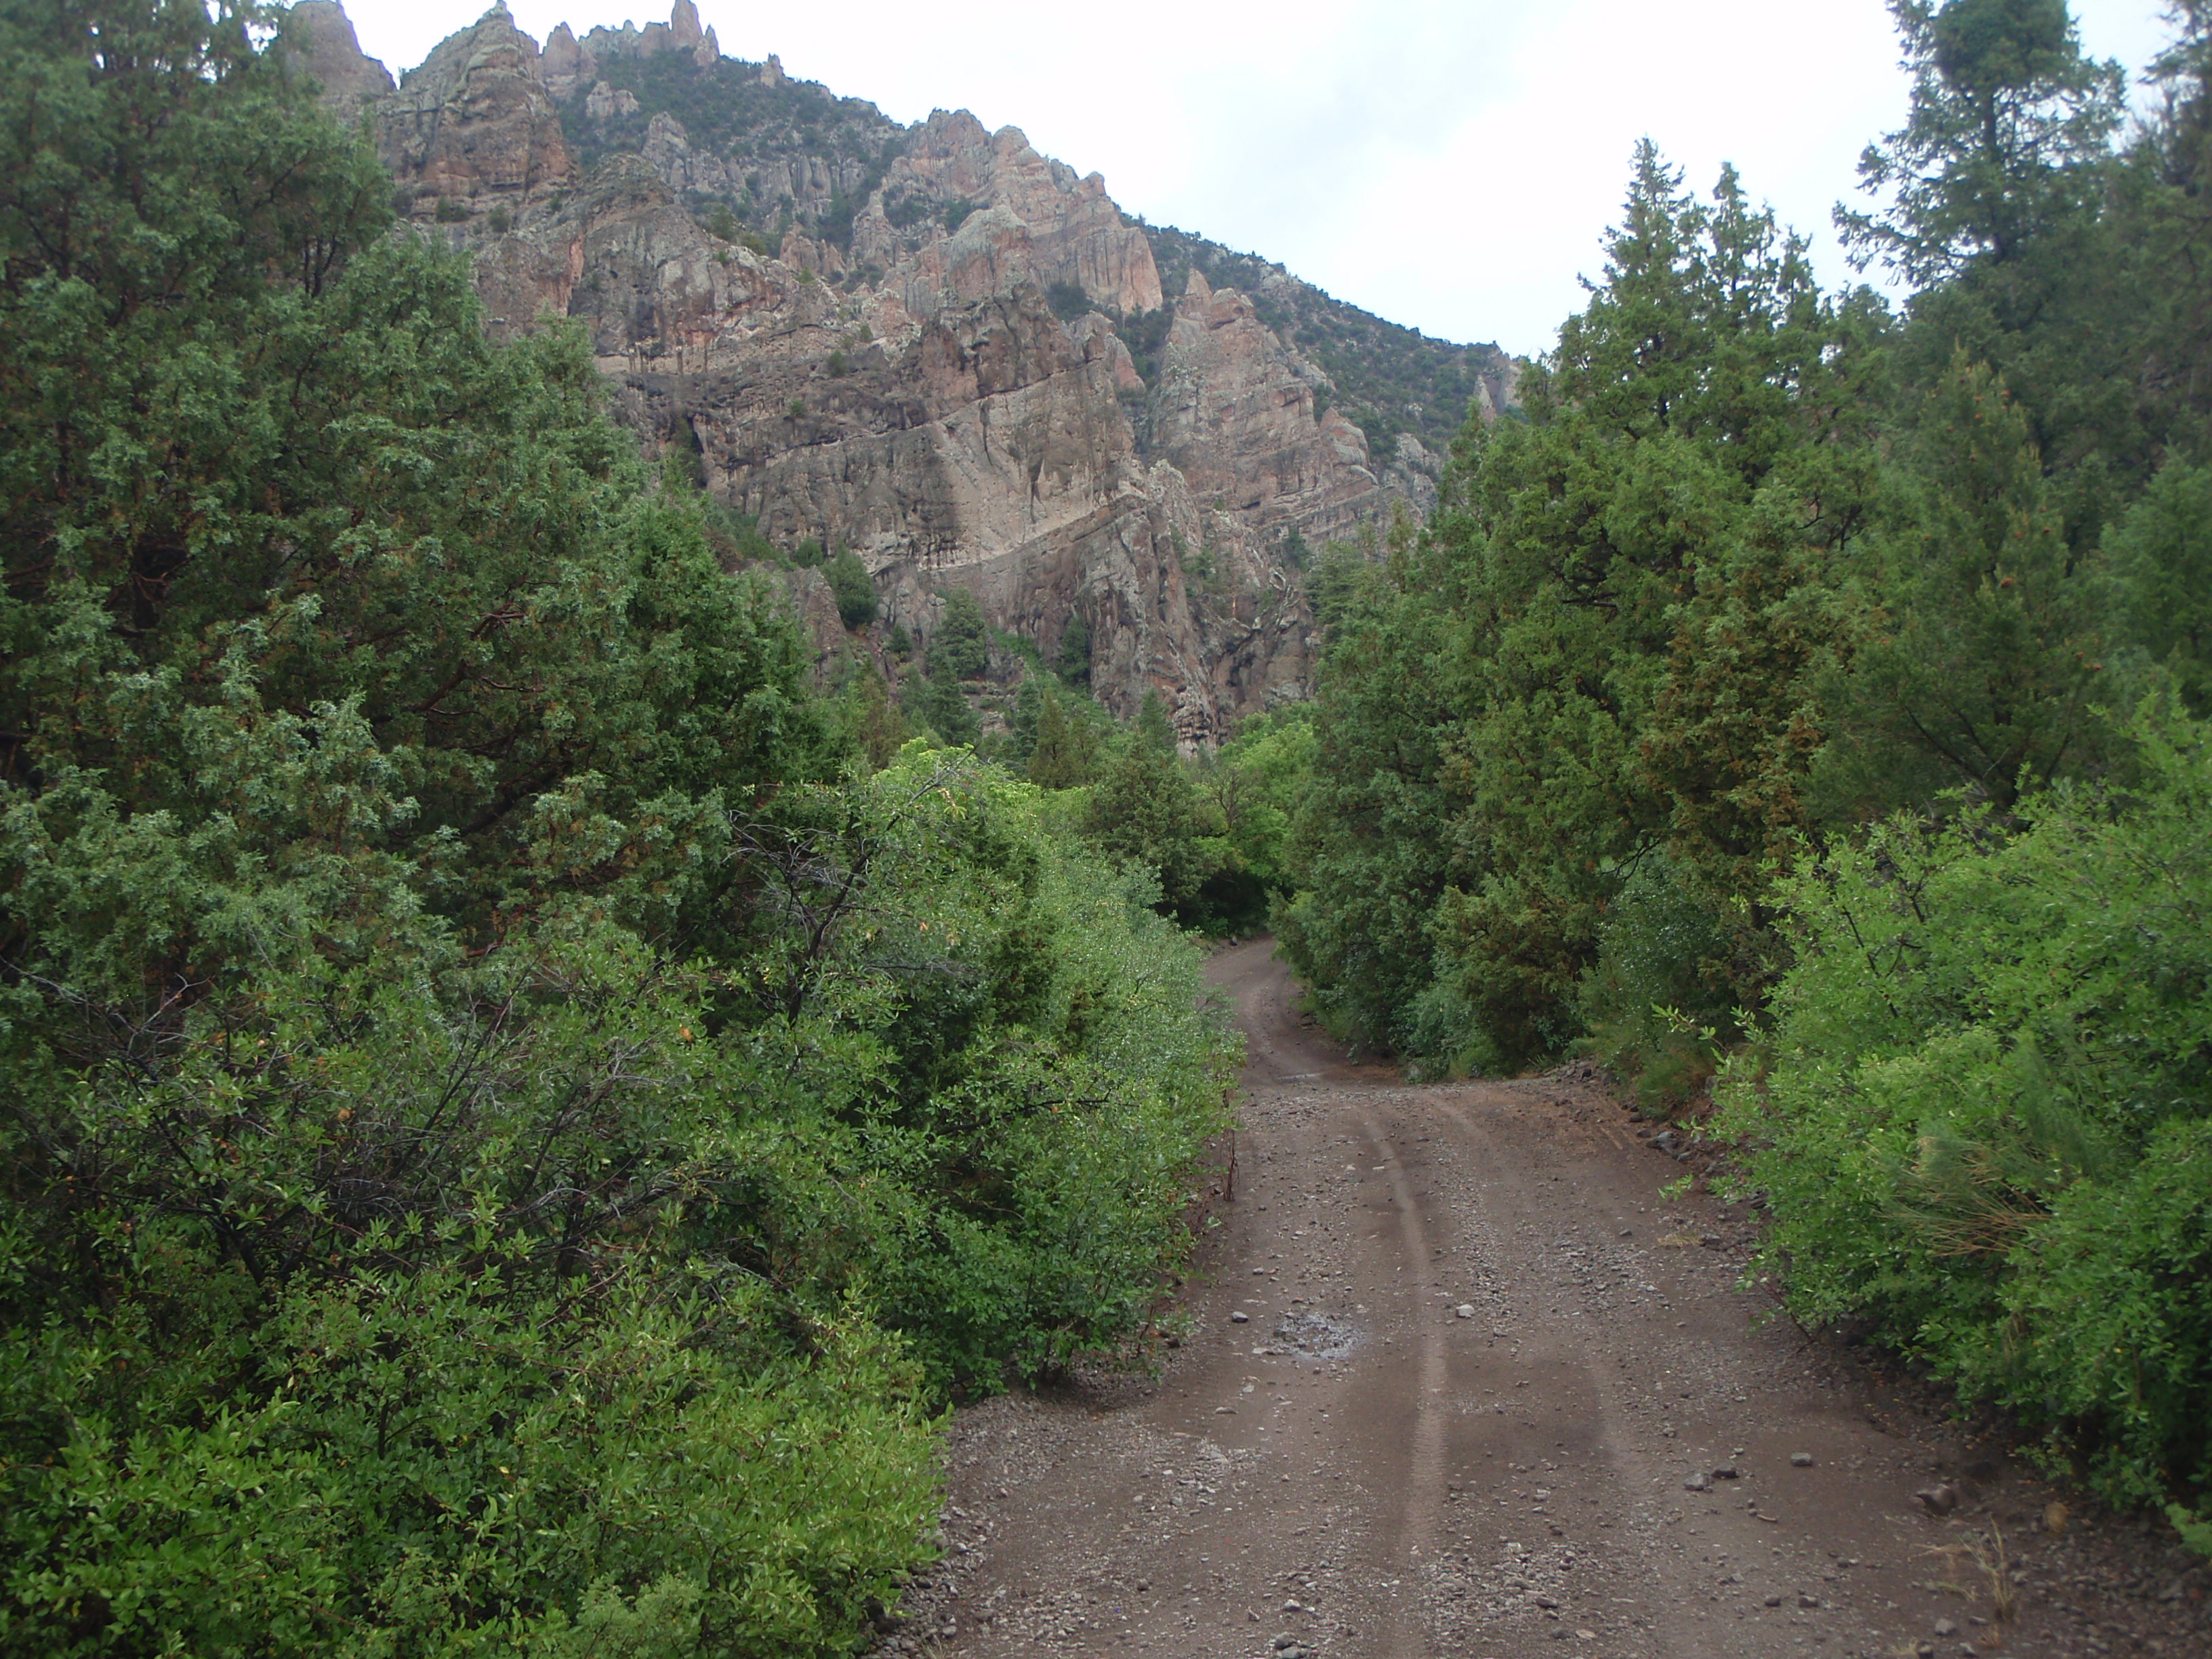
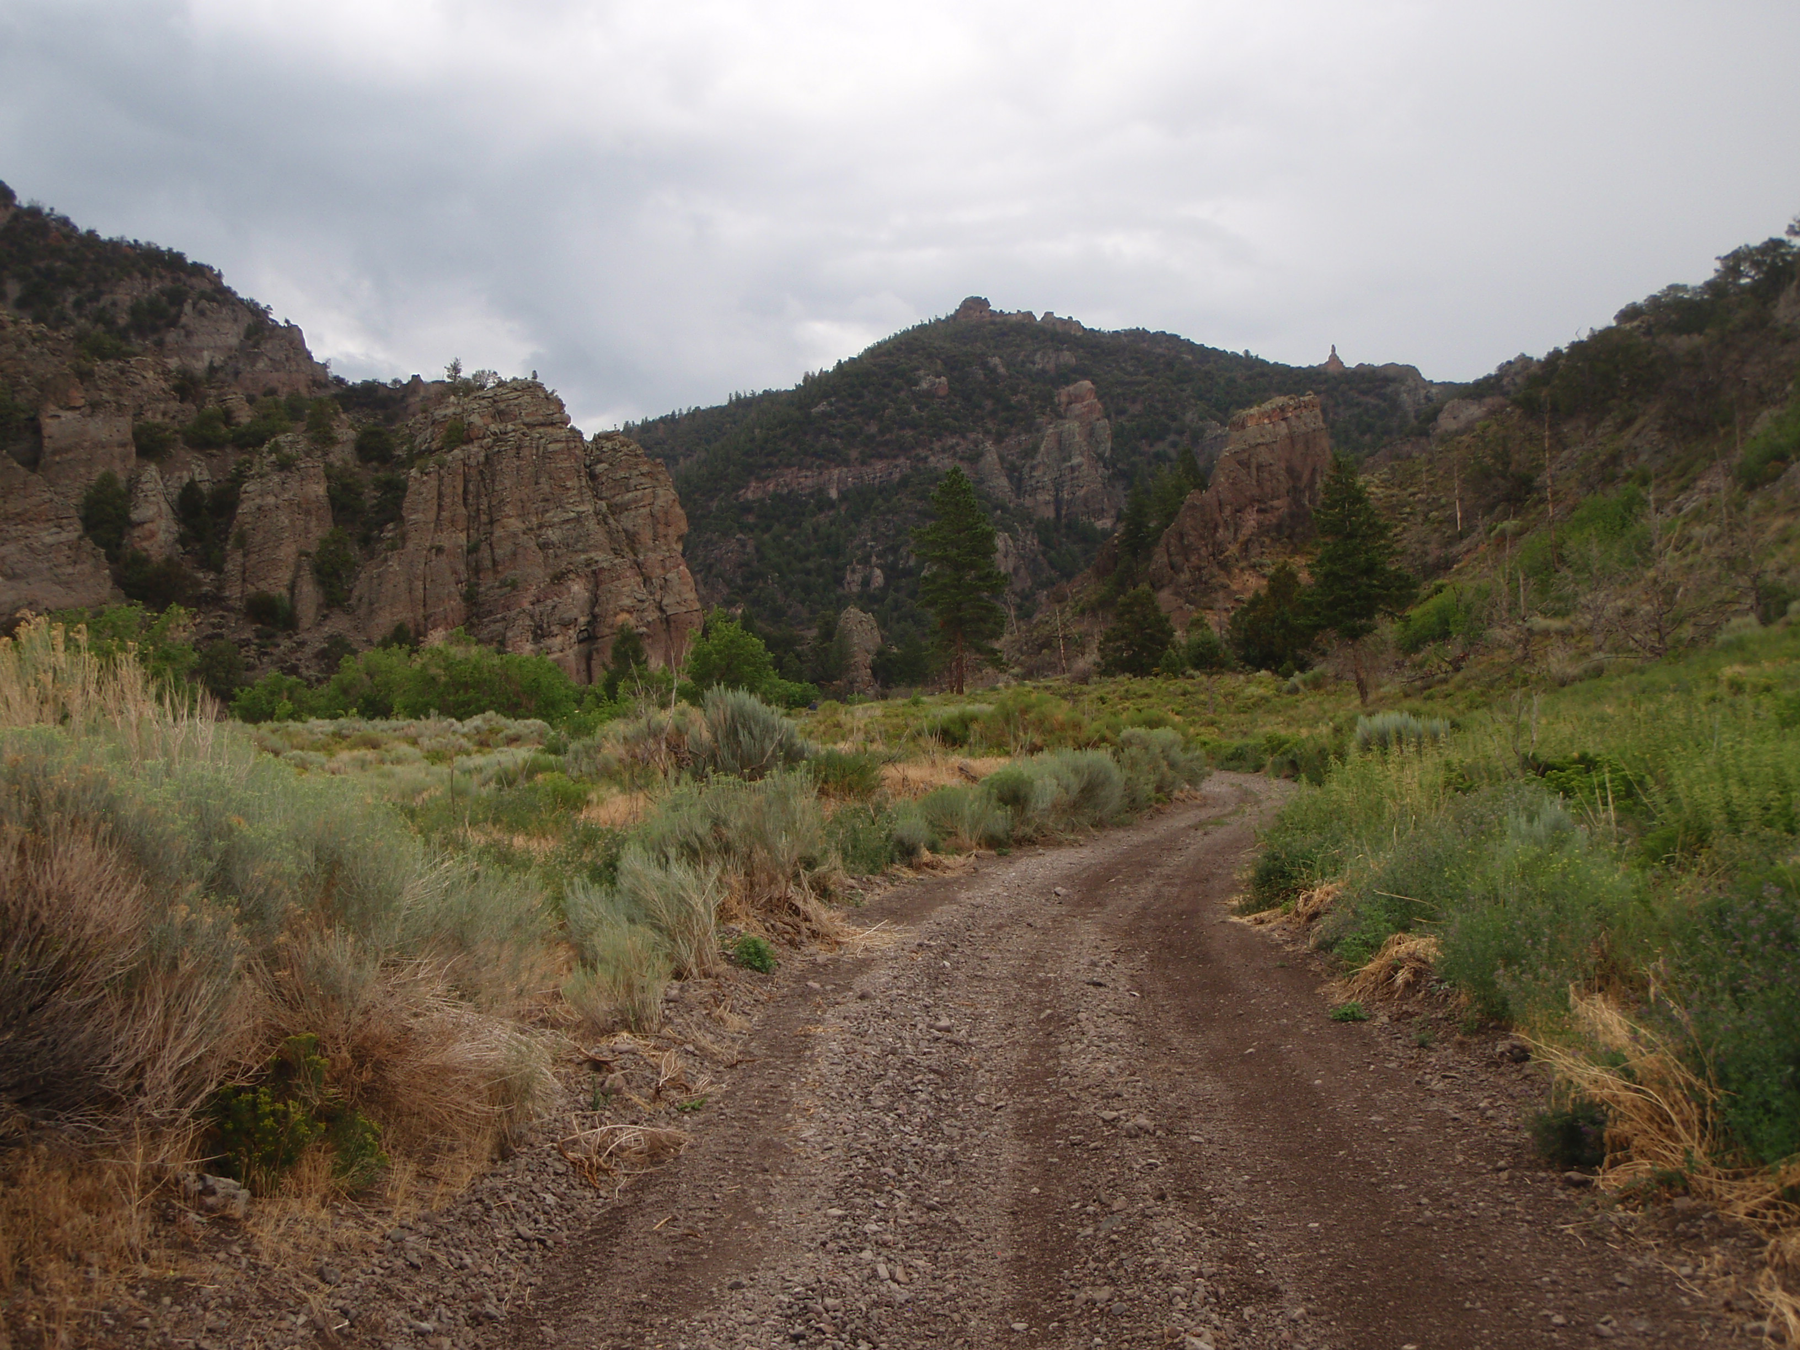

This ride begins in Panguitch and moves west riding up 3 Mile Creek. After crossing over indo Bear Valley, you will pass the guard station and Bear Valley Creek then continue on the Spanish Trail to Red Creek Reservoir. Restrooms are located here. Leaving Red Creek Reservoir, the ride will continue through Caddy Creek. On Five Mile Ridge you will enjoy one of the rockiest rides you will ever experience by crossing the “Rock Garden”. This Ride will return to Panguitch via a very wide loop. Reaching elevations of 9,000 feet you will experience beautiful and majestic views, as well as the Brian Head Fire burn area. Bring a camera and take pictures from the many opportunities presenting themselves along the trail. This ride is classified as skill level “ADVANCED” due to steep switchbacks and the body shaking “Rock Garden”. Please bring your lunch as we will be stopping along the trail for a break.

